Minutes for the LEYM Executive Committee Meeting
October 8, 2022
This meeting was held via Zoom
Present: Joanne Neuroth, Tom Kangas, Clemence Mershon, Peggy Daub, Jeff Cooper, Sally Weaver Sommer, Jon Sommer, Bill Warters, Mike Holaday, Shelley Kotz, Erika Smith, Susan Loucks (clerk), Kate Enger (recording clerk).
EC22-10-1 Friends settled into centering worship at 10:07
EC22-10-2 Minutes for the LEYM Executive Committee Meetings July 27 & August 11, 2022 were approved as they appear on the website.
EC22-10-3 Jeff Cooper presented proposed changes to Policies and Procedures:
- An update to the mileage reimbursement rate to 22 cents, as presented in the approved 2022-23 budget.

- A change in the following passage:
Unless otherwise noted, under ordinary circumstances: . . . - Committees meet during Representative Meeting and Annual Meeting, and meet or communicate as needed between these meetings.
to read:
Unless otherwise noted, under ordinary circumstances: . . . - Committees meet or communicate as needed, especially to prepare for Representative Meeting and Annual Meeting. Approved

EC22-10-4 Sally presented for the Arrangements and Site Committee. They have reserved space at the Convocation Hall at Ashland from 3:00 Thursday, June 15 to 1:30 Sunday, June 18. Convocation Hall has one big room and multiple other spaces that can be used for meetings and workshops. Friends will be able to choose between housing options with or without air conditioning and private bathrooms. The contact person at Ashland, Erica, has been easy to work with. Committee members plan to meet with Erica and work with Tom Kangas to solidify plans and methods for payment. The committee may need an additional helper to sit at the registration table. Mike Holaday plans to reach out to the meetings closest to Ashland to seek some volunteer help for the arrangements and site committee for annual session prep and running errands. A call for volunteers can also go in the spring bulletin.
EC22-10-4 Clemence presented for the Adult and Family program committee. They have discerned the theme Navigating Anew, which will help us visualize a new way of being together in a new space. Friends will be encouraged to consider how we guide our path, as well as choosing a destination. This open theme offers possibilities for moving in several directions. The committee are considering four speakers and will continue to discern which may be the best option as well as exploring which will be available for our annual sessions.
EC22-10-5 Tom Kangas presented the following financial report.
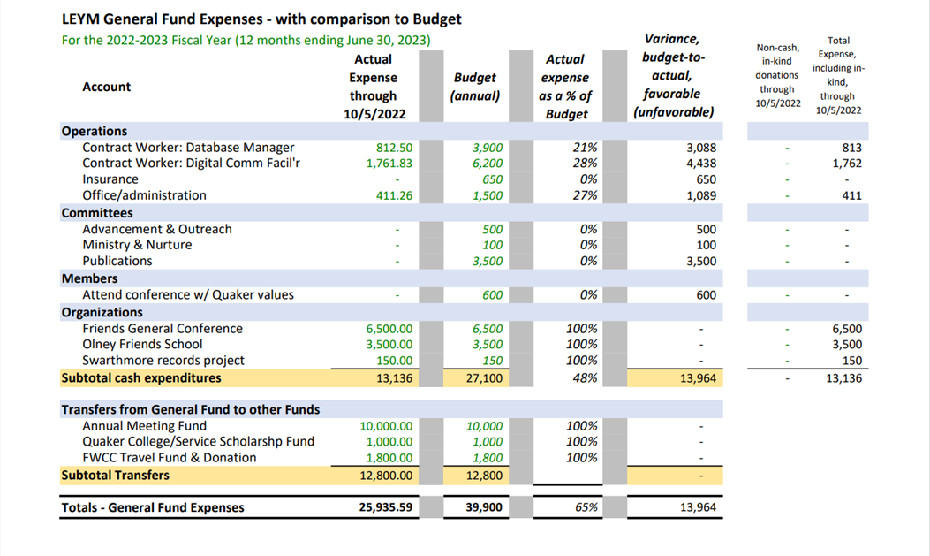
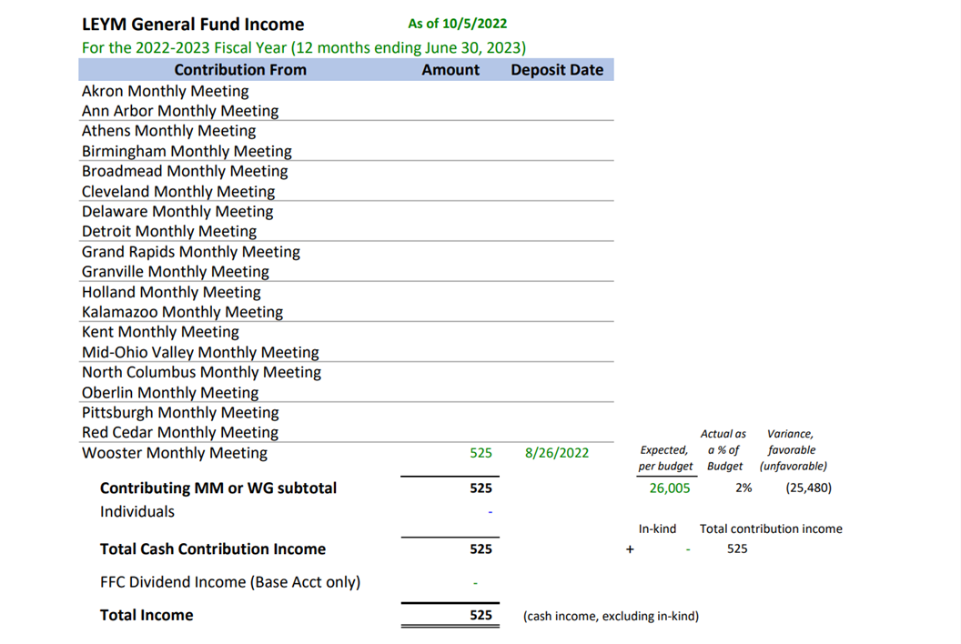
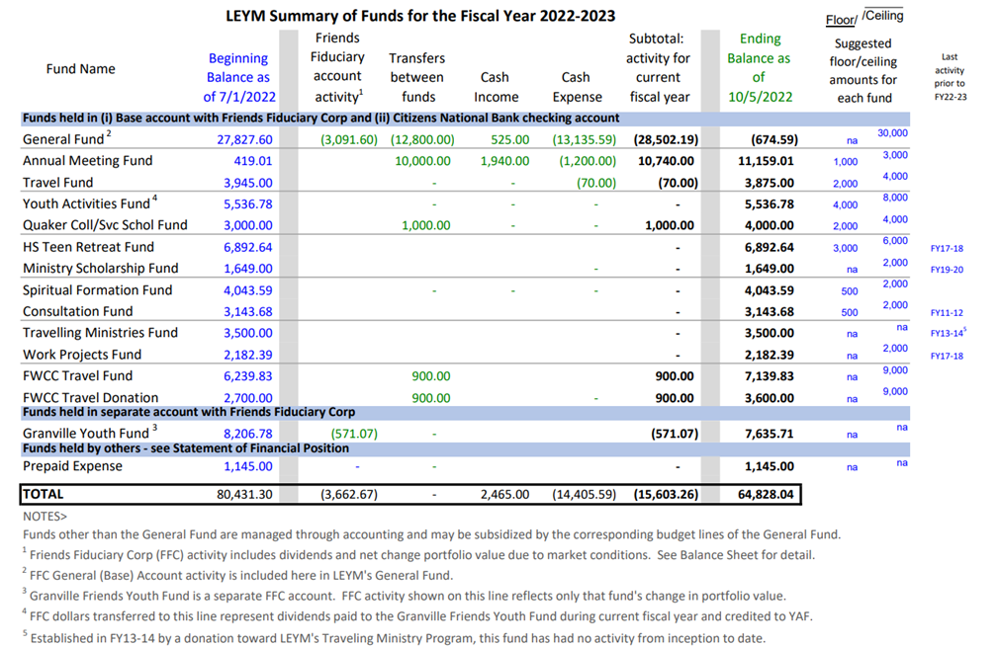
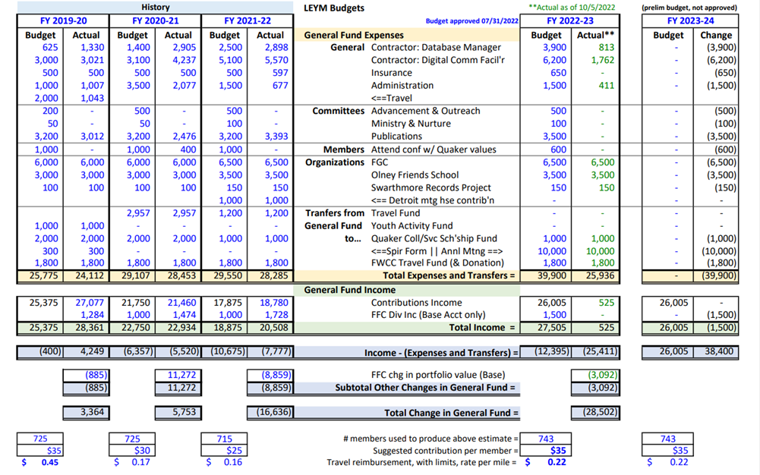
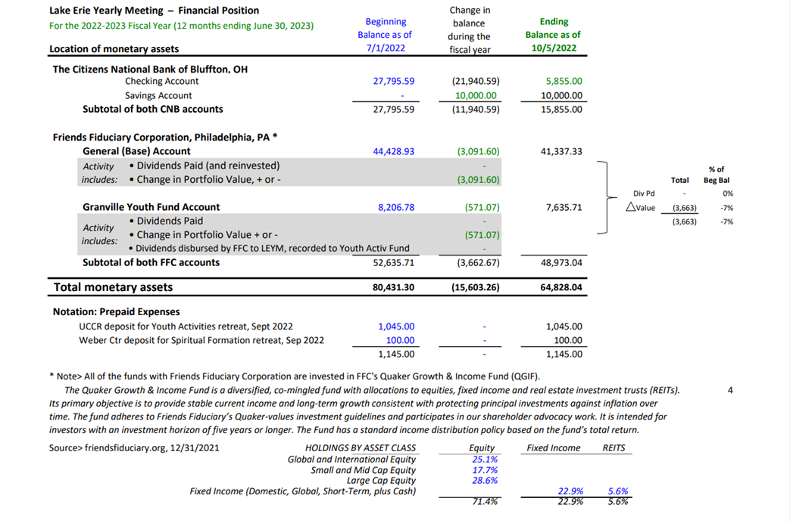
The Finance Committee has started a savings account to help protect funds due to concerns raised when a mailed check never arrived to the vendor.
Per member contributions from monthly meetings were reduced last year, and the plan is to restore them again.
The general fund is in a deficit at present. As monthly meetings pay their contributions, the fund should fill again. Registration dollars will also help replenish funds.
$10,000 have been transferred from the general fund to the annual meeting fund. Costs for attending Annual Meeting are set by the Finance Committee and the Annual Meeting Planning Committee, who will work together to decide how the money allocated from the general fund will be utilized to defray the cost of Annual Sessions.
EC22-10-6 Susan reported that the Ad Hoc Committee considering how best to structure the Yearly Meeting’s committees/interest groups is looking at other yearly meetings for ideas. Ellerie Brownfain (Birmingham), Susan Loucks (Pittsburgh), Peggy Daub and Jeff Cooper (Ann Arbor), and Ann Sprague (Detroit) are serving on this Ad Hoc Committee.
EC22-10-7 Susan reported on evolution of the idea, presented during YM sessions, that meetings continue to discern and share their discernment regarding anti-racism, and come prepared to do deeper collective work on the topic in 2023. This idea has met with some additional confusion and hesitation from committees and individuals after annual meeting, and she solicited ideas from the executive committee on the right way forward. The group shared thoughts on potential ways to build an anti-racist culture in the YM.
Friends had the following observations and questions.
Are we ready for this?
M and N had already created queries, is another query focused on anti-racism too much for monthly meetings?
We could invite Monthly Meetings to work on their own minutes and share them. We would see if racism rises as a primary topic in their work.
Friends of Color created a very moving epistle two years ago that included powerful queries. It’s important to go back to the query responses already collected.
“Making a statement we can all agree on” may not be the way to go at this time.
Make Friends of African Descent queries available.
Friends would value a communication board where we can post ideas and things we are wondering about or struggling with.
Experiential activities can be very valuable, such as volunteering with groups that are already doing effective anti-racism work.
Susan will continue to explore a way forward, and program committee will discuss further how to incorporate this question into their plans for annual sessions.
EC22-10-8 Friends discussed some practicalities related to the New Annual Sessions date. Because it is earlier, Annual Sessions moves into this fiscal year. We will hold Representatives’ Meeting earlier this year - on March 11. Our clerk will continue to explore with Friends whether to meet in-person, via Zoom, or in a hybrid format.
EC22-10-9 Jeff raised the question whether documents from Annual Sessions need to be in by 4 weeks, as Policies and Procedures states, or if we can go to 6 weeks. We have not met the 4 week deadline in recent years. Executive Committee expressed approval for this change, which likely needs to be discussed by the Meeting as a whole.
EC22-10-10 Friends joined in silent worship, and meeting rose at noon.

