Minutes for the LEYM Executive Committee Meeting October 23, 2021
Please note, this meeting was held via Zoom to help prevent the spread of the Coronavirus.

Present: Susan Loucks (Clerk), Jo Posti (Assistant Clerk), Kate Enger (Recording Clerk), Jeff Cooper, Peggy Daub, Mike Holaday, Tom Kangas, Shelley Kotz, Becky Morehouse, Joann Neuroth, Jon Sommer, Sally Weaver Sommer, Bill Warters

Meeting opened with silent worship at 12:30 pm.

EC21-10-1 Names for approval Nominating Committee – Mike Holaday presenting
The Nominating Committee brought forward Chuck Slayton (Pittsburgh MM) for approval as representative to FGC Central Committee. Approved.

EC21-10-2 Path of action for the year Nominating Committee – Mike Holaday presenting
Report from the Nominating Committee:
Mike created a spreadsheet of all Friends who have held appointed positions in the YM since 2011, as a tool for awareness of service-oriented Friends and also a record of their years of service. Nominating has met once, by Zoom, since Annual Sessions. P&P makes it clear the expectation is that Nominating will have the bulk of its work in hand by Representative Meeting, so we plan to try to convene the committee via Zoom monthly for the next several months.

Discussion: This year’s tasks are different, as they include looking at bigger questions, like incorporating the work of the visioning committee, and deciding whether to be online or hybrid for 2022. Bluffton May not be available for 2022.

Report accepted.

EC21-10-3 Policies and Procedures Proposal – Jeff Cooper presenting

Report: Revisiting Proposed Updates to Policies and Procedures

As noted previously, among several proposals from the ad hoc committee on Policies and Procedures at the last Annual Sessions, most were approved but two were held over for further consideration.

1. Proposal to have Publications & Archives Committee, rather than the Meeting worker, “review Policies and Procedures annually and advise the clerk of any inconsistencies that have arisen as procedures have changed.”
The individual with responsibility for such updating probably matters more than the position of that individual. Nonetheless, here are the four positions that have been either tried or considered.
Recording clerk. The review of P&P was originally assigned to them, but in many years was apparently neglected.
Meeting worker. When it became clear that recording clerks were not doing this review, Mathilda Navias took it on as Meeting worker. She was exceptionally well qualified for this, but soon departed. Bill Warters, our current Meeting worker, does many other things wonderfully well but has stated that he has no interest in this task.
Publications & Archives Committee. Policies and Procedures is considered a publication and P&A tends to have Friends attentive to detail and consistency of style; this was supported by P&A. Moreover, the committee could select one or more Friends with talent and/or experience in this area.
Assistant Clerk. This plan would result in alternating between a Friend serving their fourth year at the clerks’ table and a newcomer to the table. This would be a good way for newcomers to familiarize themselves with Policies and Procedures.
Please note that Publications & Archives will likely be involved eventually, as almost every change results in needing to change the index, and sometimes page headings and the table of contents, and P&A would not expect others to do this work on the document.

P&P Proposal carried over from annual sessions: to have Publications & Archives Committee, rather than the Meeting worker, “review Policies and Procedures annually and advise the clerk of any inconsistencies that have arisen as procedures have changed.”
Approved. Our clerk is seeking guidance on whether this issue needs to be raised with the LEYM membership as a whole.

2. Proposal to change the title “Meeting worker” to “Digital Communications Coordinator”.
The need to change from “Meeting worker” was proposed by Finance Committee (YM2020-12), as they wished to avoid referring to the person holding this position as an employee; they suggested “Web manager.”

Approved changing the Meeting Worker title to “Digital Communications Facilitator.”

EC21-10-4 Maintaining Race/Ethnicity Info and Maintaining Age related data – Bill Warters presenting

LEYM Ad Hoc Technical Platform Advisory Committee Report to Executive Committee

The Technical Platform Advisory Committee convened for the first time on October 13, 2021 with a focus on two issues that were delegated to us for a recommendation during the 2021 Annual Sessions.

- Maintaining Race and Ethnicity information on our members - should we, and if so, how best to store and make use of it?
- Keeping track of our younger friends - how to best manage AGE category information or date of birth information?

Maintaining Race and Ethnicity information
Recommendation: We believe LEYM should continue the practice of asking for Race/Ethnicity data during Annual Sessions registration, as we understand that groups pay more attention to issues that they gather data on. We don’t believe it is yet time to start storing race/ethnicity data in our monthly meeting membership database, as we don’t have a clear use case, explicit sharing permissions, or certainty as to the exact data we want to capture and for what purpose going forward. We are happy at this point to share data we have already gathered with FGC in its aggregate form, but not information tied to individuals. As FGC members and supporters of FGC’s Institutional Assessment project, we recommend that more formal contacts be made with FGC to seek their further guidance and perhaps some tools/guidelines for how we might best contribute in a standardized way to a broader effort that may reach beyond just our yearly meeting. We want to support FGC and help strengthen our own anti-racist faith community and believe good data may be part of the solution.

Managing Age Related Data
Recommendation: We should support the database manager’s suggestion and begin storing birth year information for our younger members, converting the current age information we have using a shared generic day and month as a placeholder for actual birthdays. We believe there may also be value in gathering the birth year of adult members going forward, as we may find value in providing special services, support, or events tailored to the needs of specific age groups.

Discussion: At present, FGC is aware of our efforts, but is not ready to take action more broadly. For now, we will stay in contact with FGC through Jo, but not share our information with FGC yet.
Recommendation regarding collection of racial data approved.
Recommendation regarding tracking birth year information for young members approved.
We may also consider tracking information for adults in the future, but that discussion will be held over.
Note: This plan needs to go to the Yearly Meeting as a whole in order to get the required information from monthly meetings. We also need to seek approval from the entire body.

EC21-10-5 Treasurer’s report – Tom Kangas presenting

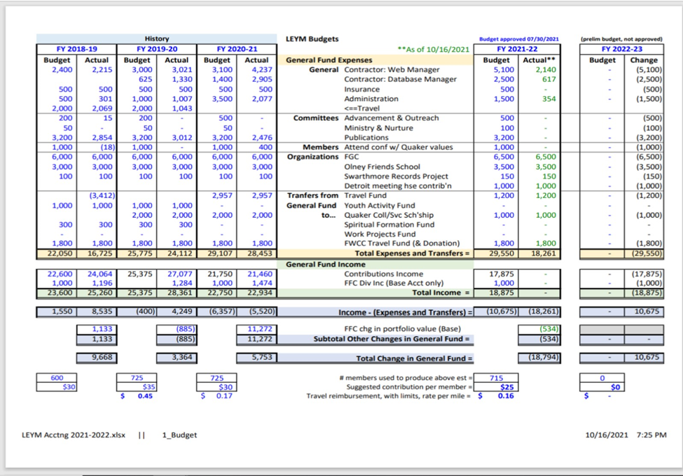
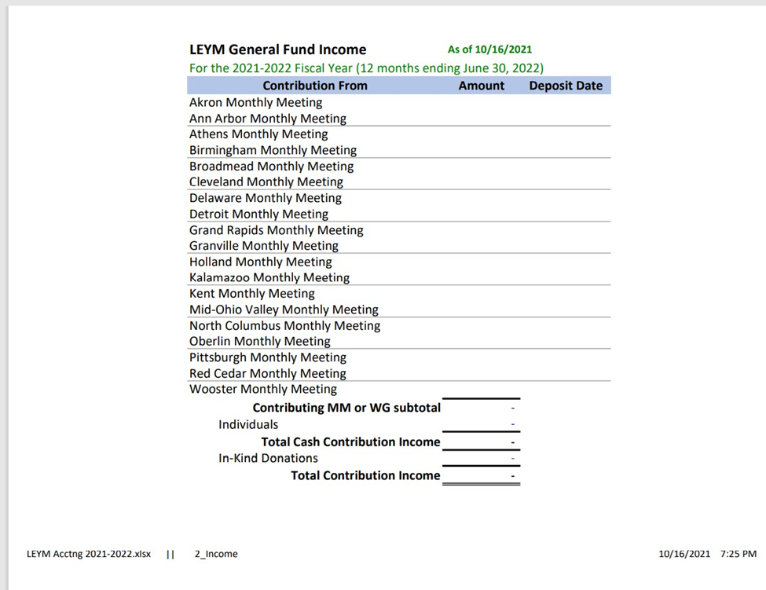
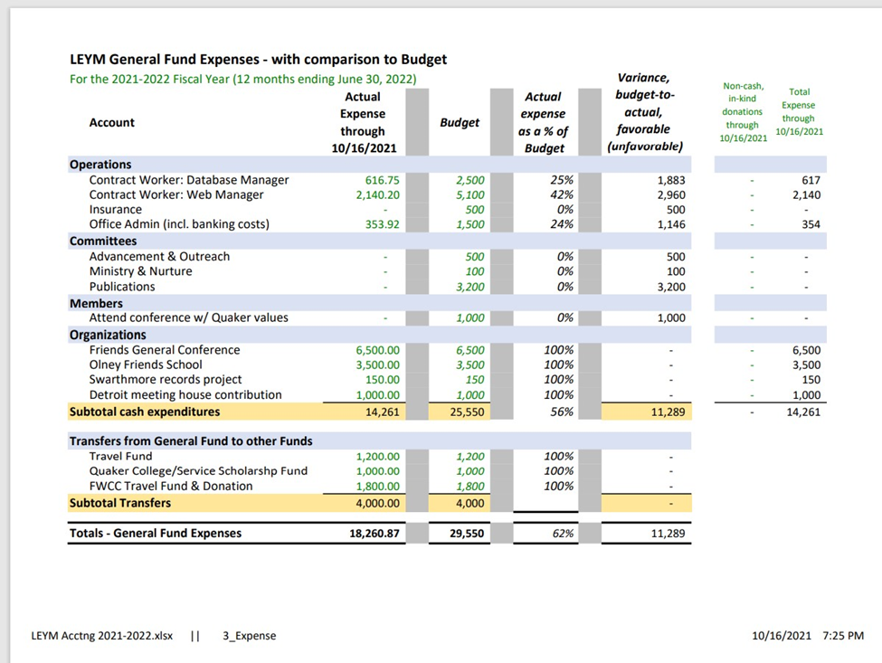
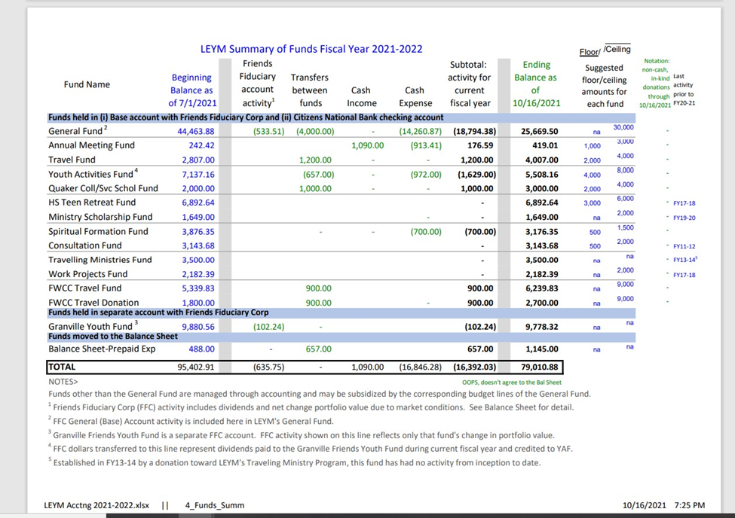
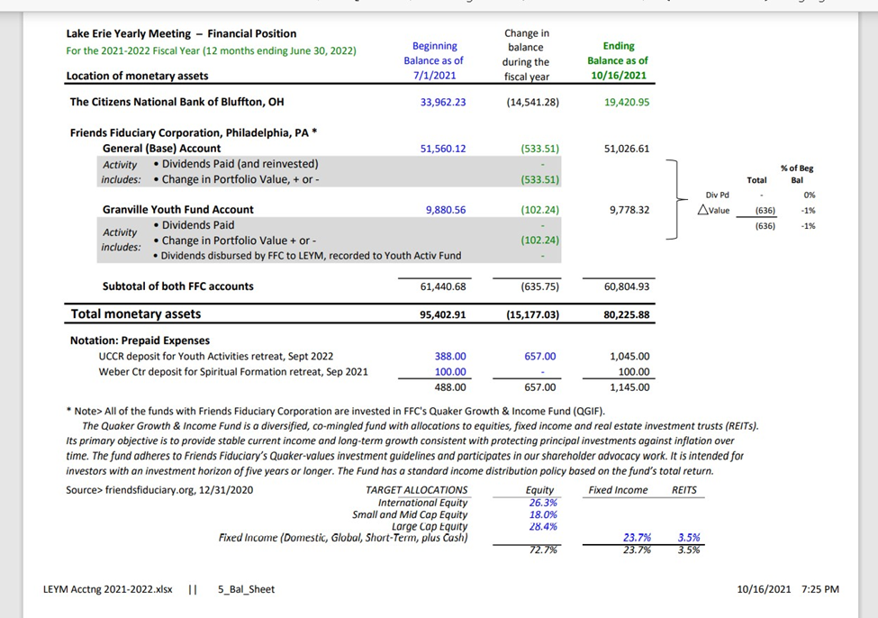

EC21-10-6 Finance Committee – Joann Neuroth presenting
1) Mileage Reimbursement: We revisited the mileage reimbursement rate we included with the budget in July, and continue to recommend that we use $.16/mile.
2) Audit: We noted that the 2020-21 audit was completed by Susan Hartman and identified no issues. She again complimented Tom Kangas for the meticulous documentation system he has built.
3) Surplus Funds: We considered a suggestion that arose in Annual Sessions that instead of varying our annual suggested contributions to match budget needs, we should keep the assessment constant allowing a surplus to accumulate during prosperous times. We are not recommending such a change in our practice.
4) Insurance Changes: We noted that our liability insurance carrier notified us that our policy now includes a contagious disease exclusion. Since legal liability exists only if we were found guilty of "negligent conduct" breaching a duty owed to attenders at our event(s), we take this to mean mostly that we should continue to exercise due diligence in making decisions about when and how to gather.
5) Draft Document Retention Policy:

RECORD RETENTION³
Document | LEYM¹ | Retention Period | Storage Location
Organizational records with permanent retention – Recording Clerk, Publications & Archives
Policies and Procedures | Yes | Permanently | Swarthmore?
Minutes (Exec cttee minutes beyond Annual Records) | Yes | Permanently | Swarthmore?
Organizational records with limited retention
Computer backup for Treasurer’s records | Yes | 1 year | Flash drives held by Finance clerk and presiding clerk
(What else should be addressed here? Database? Web?
Legal (and other than strictly financial) records with permanent retention — Presiding Clerk, Treasurer
Insurance records—claims, policies (unexpired) | Yes | Permanently | Flash drives above
Insurance Policies (expired) | Yes | 7 years | Flash drives above
Legal (and other than strictly financial) records with limited retention – Presiding Clerk, Treasurer
Contracts & leases (expired)  (Do we have contracts with data mgr and web worker?) | Yes | 7 years
Correspondence—general | Yes | 2 years
Supporting documentation for financial statements with permanent retention – Treasurer
Audit Reports | Yes | Permanently | Flash drives above
Cash Books (receipts and disbursements journals) | Yes² | Permanently | Flash drives above
Chart of Accounts | Yes² | Permanently | Flash drives above
Financial Statements—year end | Yes² | Permanently | Flash drives above
General Ledgers | Yes² | Permanently | Flash drives above
Tax returns & documents relating to income tax liability | Yes | Permanently | Flash drives above
Supporting documentation for financial statements with limited retention – Treasurer
Accounts Payable records | Yes | 7 years | Flash drives above
Accounts Receivable records | Yes | 7 years | Flash drives above
Budgets | Yes² | 5 years | Flash drives above
Bank Statements | Yes | 3 years | Flash drives above
Deposit slips | Yes | 3 years | Flash drives above
Bank Reconciliation | Yes² | 2 years | Flash drives above
Personnel and payroll – Presiding Clerk, Treasurer [left these items in due to recent envisioning discussion]
Employee Applications |  | 3 years
Employee personnel records (after termination) |  | 7 years
IRA & 401(k) plan contributions, transfers, distributions |  | Permanently
Taxes, withholding statements |  | 7 years
Payroll records, summaries, tax returns |  | 7 years
¹Applicable to LEYM as of record retention policy adoption ___.
²Beginning with the 2019-2020 fiscal year, represented within the Excel file “LEYM Acctng 20X0-20X1.xlsx.”
³Based on list published in the Treasurer’s Guide For Religious Organizations, 2nd Edition, Rosalie Bond, Author; Elizabeth Muench & Katrina Smathers, Editors; Developed and published by Philadelphia Yearly Meeting of the Religious Society of Friends, ©2008. According to the authors, the list was compiled from lists provided by Asher & Co., Zelenkofske, Axelrod & Co, CPAs Inc., and Fishbein & Co.

Discussion:
Above recommendations accepted.

EC21-10-7 Annual Records – Peggy Daub and Jeff Cooper presenting

The records are progressing and will be proofread soon. Membership count is more than a third higher this year, and Jeff is looking into what has caused such a jump.

EC21-10-8 Considerations for the future – Clerks presenting

Before we next meet, we might need to look at the responsibilities of Representative Meeting, Executive Committee, and the Yearly Meeting as a whole and consider if any of those responsibilities need to be reconsidered. Some issues may be handled effectively without bringing them to the Yearly Meeting as a whole.

Because Bluffton is not available, we may look into a hybrid gathering. Monthly meetings then may be able to take some responsibilities, such as organizing the plenary and streaming it to all the other meetings.

EC21-10-9 Date for Representative meeting will be April 2, 2022.

Meeting rose at 2:15 after a period of silent worship.

