Minutes for the LEYM Executive Committee Meeting January 23, 2022

Please note, this meeting was held via Zoom to help prevent the spread of the Coronavirus.

Present: Mike Holaday, Sally Weaver Somer, Jon Somer, Becky Morehouse, Jeff Cooper, Peggy Daub, Bill Warters, Shelley Kotz, Joann Neuroth, Tom Kangas, Jo Posti, Christa White, Susan Hartman, Susan Loucks (Clerk) and Kate Enger (Recording Clerk)

Meeting started with gathering & centering at 3:02

EC22-1-1 Minutes from October’s meeting were approved with the following change to EC21-10-7: “The volume is progressing and will be proofread soon. The reported membership count is more than a third higher this year, and Jeff is looking into whether this figure is accurate.”

EC22-1-2 Susan Harman presented the Program Committee report.
The theme of this year's annual sessions will be Many Roots, One Tree. We hope to explore together--through our workshops, our plenary session, and other opportunities with our community--many variations on this theme of deep roots and growing trees. We encourage you to consider presenting a workshop, or to invite other Friends who may have something to enlighten, challenge, or inspire us to do so. We are delighted to announce that our keynote speaker this year is Christian Acemah, the Head of Olney Friends School.

EC22-1-3 Sally presented the ad hoc Site Committee report.
The committee includes Friends from across the LEYM region. Their meetings have focused on preparing a proposal to bring to 2022 annual sessions for 2023 annual sessions and beyond. They have been utilizing the visioning report and discussing goals, objectives, and obstacles. They are making sure to include kids’ and teens’ programming and seeking to increase interactions between the generations, and to focus on shared values and truth. In addition, they are considering online and hybrid options for Friends’ participation in business and social activities. The committee is also looking into sites for meeting physically again in the future.

EC22-1-4 Tom presented the Treasurer's report
Individual monthly meetings are making their contributions. Our insurance fee went up, so that item went over budget. We are in the middle of the fiscal year, so activity is ongoing. Friends expressed thanks to Tom for his clear, careful work.

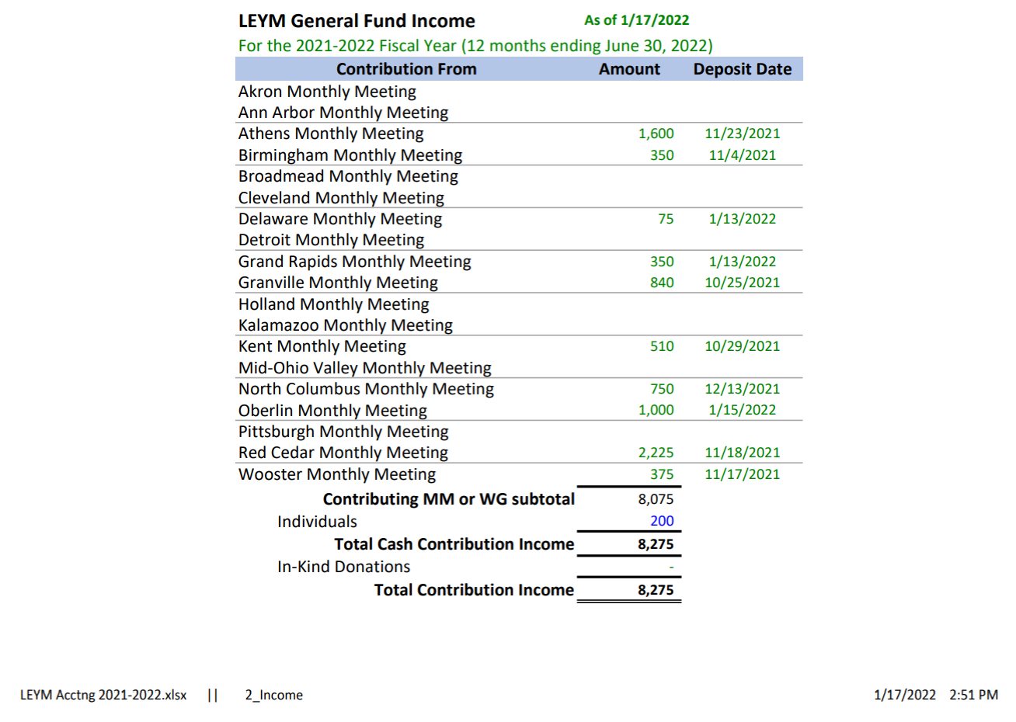

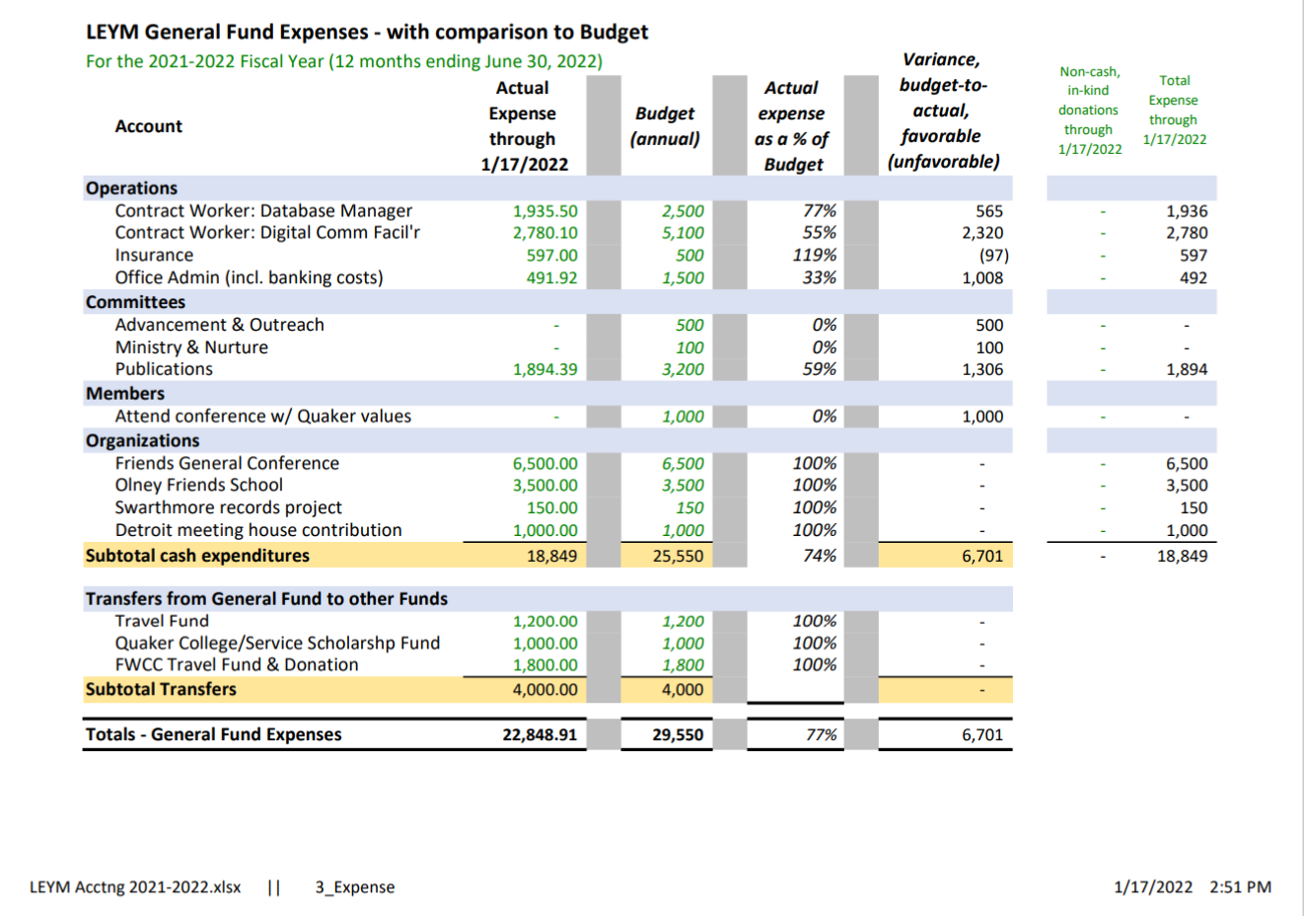
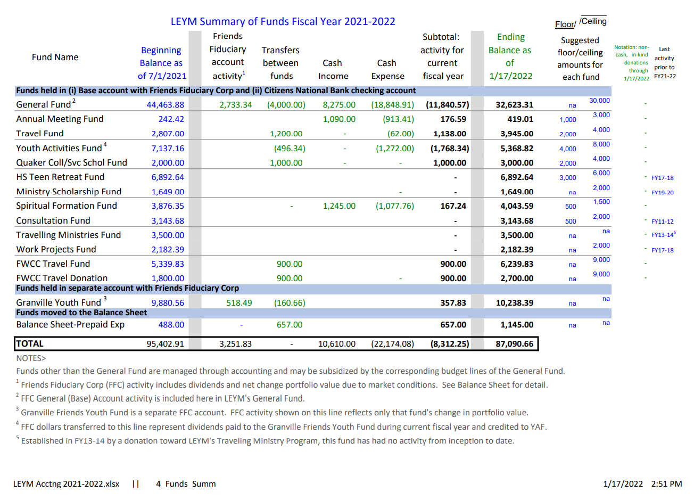

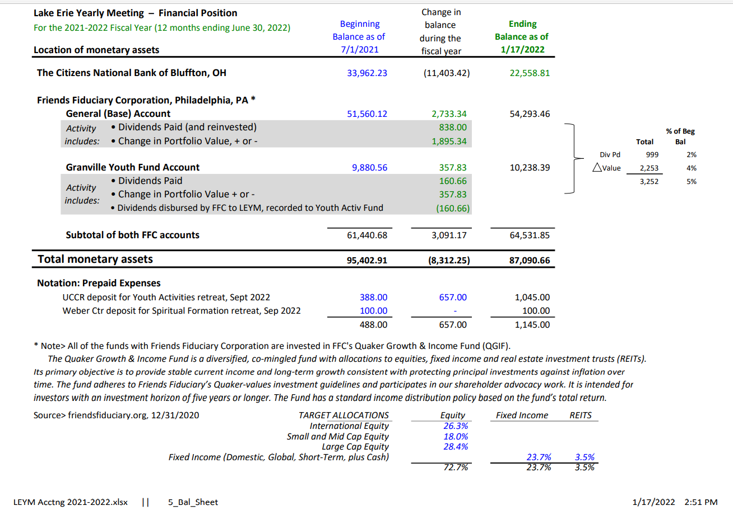
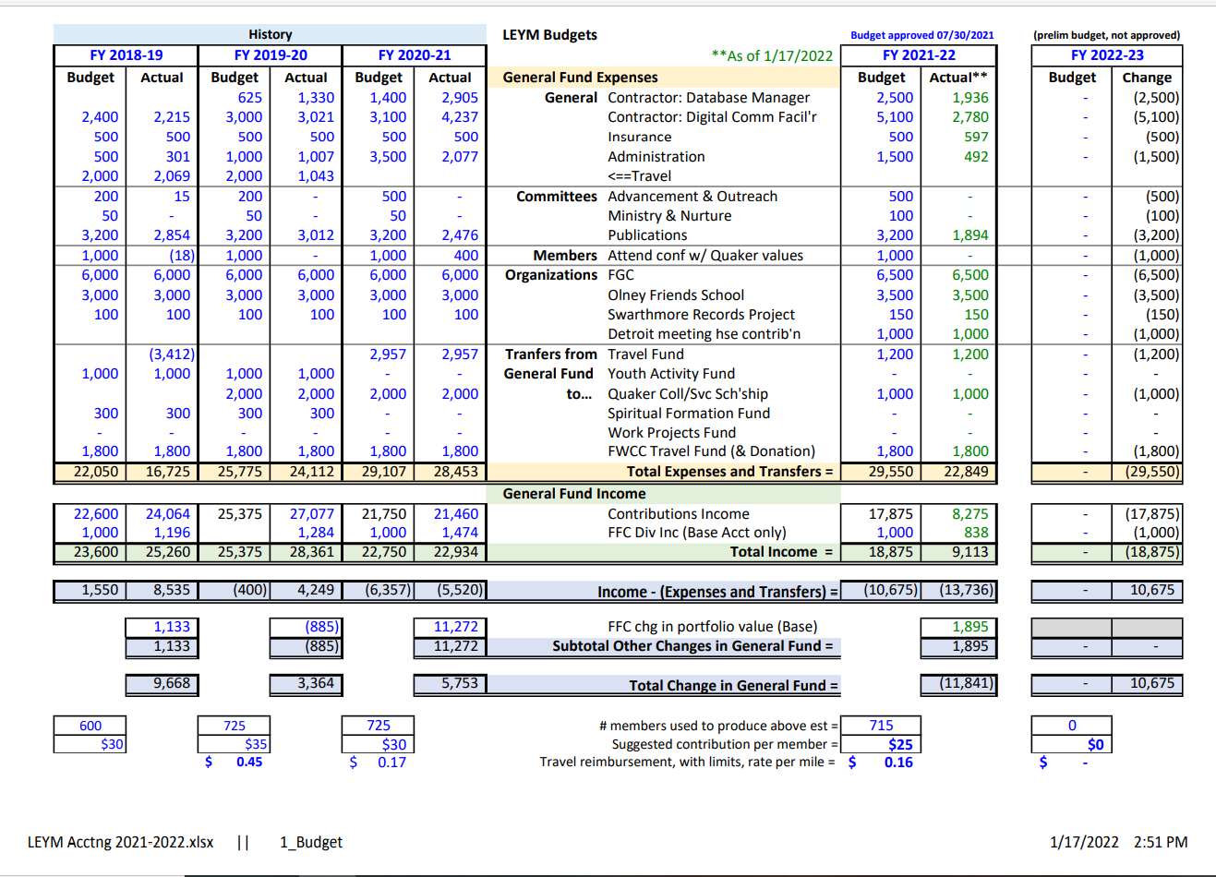

EC22-1-5 Joann presented the Finance Committee Report
Finance Committee is looking at hosting a Best Practices Evening to explore idea such as looking at finances in non-numeric ways that help us see if our use of financial assets reflects our values. The evening may help people who don’t feel they have a background in finance explore how they can serve on a finance committee.

EC22-1-6 Mike presented the Nominating Committee Report
Currently, LEYM utilizes a system of liaisons for Nominating Committee to gather and report information from committees about who plans to remain on a committee and to begin recruiting replacements where needed. Mike has found this to be a good way to divide up the work, but it has also created some silos rather than committee-level discernment in regards to best matches between Friends and positions to be filled. Mike invites us to consider how we would be affected by replacing or modifying the liaison system. FGC uses liaisons, but the full committee works on discerning who is called to serve in open positions. We might consider gathering information on the backgrounds, interests, and abilities of each Friend. Friends are encouraged to share feedback with Nominating Committee.

EC22-1-7 Susan led a discussion about crafting 2022's business agendas

We want Friends to be able to contribute. We meet so infrequently that need to gain information before making decisions. Can we prepare people with the tools they need to make a meaningful contribution, such as making reports available in spring bulletin? We may also need to consider more frequent meetings.

We could try a more interactive process regarding reports back from committees. Give them in writing, divide into breakout sessions, go over reports in depth and ask questions. Small groups would return to full meeting with selected topics that stood out to them.
Should we develop our own Faith and Practice? M and N has raised the possibility. This process can lead to rich interactions about discerning our positions on important beliefs and values. If we continue to simply borrow practices from other YMs, we may be baking in some implicit biases. To at least one Friend, this possibility has felt like a heavy obligation. The possibility of exploring our shared experiences and values one issue at a time now feels like it has some “lift” to it, and the work may be consistent with our One Tree theme.

Make sure to hold onto the spiritual value of slow, careful discernment in business meeting. Deep discussion at business meeting can be a transformational experience. Friends appreciate the experience of decision making at LEYM. Don’t want to lose the seasoning process, but we need to allow room for gifts to be manifested and interests to be pursued when they arise.

We can approach business meeting as an opportunity for change. For example, we can re-evaluate who we are and what our values are in this century and post-pandemic.

Young Friends may be more engaged if we spend more time on plans for action, and follow through on those plans together.

Seemingly routine decisions can lead to surprising discussions. We cannot predict the movement of Spirit.

EC22-1-8 Susan led a discussion about plans for Representative Meeting

We will probably have an executive committee meeting the night before.

Monthly Meetings may need a reminder to nominate people to be LEYM representatives. Those people are not just representatives for the Spring meeting.

Monthly Meetings can cross-fertilize and share projects.

People who have are attracted to specific topics could attend, whether they are representatives or not.

We could choose a practice to discuss at each representative meeting.

There is specific guidance for representatives meeting in our current Policies and Procedures. For example, we are called to have someone from every Monthly Meeting who will participate and report back.

Friends shared a desire to have an exchange of information and ideas similar to gathering around a water cooler at work, or a front porch.

Is anyone called to help with inter-visitation at online worship at various Monthly meeting? Please coordinate with Susan.

Representative meeting helps to share information as we go. Clerks’ Chats have also been helpful and are getting a good turnout. Does every meeting know about them? Anything from that that we want to share?

Can we address some business topics at Representatives Meeting?

Bill would be willing to present 1 hour tech workshops like pervasive patterns on the web that can influence behavior, or ways to protect online privacy

Representative’s meeting will be on April 2

Meeting rose at 4:50 after a period of silent worship.

