July 2021
To our Friends of Lake Erie Yearly Meeting:
Please welcome Bobby Trice and Riley Robinson as they visit the 2021 Lake Erie Yearly Meeting. We are excited that they will have ample opportunities to hear your concerns and leadings while sharing in worship, holding your business meeting in the Light, and leading FCNL presentations and workshops. They are happy to be in faith and community with you.
As the Quaker Outreach Coordinator, Bobby cultivates relationships with Friends and coordinates FCNL staff engagement with Quaker communities across the country. A member of Friends Meeting of Washington (BYM) in DC, he is passionate about deepening Spirit-led advocacy on Capitol Hill and around the nation.
As a Major Gifts Officer for FCNL, Riley enjoys witnessing the creative, effective work of FCNL staff members in Washington and in hearing of their travels around the country. He is equally moved by the enthusiasm and commitment of FCNL volunteers and supporters, as well as the respect that Friends everywhere hold for the FCNL policy process. He says, “Good legislation isn’t just about principled wording. It’s about lives improved and dollars saved, and we can all have a hand in that.” He is also a member of Friends Meeting of Washington (BYM) in DC.
We at FCNL seek to strengthen our connection to Friends Meetings and Churches around the country and find areas where FCNL can offer opportunities for action on issues concerning Friends. We are supporting this virtual “travel” in the tradition of Friends’ intervisitation with hope to stir our spirits and open opportunities for understanding one another’s experiences of how the Spirit is working in the world toward peace and justice.
We send you greetings, hold you in our prayers, and trust that God will bless your time together in loving community.
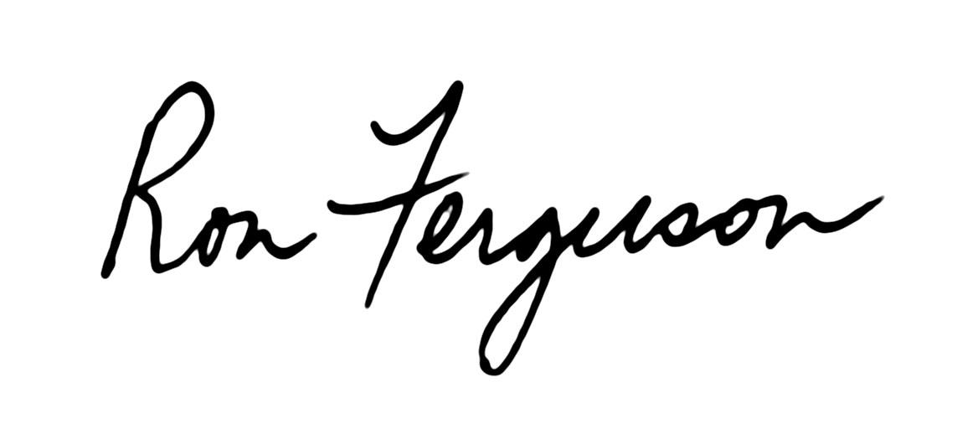
In peace,
Ron Ferguson
Clerk, FCNL General Committee
Pastor, Winchester Friends Church (IN)

