**LEYM Annual Meeting**

**July 30 – August 2 and August 12, 2020**

**Virtual Meeting via Zoom**

**Minutes and Reports**

**First Session: 3:00 – 4:30 pm, July 30, 2020**

**YM2020-1 Opening Worship and Epistle from Wilmington Yearly Meeting**

Out of our open worship, Nancy Reeves, assistant clerk (Cleveland), read aloud the epistle from Wilmington Yearly Meeting. It focused on the chal-lenges Friends face when engaging with the suffering strangers, challenges to keep compassion that may stretch us to our limits. Such compassion is nurtured in community, and it is just that intimate community that has been so disrupted by the distancing required as all try to stay safe in the pan-demic. Member meetings are finding creative ways to bridge the gaps in community, even as Friends are called to address racism as a major dis-ruption in our wider community. They feel the gaps in themselves between ideals and action, the love-in-action of compassionate engagement in a world that desperately needs mending, and are called to step forward.

**YM2020-2 Welcome and Report from Executive Committee**

Jo Posti, clerk (Pittsburgh), welcomed attenders to these Annual Sessions, acknowledging the enormous changes in our Yearly Meeting that have resulted from the pandemic. She described the discussion in the Executive Committee that looked at both challenges and opportunities opening in our virtual meeting this year. Keeping connection is an ongoing challenge. We are looking at developing an ad hoc long-range planning committee to look at the Yearly Meeting structure and how we can support monthly meetings and their clerks, as well as reevaluating the structure of our current YM committees. What skill sets are needed in our committees? We need to discern LEYM’s mission and priorities. Jo invited Friends to contact her with their willingness to serve on such a long-range planning committee.

**YM2020-3 Orientation to Virtual Meeting and Roll Call**

Bill Warters, LEYM Meeting worker (Birmingham), oriented us to this virtual meeting, its agenda, and its procedures. He then displayed the attendance roll in a variety of graphs, a triumph of technology. 153 people have registered for these Annual Sessions.

Akron 0

Ann Arbor 25

Athens 5

Birmingham 9

Broadmead 19

Cleveland 3

Delaware 0

Detroit 8

Erie Worship Group 1

Grand Rapids 3

Granville 0

Holland 0

Indiana Worship Group 0

Kalamazoo 11

Kent 0

Manitou Worship Group 0

Mid-Ohio Valley 3

North Columbus 8

Oberlin 5

Pine River Worship Group 1

Pittsburgh 14

Red Cedar 18

Somerset Worship Group 0

Tustin Worship Group 0

Waysmeet Worship Group 0

Wooster 5

Unaffiliated 3

Others 12

**Total Registered 153**

Young children’s program  
 in Athens 10  
Total Adults 36 and over 140

Total Youth and children 18

Total Young adult Friends 5

**YM2020-4 Welcoming Visitors** **and First-Time Attenders**

a. Jo welcomed visitors, including:

Bobby Trice, FCNL  
Tom Roberts, Noblesville MM (Indiana YM)  
Kathleen Wooten, Fresh Pond MM (New England YM)  
Jeffery Barr, Fredonia MM (New York YM)  
Meghan Cochran, Larkspur, California  
Sarah Freeman-Woolpert, FCNL  
Lori Sinitzky, FGC  
Daniel Lean-Moctezuma, Junta Mensual de Ciudad México  
Stanley Chagala Ngela, Richmond, Indiana  
Allison Kirkegaard, Pacific YM  
Jackie Stillwell, RSWR  
April Vanlonden, ESR  
Roberta Gellner, Saint Marys, West Virginia

b. She also welcomed first-time attenders at this session, including Rick Adams (North Columbus), Bill Greenberg (Broadmead), and Lindsay Dykema, Lynn Drickamer, Marilyn Siegel, and Mark VanRaden (all Ann Arbor). The number of first-time attenders is 52. Eight of these are visitors and 44 are from within LEYM.

*[At this point and others throughout Annual Sessions, Bill Warters, Meeting worker, provided musical interludes appropriate to our theme, mainly from the website “Playing for Change.”* *~ Ed.]*

**YM2020-5 Epistle Committee**

The work of the Epistle Committee was described by Nancy Reeves. The Committee would meet a couple of times during the Annual Sessions and prepare the epistle for Saturday afternoon. Participation was invited. Please send an email to Nancy at [*neohdiver@gmail.com*](mailto:NEOHdiver@gmail.com).

**YM2020-6 Documents Available in Advance**

The clerk reminded Friends of the documents made available in advance on our website. She also noted that we will acknowledge Friends who have died in the past year at a later session.

**YM2020-7** **Adult and Family Program Committee: Presentation of the Theme**

Thomas Taylor (Ann Arbor) welcomed all and described the Adult and Family Programs to come at these sessions. Other members of the committee are Claire Cohen (Pittsburgh), Susan Hartman (Ann Arbor), Greg Mott (Broadmead), Steve Morehouse (Ann Arbor), and Aran Reinhart (Broadmead). There will be no plenary speaker this year. “Letting Go: Listening with Whole Hearts and Open Minds” is this year’s theme. The theme is especially relevant in this era of closed minds and hearts, with its plentiful instances of violence, oppression, and untruth.

Thomas proposed two queries to reflect on as we open the Annual Sessions: 1) What do I have to let go of to listen more fully and openly? 2) What and whom do I need to listen to?

He invited us to consider where our “center” is, its bodily base, and to experience it intentionally through guided movement. He referred to Eight Pillars of Joy formulated by the Dalai Lama and Desmond Tutu, which enable us to listen: four pillars of the mind – Perspective, Humility, Humor, Acceptance; and four pillars of the heart – Forgiveness, Gratitude, Com-passion, Generosity. He encouraged us to stretch and flex ourselves and move! Be kind to your body!

**YM2020-8 Consent Agenda and Announcements**

a. The clerk described the process of working with a consent agenda, a way of accepting reports as published in the advance documents without taking them up in sessions when no action is required. Saturday’s business agenda will ask for these items to be accepted. She listed the items in question (*see* pp. 49–63).

b. Those wishing to have announcements read should email them to Jo.

c. Jo talked about a Zoom meeting for interested prospective parents for the coming academic year at Olney Friends School. Friends can contact Jo for the link.

d. A new database manager is needed, a paid position. Friends knowing of a potentially interested person should contact Jo ASAP for the link.

We closed with a period of open worship.

**Second Session: 11 am – 12:30 pm, Friday, July 31, 2020**

**YM2020-9** **Opening Worship and Epistle from FGC Pre-Gathering Retreat for Friends of Color and their Families**

Out of a period of open worship, Nancy Reeves, assistant clerk, read the Epistle of the 2020 FGC Pre-Gathering Retreat for Friends of Color and their Families.

Because Friends at these Annual Sessions felt the weight and importance of this epistle, which spoke directly and forcefully to our hearts, we reprint the epistle in full. Member meetings are encouraged to lift up the queries in the epistle.

**The Outgoing Epistle of the 2020 Virtual Pre-Gathering   
of Friends of Color and their Families**

**Friends General Conference**

“We are a harvest of survivors. But then, that's what we've always been."

-Octavia E. Butler, *Parable of the Sower*

To Friends Everywhere:

We begin by remembering our ancestors who were strong enough to make a way for us. Friends of Color and their families met for Pre-Gathering Retreat on 26 Day through 28 Day Sixth Month 2020. This is the eighth year Friends of Color have met for our Pre-Gathering Retreat. First-timers felt welcomed and validated. This year, we met virtually with our largest attendance yet. There were 47 attendees, ranging in age from 11 months through 77 years, from Canada, Mexico, Switzer-land, and the United States of America.

The importance of this Gathering for Friends of Color worshipping in community together cannot be overstated. To our Friends in the wider Quaker world, we, the Friends of Color, can’t breathe. During this weekend, we enjoyed the rare oppor-tunity of not being othered in Quaker space. We experienced the joy of being seen as we are and the affirmation of a supportive spirit among ourselves in the “Amen corner.” The term “Amen corner” comes from the Black church and is a communal space that validates, affirms, and uplifts the spirit. In isolation, due to COVID19, we are being kept apart and away from those we love, trust, and need. The pre-gathering retreat brought back the source of community and family that has been missing. We were able to exhale, relax, and breathe together. Many of us did not realize how exhausted we were until we were able to relax with one another. The gifts of the spirit were abundant. We shared in worship, gentle yoga and meditation, meaningful discussions, journaling, and self-discovery. We also listened and shared in each other’s joys, triumphs, pains, and sorrows. We experienced spiritual renewal that was awakened by moving through pain to hope for the future for ourselves and our children. Attention and space was given for people to play games, dance, talk, grieve, play music, watch videos, and write.

We have much gratitude to the Program Coordinator for the Ministry on Racism – the pioneer who laid the groundwork to make the Pre-Gathering Retreat available to us within FGC gathering and who faithfully makes it happen each year. We are grateful for being able to acknowledge all that makes us human, for finding home and connection. Our inner Light is magnified and our capacity to breathe deeply is nurtured when that of God is acknowledged in each of us. It is our hope that other Friends of Color will know that such a space exists and know that they are desired, needed, and will be warmly embraced.

The Pre-Gathering Friends of Color Retreat provides a reprieve. Friends of Color need respite from the systemic racism too often found in our American Quaker community that often goes unseen by many white Friends. Friends of Color need respite from the insidious lie of white supremacy manifested in daily oppressive traumatic stressors (microaggressions) which have the effect of blaming the oppressed for our own oppression. Friends of Color need respite and support which our home meetings have not provided. Friends of Color are fatigued from being asked to teach white folks.

We ask all Quakers to heed a Call to Action. Please sit with these queries:

1) What is the Spirit leading me to do about the historic and ongoing racial pandemic across my meeting, my community, my work environment, and my country?

2) How can we honor the memory of people who have lost their lives to the struggle for a better world?

3) How can we construct ways for people to engage and remain engaged *beyond* good intentions in the struggle for true equality in health, education, wealth, and against state sanctioned violence?

4) How can we encourage the support of Friends of Color in Quaker worship and meetings around the world?

5) How can Friends de-center themselves in order to listen to and hear Friends of Color?

6) How can I support respite for Friends of Color?

In this time of COVID19, People of Color discovered that a deadly pandemic is secondary to the long-time pandemic of racism in our lives. People of Color are more likely to die from COVID19 due to the effects of racism and oppression.   
Think about how this pandemic has turned your world upside down, economically, emotionally, psychologically. Now imagine there is no one working on a vaccine, and that if you get sick or die, no one notices or cares. For People of Color, the human-made pandemic of racism is deadlier than COVID19, and we need you to do work so that we can BREATHE.

In Peace, Love and ….

2020 FGC Virtual Pre-Gathering Retreat for Friends of Color and their Families

Jo Posti offered reflections on the importance and timeliness of the theme of this epistle.

**YM2020-10 Ad Hoc Committee on Updating *Policies and Procedures*, Report**

Jeff Cooper (Ann Arbor) shared a report from the ad hoc committee. Friends approved the proposed revisions to the policy on budget sections of the *Policies and Procedures*.

The report follows.

**Ad Hoc Committee on Updating *Policies and Procedures*:   
Report and Proposal**

Jeff Cooper reporting.

In the interest of streamlining our business sessions, the proposed changes at this time are limited to financial matters. I have corresponded with Finance Committee and the treasurer, and they were helpful with wording these proposals in a way that they support. The proposed changes occur in four places but two address the same issue, so there are only three issues, all involving drawing up a budget. Below, the proposed changes are shown in red [gray] ink.

**III. C. 4. b:** **Finance Committee responsibilities.**

At responsibility (2), recommend a budget, *add* the text in red [gray] to reflect current practice:

(2) Recommend the budget for the following fiscal year to Representative Meeting for consideration and transmittal to Annual Sessions. This includes the per-mile reimbursement rate. *(See IV. A. 3. c, on travel costs.)* In consultation with the presiding clerk, the Committee also proposes a pay rate and the number of hours per year for the Meeting worker.

**III. C. 4. b (3) and IV. A. 6. a-b:** **Predicting Contributions from Monthly Meetings.**

*Explanation:* Budgeting for income from monthly meetings based *solely* on the number of members reported in the annual Statistical Reports (shown as current practice) is not always the best procedure, as this number tends to differ from the number on which meetings base their contribution. Recognizing this suggests changing two places:

At III. C. 4. b, Finance Committee responsibilities (3), “Determine the recom-mended share per reported member,” *delete* “reported”: “Determine the recommended share per ~~reported~~ member.”

And at IV. A. 6. **Remittances from Monthly Meetings**, *clarify* our procedure as follows:

*Delete* the current IV. A. 6. a:~~Monthly meetings provide current membership statistics in their annual Statistical Reports.~~ Instead, cover this with new text in the current IV. A. 6. b, which then becomes IV. A. 6. a:

a. The Finance Committee determines a recommended per-member share for the constituent monthly meetings, based on the final budget approved by the Yearly Meeting and, in part, on the membership figures supplied by monthly meetings in their annual Statistical Reports, and notifies each monthly meeting of this per-member share. (Monthly meetings decide how to count members for the purpose of making their contribution to LEYM.)

**IV. A. 2. b:** Paragraph on **money budgeted to send Friends to FWCC World Plenary Meetings**: *Add* two sentences as follows (shown in red [gray]) to clarify current practice:

b. The annual budget should include a proportional amount of the estimated travel expenses for two delegates to attend ~~periodic international gatherings~~ World Plenary Meetings of the Friends World Committee for Consultation. This money is transferred into the FWCC Travel Fund, where it builds until requested by LEYM representatives attending these meetings. Currently an equal amount is budgeted to support enabling Friends from less affluent parts of the world to attend these World Plenary Meetings; this latter amount is transferred into the FWCC Travel Donation Fund.

The full text of *LEYM Policies and Procedures* can be seen on the LEYM website (leym.org).

**YM2020-11 Finance Committee Report No. 1**

Joe Mills (Kalamazoo) reported.

a. *Travel Fund* – At Representative Meeting, the committee proposed that the travel fund be re-established. This proposal was approved.

*b. Signatory authority* – The Committee proposes appointing Sally Weaver Sommer as an ongoing signatory for the LEYM Citizens National Bank of Bluffton account. The full list of signatories, to be updated in August 2020, is: the treasurer, the presiding clerk, and the clerk of Finance, plus Sally Weaver Sommer, who is a local resident of Bluffton and has easiest access to the bank. This was approved.

c. *Audit* – An *annual* audit is proposed, to replace the current practice of auditing LEYM accounts every four years. Friends approved the proposal.

d. *Budget* – The proposed deficit budget would reduce the general fund, but that fund is already above its suggested ceiling. There are further proposals to reduce mileage reimbursement to 17 cents a mile, and lower per-member assessment amounts for monthly meetings to $30. Friends will consider this proposal at the Saturday business meeting.

The report of the Finance Committee follows.

***Report of Finance Committee***

*Items for Action*

Travel Fund

We recommend that a Travel Fund be re-established. We note that this is in accordance with existing LEYM policy documents, and [approval of] its dis-continuance in 2018 is unclear. Transfers will go into it each year, expenses come out of it, and unused funds in a given year accumulate over time. This recommendation was made to LEYM Representative Meeting in April 2020,   
but we are unclear about whether Representative Meeting’s acceptance of   
our report constituted approval. We propose that unexpended funds from the FY19-20 budget line item (originally budgeted for $2000) would be the first transfer if the Fund is re-established.

Signatory authority

Sally Weaver Sommer has signatory authority with the bank (and we find it useful because both Sally and the bank reside in Bluffton, Ohio). Current LEYM policy does not support this practice. We recommend a formal minute author-izing Sally to be a signatory at Citizens National Bank on LEYM’s behalf and related updates to policy. In August we would update bank signatories to include treasurer (Tom Kangas), presiding clerk (Jo Posti), and the new Finance clerk to the FFC account and the same people plus Sally at the bank.

Annual audit cycle

We currently have an audit every four years or with the arrival of a new treasurer. We propose an annual audit, believing documentation will be fresher if we do it annually, resulting in better oversight for roughly the same fee, and more sense of routine. Our past auditor, Susan Hartman, is supportive of this change.

Budget

The proposed budget for FY20-21 would generate a $6357 reduction to the General Fund. Finance Committee asserts that this is reasonable given that, as of June 30, 2020, the balance in the General Fund exceeds its suggested ceiling by $8,700. The principal drivers for the $6357 deficit budget are expected database conversion costs (to use a new database program) budgeted in the Administration line, and reduction to income resulting from a recommendation to reduce the assessment from $35 to $30 per member for 2020-21.

We propose that the mileage reimbursement rate for Yearly Meeting travel for FY2020-21 be set at $0.17. This matches the IRS rate for medical and moving expenses. The Committee feels reimbursing at a higher rate could possibly result in taxable income to the person being reimbursed leading to more IRS reporting requirements.

For the FY2020-21 budget we considered whether funds are nearing or over the top of their range relative to budget transfers to each fund from the General Fund.

*Informational Items*

Technology grant

FWCC has announced the availability of $1000 grants to YMs to help with special technology needs during the pandemic. Bill Warters has helped us to identify uses that would benefit LEYM, and the Finance Committee (in consul-tation with the Executive Committee) will ask for a grant.

Contractors v. Employees

The Committee has reviewed the Independent Contractor status for Yearly Meeting workers. Based on review of IRS guidelines and our actual practice, the Finance Committee, treasurer, and presiding clerk affirm that “independent contractor” is the appropriate classification (as opposed to employee) for the roles of database manager and Web manager, who perform work for LEYM.

Finance Committee asks

1. That LEYM refrain from referring to Web manager and database manager in minutes or published materials as “employees.”
2. That LEYM discontinue use of now overly broad “Meeting worker” designation, in favor of “Web manager” and “database manager,” terms which more closely reflect our current practice.
3. That LEYM describe the liaison role played by the clerk with our Web manager and database manager as “contract management” rather than “supervision.”

**YM2020-12 Treasurer’s Report (no. 1)**

Tom Kangas, treasurer (North Columbus), reported.

The income picture is good, with a total income of $27K.

Total expenses came to $24K, representing 94% of the budgeted amount. Three line-items exceeded their budgets – data base manager, web manager, and office administration.

The general fund and, indeed, all but two of the funds have increased in value.

Tom displayed the proposed budget for 2020–21 and outlined the salient points.

The treasurer’s report appears below and on the following pages.

Further business was held over until the next business session when some concerns about the wording of minute 9 could be worked out.

We ended with a brief period of open worship.

**Treasurer’s Report, p. 1**

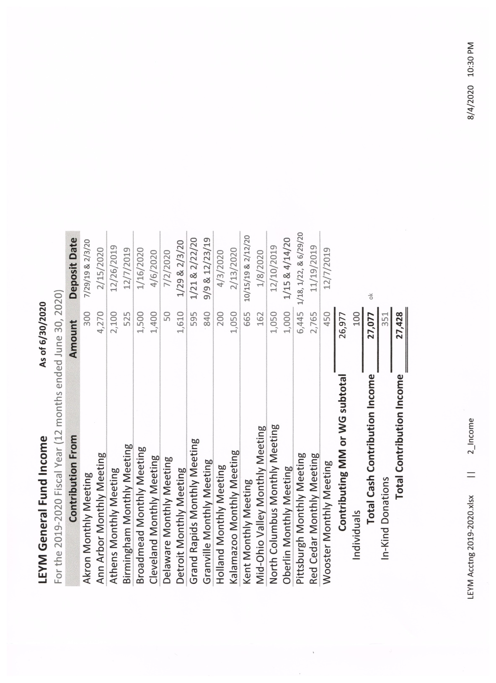

**Treasurer’s Report, p. 2**

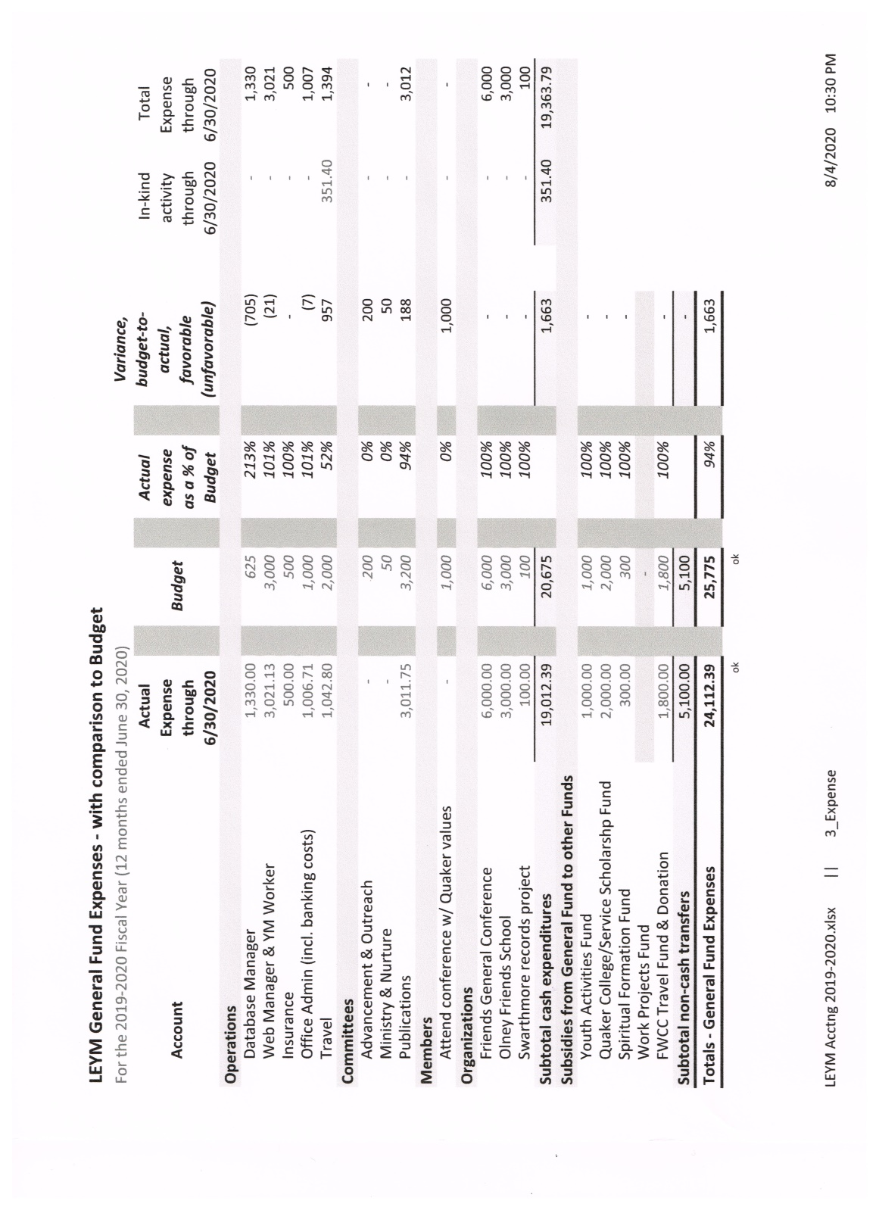

**Treasurer’s Report, p. 3**

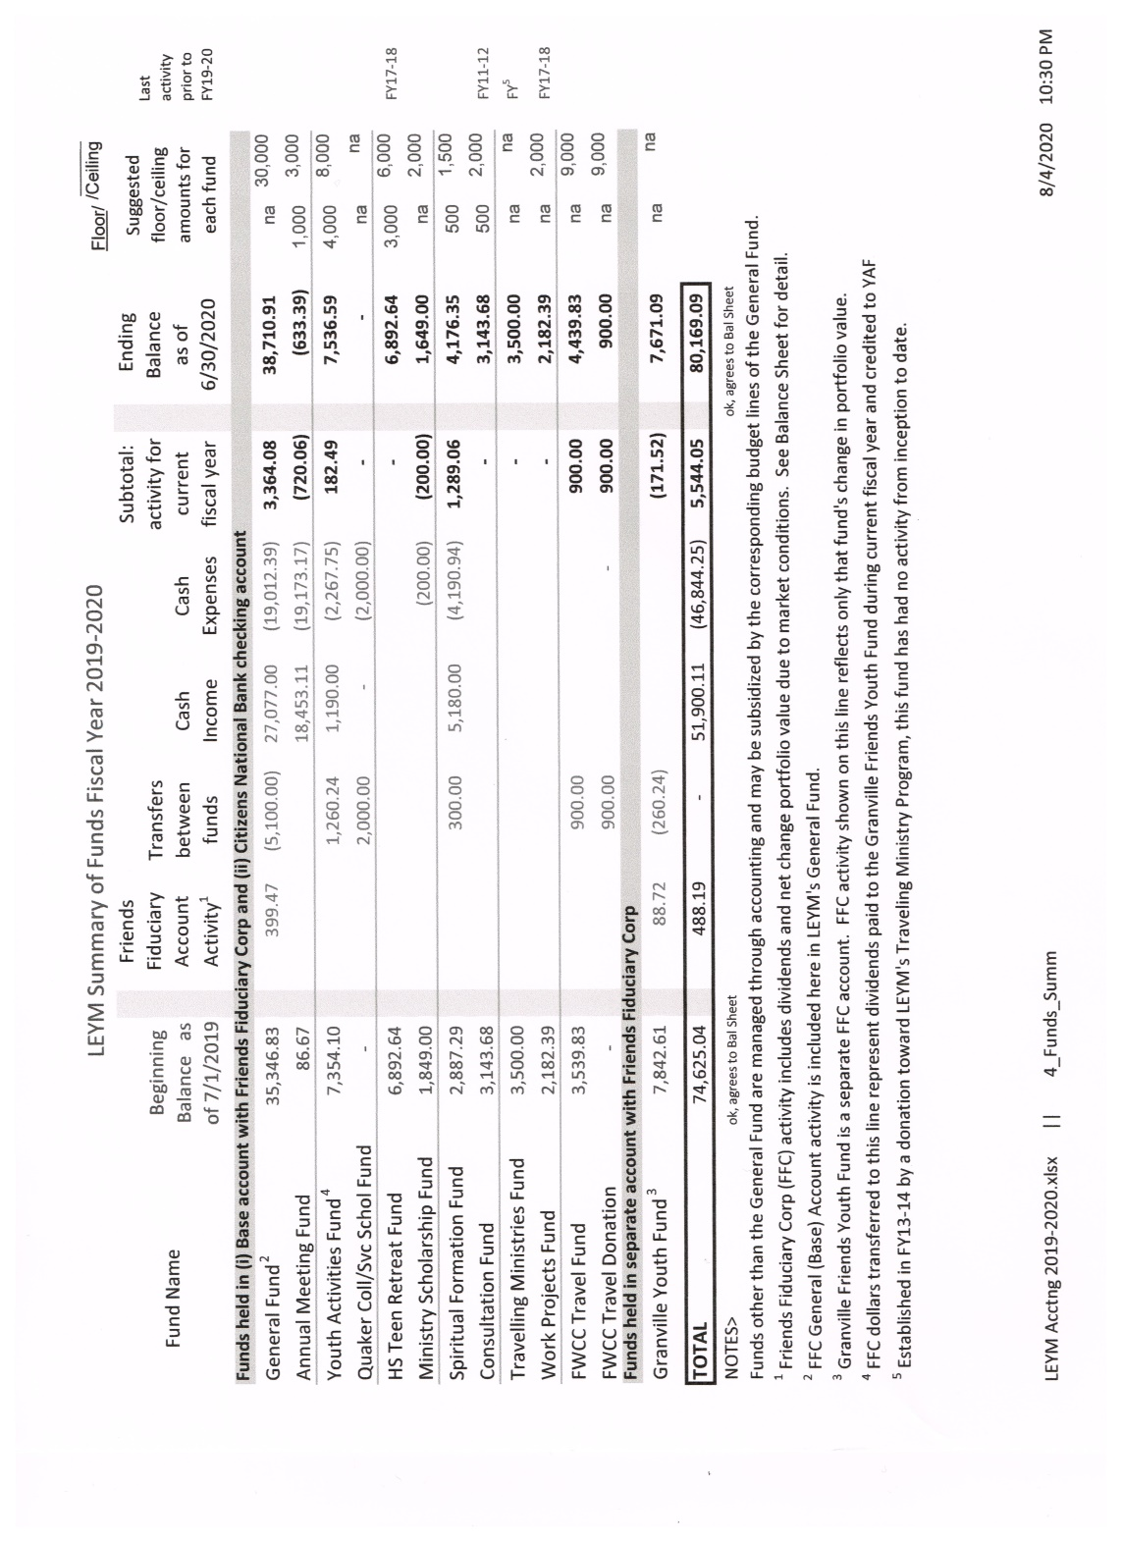

**Treasurer’s Report, p. 4**

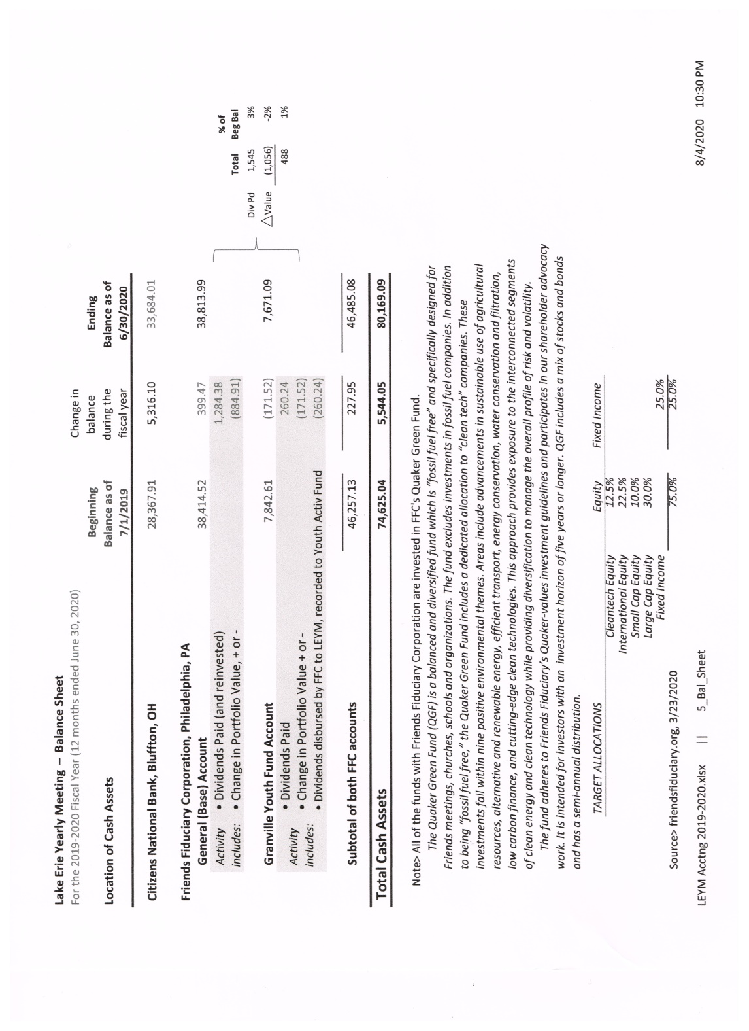

**Third Session: 11 a.m. – 12:30 pm, Saturday, August 1, 2020**

**YM2020-13 Opening Worship and Epistle from Intermountain Yearly Meeting**

Out of a period of open worship, Nancy Reeves, assistant clerk, read the Epistle from Intermountain Yearly Meeting, June 9–16, 2019. The theme of the Yearly Meeting was “Faith, Fear, and Future.” The gathering explored ways to sustain love, faith, and hope in our connections to God and to one another and to overcome fear in uncertain, turbulent times. They found renewal and restoration in the beauty of the land and in the depth of their listening, especially in their worship sharing, in creative arts, and in the inspiration that others can provide. Despite aging memberships and a sense that many meetings are fragile, member meetings continue to address the injustices closest to them, primarily in the plight of immigrants and oppression at the border with Mexico as they seek to “bend toward justice.”

**YM2020-14 Announcement about Scheduling**

Jo Posti, clerk, observed that these virtual business sessions have gotten overfilled. We are not able to conduct all the Yearly Meeting’s business within the time allotted. Therefore, we will hold an additional business meeting later in August, at a time to be determined.

*[At this point we approved wording for minute 2020-09, deciding to print the entire Epistle from the FGC Pre-Gathering Retreat for Friends of Color and their Families. ~Ed.]*

**YM2020-15 Nominating Committee Report (no. 1)**

Clémence Ravaçon Mershon (Erie Worship Group) gave a first reading of the Nominating report, outlining positions filled and positions yet to be filled and answering clarifying questions.

**YM2020-16 Peace & Justice** **Committee Report**

Joel Ottenbreit (Detroit) outlined a joint proposal from Peace & Justice   
and Earthcare Committees. It has been difficult to attract LEYM people interested in participating. The proposal is to have a four-session interest group over the next year which would engage with the topics that have been part of both Earthcare and Peace & Justice. The format would be less for-mal, with no reporting obligations to the Yearly Meeting. It would generate fellowship and ideas on moving forward. The full proposal follows.

**Proposal for the Development of an LEYM Interest Group   
for Addressing Concerns Regarding Peace & Justice and Earthcare**

1) There will be four 90-minute virtual meetings offered during the year for a group of up to 12 people, designed for attenders to express concerns about peace, justice, and earthcare. Individuals in this group would attend based on interest, and no commitment would be made to attend more than one meeting.

2) There will be a topic provided with some limited media to view or an article to read – one topic for Peace & Justice and one topic for Earthcare. The resources would be provided prior to the meetings, but reviewing the material is optional.

3) The meetings will begin with introductions and some fellowship, giving each person an opportunity to say something about their current situation if they so desire.

4) The topics will be discussed using a worship sharing format. Each person can express their feelings about the P&J topic, the Earthcare topic, or a topic of personal interest related to P&J or Earthcare.

5) After everyone has had a chance to speak, attenders will be asked if they have   
a reflection about the discussion to share. If a topic stands out with significant interest, the convener will ask if anyone wishes to form a working group to advance this idea. If there are several people who are interested, the names of the members of this group will be forwarded to the Executive Committee for approval to become a working group.

6) The participants will be given the opportunity to take an online survey that will gage interest in this group’s new structure and offer suggestions for improvement.

7) The convener of the group will collect ideas offered by the group along with the survey information to present to the Executive Committee for review in the future.

**Benefits**

1) The interest group provides a platform for Quakers to speak their minds on concerns related to P&J along with Earthcare.

2) The built-in principles of fellowship, worship sharing, and no formal commitment are designed to increase attendance. This will provide a “spiritual refuge” for Quakers to express their concerns without judgment.

3) The business of Yearly Meeting can happen organically in this structure. If there is an overwhelming sense that one topic has stood out in discussion, a working group can happen organically to advance an action item or make a presentation at LEYM.

– In Friendship, Joel Ottenbreit

**YM2020-17 Treasurer’s Report (no. 2)**

The treasurer’s report was accepted as presented earlier (YM2020-12).

**YM2020-18 Finance Committee Report (no. 2)**

Friends approved the budget presented earlier (YM2020–11), including the proposals to reduce mileage reimbursement to 17 cents a mile and lower per-member assessments for monthly meetings to $30. (*See* below and on next page.)

**Budget for 2020–21**

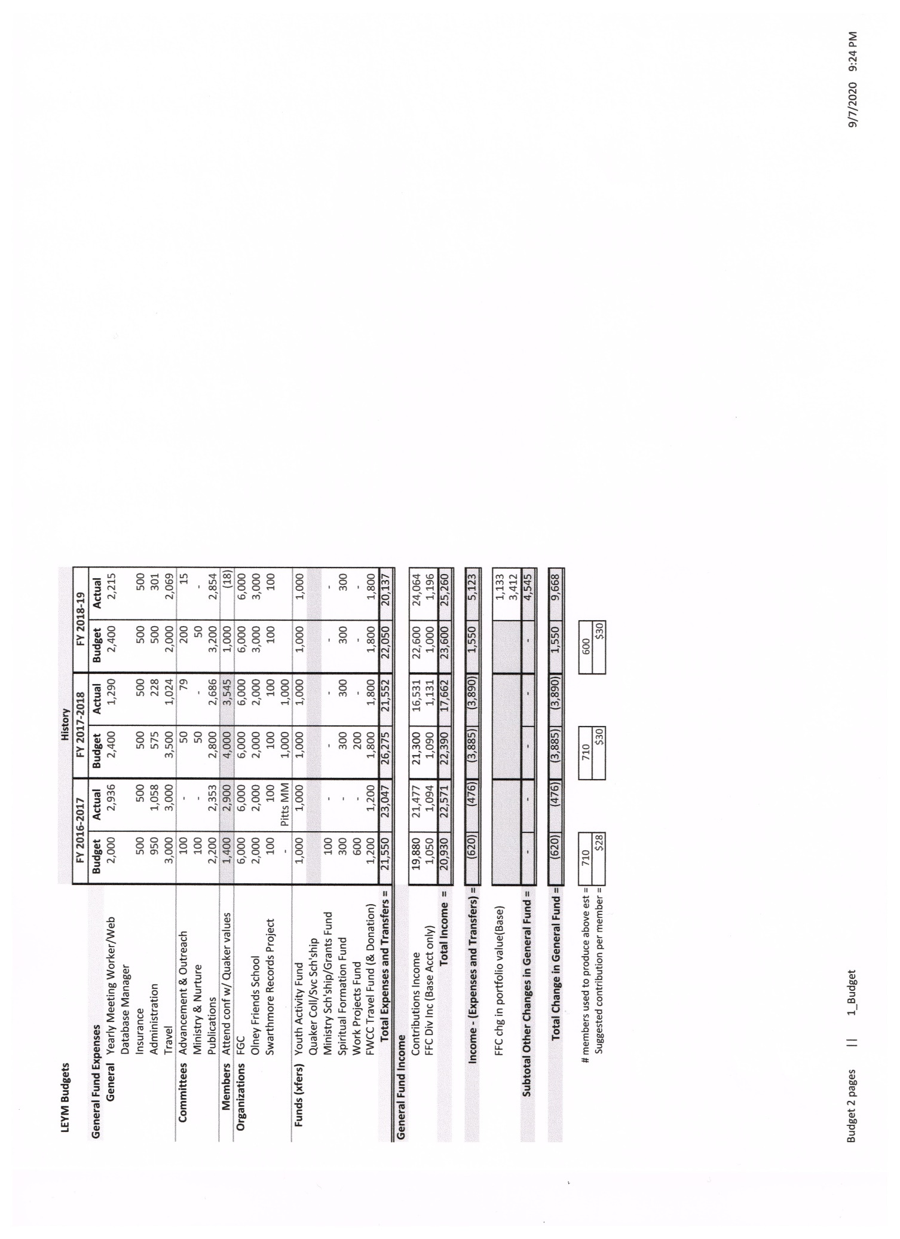

**Budget continued**

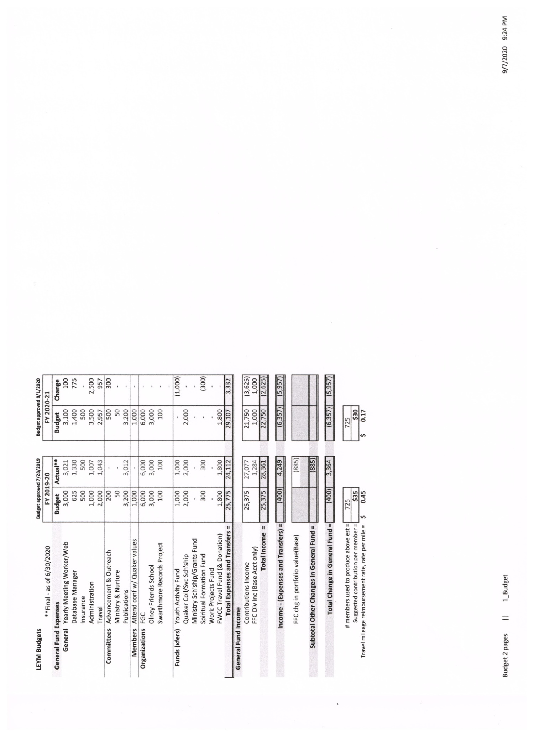

**Fourth Session: 3:00 – 4:30 pm, Sunday, August 2, 2020**

**YM2020-19 Preschool and Elementary School Report and Epistle**

The Elementary Group consisted entirely of families from Athens, who met in person there. Diane Mott (Broadmead) described their activities, and Jo Posti read aloud their epistle, which appears below. Many photographs of the group’s weekend were shared online.

**Preschool and Elementary School Epistle**

Even though we were not at Bluffton University, the Preschool and Elementary groups were able to be together in person. Friday consisted of pancakes and ice cream for breakfast, playing with friends, and a short worship sharing in the Clapps’ home. Saturday was filled with the Samuel story about listening, lunch, sharing hammocks, playing in the rain, and ice cream making. So much fun was had with Friends of Athens, Ohio.

Eight students attended: Elisabeth Clapp, Bradley Clapp, Adrianna Clapp, Star Clapp, Maggie Snow, Claire Mowery, Gigi White, and Zeke White.

**YM2020-20 Teen Epistle**

Jonah Brownfain (Birmingham) read the Teen Epistle:

Our epistle this year is quite succinct.

On Thursday we played Scattergories to calm our nerves;   
hilarity ensued (but we ultimately got what we deserved).

Friday came to highlight our art skills with us playing Pictionary,   
not for the posterity.

On Saturday we wrote our epistle while eating ice cream with caramel drizzle.

Jonah, Alex, Gabe, Sophie, Danielle, Jessie, Micah, and Rosa

**YM2020-21** **Middle School Epistle**

The Middle school epistle was submitted in writing on August 2. It reads:

Christa White and Diane Mott (teachers), Ethan Charlot, and Andrew Mott. We learned for three days how to listen with whole hearts and open our minds to let go. We played a game with household objects that were related and unrelated   
and learned how to take other people’s thoughts. We practiced active listening with a drawing game. We listened to the black sock song.

The session ended with an extended period of open worship.

**Fifth Session: 7:00- 8:00 pm, Wednesday, August 12, 2020**

The meeting opened with a brief period of open worship.

**YM2020-22 Acknowledgment of Deceased Friends**

Margaret Eleanor Starbuck* (Salem Monthly Meeting, Ohio), mother of Eric Starbuck (Pittsburgh), died at 102. Other deceased Friends from Pittsburgh include Ellie Piper,* Anne Kuhn,* Bill Matlack,* and Phillip Smith.*

Mary Beth McCalla* of Oberlin Meeting, died in May 2020, at 98.

James Drummond, a longtime attender of Red Cedar Meeting, and Will Alexander,* another longtime attender of Red Cedar, who had moved to Oregon.

James Eblin from Athens, then North Columbus, lately of Oregon.

William Garland of Kalamazoo Meeting; Robert Nagler, active in Kalamazoo.

\**See* the Memorial Minutes and Obituaries

**YM2020–23 Ministry & Nurture Committee Report**

Shelley Kotz (Broadmead) reported.

a. Shelley outlined a proposed substantial expansion to the current policy on Traveling Minutes recorded in *Policies and Procedures*. The revisions were approved.

b. Kalamazoo MM continues its support of Mey Hasbrook’s traveling in the ministry and requests another year’s endorsement from LEYM. Friends approved this endorsement, with one Friend standing aside.

The full report follows.

**Ministry & Nurture Report, 2019–2020**

Since Representative Meeting in April, Ministry & Nurture has met several times via Zoom and been in regular contact by email and phone to discuss items that we are working on.

A. In June a special meeting was held with members of the anchoring committee for an individual engaged in **traveling ministry**. The meeting concerned the role of Ministry & Nurture when a travel minute is submitted to the Yearly Meeting.

A travel minute originates within a monthly meeting. If the individual will be traveling outside the area of Lake Erie Yearly Meeting, the travel minute should be endorsed by Yearly Meeting. The request for endorsement should be forwarded to the Ministry & Nurture Committee for Lake Erie Yearly Meeting by the clerk of the monthly meeting. The request should include the name of the person who will be ministering, a description of their ministry, the names of individuals on their anchoring committee, an end date for the travel minute, and the name of the standing committee that oversees the anchoring committee. The request should include the name of a contact person (one) from the monthly meeting that Minis-try & Nurture may contact if there are questions or concerns. If the request is for renewal of a travel minute, it should include a copy of endorsement and the new end date, as well as any changes to the other information.

The information to be included with the request for endorsement of a travel minute from a monthly meeting is more extensive than what is currently listed in Lake Erie Yearly Meeting’s *Policies and Procedures* manual. We arrived at this list of information based on our experience with a recent travel minute as well as refer-ring to the procedures used by other yearly meetings. We are recommending that the existing procedure for travel minutes be updated to include this information.

Ministry & Nurture Committee would like to add some of the information that was shared with us before this meeting to the LEYM website in the resources section. The materials are *Jewels of Quakerism on Anchor Committees*, and one from FGC called *Some Guidelines for Care of Friends Led to Various forms of Ministry.*

The Committee was very grateful to the individuals from the traveling minister’s anchoring committee for spending time with us to clarify this situation.

We have received a letter from Kalamazoo Monthly Meeting stating that they are continuing to support the traveling ministry of Mey Hasbrook and are requesting that LEYM continue its endorsement of Mey’s ministry. Based on the information included in their letter and the endorsements from the meetings that Mey visited, we are recommending that LEYM endorse Mey’s traveling ministry for a period of one more year. A copy of the letter from Kalamazoo Monthly Meeting is included.

B. Rebecca Morehouse, one of the co-clerks of Ministry & Nurture, worked for several weeks with Bill Warters, the LEYM Meeting worker, to facilitate an **online meeting for worship for Lake Erie Yearly Meeting** in response to stay-at-home orders due to COVID-19. After several weeks, as individual monthly meetings started their own online meetings, the meeting sponsored by LEYM was laid down. We are especially grateful to Bill Warters and Jo Posti for encouraging and facilitating this meeting.

C. The Ministry & Nurture Committee also reviewed the **State of the Meeting Reports** sent to us by monthly meetings. A summary of monthly meeting State of the Meeting Reports is attached as a separate part of this report (*see* p. 49).

Individual SoM’s are included in the *Annual Records*. Please read them if you are interested in having more information on any of the actions mentioned here.

An issue that came to our attention in reviewing the State of the Meeting Reports is that several meetings reported having experienced tension within their meetings owing to interpersonal problems between members. We were contacted by or reached out to clerks from these meetings to see if Ministry & Nurture could be of help. At this time the meetings have managed issues with right order. We assured them of our availability if any future help is needed.

Because interpersonal problems do have the potential to cause tension and discord within a meeting, Ministry & Nurture would like to explore materials from FGC or other sources that might be useful to have in the resources section of the LEYM website.

D. Ministry & Nurture completed a summary of **responses to the 2019–2020 Query**, which is included as part of this report (*see* p. 11). Responses to the query were limited in number. We discussed why this might be, what we can do to increase response, or if we should even have a query. After discussion, we agreed that having a query is an important and useful tool. It is a traditional manner of addressing questions that shape our beliefs and can direct us to thinking about issues that are important but difficult. We have received some feedback regarding last year’s query and continue to welcome feedback. Members of Lake Erie Yearly Meeting may contact a member of Ministry & Nurture to share their thoughts.

In discussing a query for the coming year, we feel that events of the last six months – the COVID-19 pandemic and the tragic police killings and subsequent protests – are too important not to be addressed. We are continuing to work on the query at this time.

E. Ministry and Nurture holds the **Spiritual Formation Program** under its care; the work of choosing themes, arranging retreats, and suggesting readings is done by the Spiritual Formation Planning Committee. Typically the Spiritual Formation Program consists of a fall weekend retreat based on a theme chosen by the planning committee with a follow-up one-day retreat in the spring. In the intervening months, smaller Spiritual Formation groups within monthly meetings meet regularly to discuss readings based on the theme and to support one another in their spiritual life.

A Spiritual Formation retreat was held in September at the Weber Center in Adrian, Michigan. The retreat, led by Joann Neuroth from Red Cedar Meeting, was titled, “Meetings as Spiritual Crucibles and Incubators.”

At Lake Erie Yearly Meeting’s Annual Sessions in 2019, the Spiritual Formation Planning Committee members stated that, after having served on the committee for a number of years, they wished to step down and requested that others who participate in Spiritual Formation volunteer to be on the committee. At the time of the retreat, several individuals stepped forward to plan the spring retreat and theme for 2020–21 as well as make arrangements for a leader for the upcoming year.

Due to the Covid-19 pandemic, the spring retreat for Spiritual Formation did not take place. We have learned that the new Spiritual Formation Planning Committee has met and is planning a fall retreat.

Rebecca Morehouse and Shelley Kotz, co-clerks

**YM2020-24 Advancement & Outreach Committee Report**

Ellen Barnes (Detroit) described the plan the A&O Committee has drawn up to increase outreach through social media. The full report appears below.

**Advancement & Outreach**

**Report to LEYM Annual Session, 2020**

The purpose of this report is awareness.

An idea was presented to A&O about LEYM advertising on social media to help meetings, especially smaller ones, attract new attenders. We currently can be found online, but potential seekers need to know what to look for. This will not be proselytizing, but awareness of who we are.

The A&O Committee all thought it was a good idea. However, research needs to be done.

The current plan is:

* Educate ourselves on what social media advertising looks and feels like. (The majority of the Committee members do not use social media.)
* Research:
  + What kind of message we want to deliver, and how best to do it.
  + Find out what resources/material/information FGC might have.
  + Find out what other Yearly Meetings are doing.
* Pick the brains of LEYM and brainstorm ideas.  
  Outline plan and determine necessary resources
* Themes
* Media/medium
* Costs
* Potential leverage partners (Other yearly meetings? FGC?)
* Develop options and examples
* Determine pilot markets
* Timeline:
* Outline plan to present to Executive Committee in October.
* Solidify plan, potentially with examples, by Representative Meeting next April.

This is a preliminary plan. There will be additions and changes as we work through it.

**YM2020-25 Youth & Children Program Committee Report**

Kate Enger (Athens) reported. Plans are afoot to revive the Teen Retreat, with help from Robb Yurisko (North Columbus) and Ellerie Brownfain (Birmingham). Noah Molina (Athens) will see that Minecraft participation can continue among young Friends. The full report follows.

**Children & Youth Committee Report, Spring 2020**

1. **Requested action item: Reviving Teen Retreats**

Robb Yurisko, who led teen retreats in the past, is willing to help revive the events, and some teens do appear to be interested. Friends who feel led to help, or even to take leadership, are encouraged to contact him at *rlyurisko@gmail.com*. Robb wrote:

I wouldn’t mind getting things started and seeing how things unfold. Perhaps planning a retreat to see what energy there is among the teens.

Where Spirit leads is best. Some time in discernment with Committee members about a way forward would be ideal if there is a need for the work.

Perhaps another Friend in the YM would feel called to the position. Then I would be happy to serve on the Committee instead.

I hope to be at YM this year!

1. **Fall Youth Retreat:**

Diane Mott sought feedback on whether to reserve space for the fall youth retreat this year. It sounded like the consensus via e-mail was that having children gather in the fall would still be too risky due to public health concerns.

1. **Annual Sessions Plans**
   1. LEYM Annual Sessions will include Minecraft world building and a Mine-craft adventure for all children and teens. Minecraft is an online game that focuses on exploration and creativity rather than conflict. Noah Molina has been building some virtual areas to explore, and he and Jonah Brownfain will host a special event during which youth will endeavor to rescue an endangered village together. Noah will also serve as a friendly young adult presence during scheduled sessions to keep the space safe, and will choose game settings to make this Minecraft realm as creative and positive as possible. Young participants will need a Java edition Minecraft member-ship, which costs about $27, to participate. Memberships are available at Minecraft.net. If young Friends already play Minecraft and have a Java edition of the game, they do not need to purchase another. Noah Molina will need each child’s username so they can be invited to the realm where they can play together. Noah's email is [ockanoah@gmail.com](mailto:ockanoah@gmail.com). If a child has friends from other yearly meetings, those friends are welcome to send their usernames and join in the fun. Parents are encouraged to contact Kate Enger at [psychdrkate@gmail.com](mailto:psychdrkate@gmail.com) if financial assistance would help their young person participate in the Minecraft activities.

I suspect youth will want to spend more time in their Minecraft realm. If anyone would like to buy an adult membership and help Noah provide friendly adult supervision, please contact Noah at the email above. I (Kate) plan to help out some, too.

* 1. Annual Sessions will also include Zoom time for age-specific activities. If a child would like to participate in these activities, parents will need to provide the email to which their invitation to the meeting should be sent on their Annual Sessions registration form. Zoom classes are scheduled in between adult activities so parents can help children sign on, and to facilitate the sharing of computers.
  2. Young adults will also have some Zoom time set aside for their own use. Young adults are encouraged to contact Noah or Bill Warters if they’d like to organize an activity together. Bill can help them get their Zoom session organized.

1. **T-shirts are available for purchase.**

This year's design was created by Passionworks, a studio for artists living with disabilities. Noah Hogan, an Athens Friend, is a Passionworks artist. A small portion of the sale of each shirt will go to Passionworks to support its mission.

If you'd like a shirt, please send your size and mailing address, along with $17, to Kate Enger at:

75995 Vandyke Road

New Marshfield, OH, 45766

Orders must be in by July 9. Your t-shirt will be mailed to you in hopes that it will arrive in time for you to show it proudly via Zoom. The shirt will likely match the lighter lavender color in the design below:

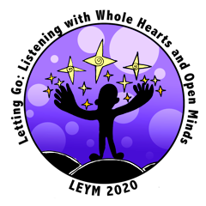

**YM2020-26 Final Nominating Committee Report**

Clémence Ravaçon Mershon outlined the final recommendations from the Nominating Committee. The full slate was approved (*see* pp. 168–172).

**YM2020–27 Consent agenda**

Reports have been posted to the LEYM website and included in the docu-ments in advance. These are reports from the database manager, AFSC representatives, the Clerk of the FCNL General Committee, FGC Representatives, Olney Friends School representative, Publications & Archives Committee, and Quaker Earthcare Witness. These constitute a series of reports that are accepted in a consent agenda. The Meeting received these reports. *[These appear at the end of these minutes, along   
with a report from Ministry & Nurture Committee. The report from QEW was not found. ~Ed.]*

**YM 2020-28 LEYM Epistle**

Nancy Reeves, assistant clerk, read aloud the Epistle describing the theme and activities of this year’s Virtual Gathering. With some edits, the letter was approved. The full Epistle appears appended to the end of these minutes..

**YM 2020-29 Clerk’s Announcement about Ad Hoc Committee**

Jo Posti read aloud names of Friends who have agreed to serve on an ad hoc committee exploring ways that the Yearly Meeting can be more effective in its functioning and outreach: Susan Loucks (Pittsburgh), clerking, Ellerie Brownfain (Birmingham), Sally Weaver Sommer (Broadmead), Mike Holaday (Grand Rapids), Clémence Ravaçon Mershon (Erie Worship Group), and Becky Morehouse (Ann Arbor).

**YM2020-30 Minute of Gratitude**

Jo thanked Nancy Reeves and Peter Wood for their years of service to the Yearly Meeting as clerk and recording clerk as well as their guidance and friendship. She expressed gratitude for their care for LEYM, especially during this past year, during which their responsibilities changed consider-ably in our virtual format.

The meeting closed with a recorded musical postlude.

Submitted by Jo Posti, Presiding Clerk

Nancy Reeves, Assistant Clerk

Peter Wood, Recording Clerk

*Reports accepted by consent agenda (*see *YM2020-27) but not presented at business sessions begin on the next page.*

**Ministry & Nurture Committee:   
Summary of State of the Meeting Reports**

The 18 State of the Meeting reports we received are clearly divided into conditions before and after the arrival of COVID-19.

Generally the spiritual state of the monthly meetings and worship groups making up Lake Erie Yearly Meeting remains strong. We value the time spent together in unprogrammed worship, seen as the heart of the Meeting, and we enjoy additional fellowship through potlucks, worship sharing, ongoing small groups, social action, and retreats.

We are generally aging, predominantly white, and relatively affluent. Some meetings report new attenders drawn in by their increased web presence, activities, or outreach. Several meetings have revised their social media presence, most with rewarding results. Other meetings struggle with their small size or aging member-ship. There is a sense from several meetings that we are not providing adequate care and spiritual nurture for families with children. Some meetings lack any regularly attending young people and offer child care or programs only when young people do come. Several meetings have had or are facing major transitions in their physical space for worship.

Quality of worship is mixed, with some meetings worshiping mostly in silence, while others experience varied and spiritually rich vocal ministry. Sometimes political or intellectual messages are not felt to be Spirit-led. Occasionally ministry during worship has been disruptive. Several meetings have experienced inter-personal problems between members, creating tensions that affect trust and cooperation within the meeting.

Two meetings have adopted the practice of reading back decisions or minutes during meetings for business. Reading a *Faith and Practice* document together is another approach two meetings have taken to deepen knowledge of Quakerism and support rightly ordered practice.

Meetings meet needs for spiritual deepening with Spiritual Formation groups, Seekers series, viewing *Quaker Speak* videos, groups on aging, sharing individual spiritual journeys, and supporting multiple individual ministries.

Fellowship is further experienced through outreach, such as helping a student financially, eating meals with college students and neighbors, writing letters to U.S. government representatives and Amnesty International, and supporting a Peace Park. Meetings have joined with other faith groups for social action like serving at soup kitchens and food pantries, Alternatives to Violence Program, sanctuary, engaging in local and national racial equity and social justice initiatives, and environmental and immigration issues.

Most meetings are involved with wider Quaker organizations in addition to Lake Erie Yearly Meeting, such as Green Pastures Quarterly Meeting, Michigan Friends Center, Friends General Conference, American Friends Service Committee, Friends Committee on National Legislation, the School of the Spirit, and Friends World Committee for Consultation. We also reach out to other faith groups for social action issues. Two meetings are supporting small worship groups.

The arrival of COVID-19 changed the rhythm and dynamics of our meetings significantly. Meeting responses to the sudden end to face-to-face worship ranged from confusion about process to worry about members unwilling or unable to join online worship. Some smaller meetings did not shift to online meetings for worship. In those meetings, members joined online worship with other meetings, reached out to each other with phone calls, held worship simultaneously from separate homes, or experimented with outdoor distanced meetings.

Most meetings quickly shifted to online worship using Zoom. Those that shifted reported relief and pleasure that the process was not too onerous, actually enhanced the ability to hear ministry, and increased attendance due to the presence of those who could not otherwise attend. One meeting wrote, “Perhaps the biggest surprise for some is the discovery that we still experience being gathered in the Spirit when we are only connected virtually. This reaffirms for us that Spirit is not bound by time or space; that when we are one in Spirit, we transcend limitations.”

State of the Meeting Reports from each of the individual meetings and worship groups are included in the *Annual Records* (*see* pp. 81 – 128). Please read them if you are interested in having more information on any of the actions mentioned here.

**Publications & Archives Committee**

**Report, July 2020**

Publications in the first part of the year proceeded smoothly and on schedule, with the fall *Bulletin* and the *Annual Records* mailed out together in late October and the winter *Bulletin* mailed in January.

With the onset of the coronavirus pandemic in February-March, and both the Representative Meeting in April and these Annual Sessions in July–August being held online, changes were made to both the schedule and the content of the spring *Bulletin.* That issue highlighted the program and schedule of the Annual Sessions, along with information on accessing them and how to register online. The editors also solicited contributions reflecting Friends’ responses to the pan-demic and resulting quarantine and included several poems and an artwork by Friends from the Yearly Meeting.

With many meetinghouses still closed when the spring *Bulletin* was mailed in June, fewer print copies were made and distributed. This smaller number allowed the issue to be printed in color while still adhering to our budget for the year, spending $3011.75 of our $3200 budget.

Jeff Cooper served as editor of the *Annual* Records again this year, and he also served as co-editor with Peggy Daub of the *Bulletin*. Committee member Rosemary Coffey provided eagle-eyed proofreading of the *Annual Records* and each issue of the *Bulletin*.

The deadline for submitting materials for the 2020 *Annual Records* is September 1, and the deadline for the fall *Bulletin* is October 1.

Peggy Daub, Clerk

**Report from Maryann Concannon, Database Manager**

**August 2019 –June 2020 (Ten Months)**

LEYM Database

I began my tenure as database manager in August 2019. It was a rough start, finding my Access skills were rustier than I imagined. I had hope that over time I would get the hang of it but found my lack of sophisticated Access skills really hampered me. I also found that experts in Access have become few and far between. I did find someone at Red Cedar Meeting who actually lives in my neighborhood within walking distance, but then Michigan went into lockdown and that source was not available to just walk over and help me. Also, in July of last year I thought my job was going to turn into part-time, giving me the time to work on the database, but that never happened. So I have felt the database has gotten the short stick – so to say. I have asked LEYM to see if they can find a new database manager for 2020–2021.

Time Spent

During these ten months I have worked 59 hours. Currently I am updating the directory, which had not been done in a few years. It needs to be done every few years. I currently have completed the following meetings:

[Ann Arbor]

Athens

Broadmead,

Delaware

Detroit

Erie

Grand Rapids

Holland

Indiana

Kalamazoo

Manitou

Mid-Ohio

Oberlin

Pine River

Pittsburgh

Red Cedar

Somerset

Tustin

This represents all the meetings that got back to me with their updated directories.

A few meetings are “working on updates” or “passed request onto appropriate person.” I have not heard back from a handful, and have made phone calls and second email requests to them.

Tasks I have done in the past year included:

FWCC survey completion

Listservs for LEYM Meeting worker

Updates for Website

Work for LEYM Meeting worker

Updating Meeting officers and committee heads for a few meetings

Completing query from FGC

And now, of course, updating the directory.

Thank you for the opportunity to serve you the past year.

**LEYM AFSC Liaisons**

Bill Warters, Claire Cohen, Kathleen Helbling, Paul Helbling

July 19, 2020

**AFSC Liaison Report to LEYM**

*After Reviewing Its Legacy, AFSC is Charting a Path Forward*

This year the American Friends Service Committee (AFSC) completed its 2020 – 2030 strategic plan, the creation of which was a multi-year effort. The plan was approved June 20 at the Annual Meeting, held virtually by Zoom due to the Pandemic. LEYM Liaisons attended the Annual Sessions virtually this year, so no travel funds were expended. The strategic plan looks forward thoughtfully, while acting courageously in the present to address immediate concerns. AFSC’s updated vision, mission, and core values were articulated as follows:

**VISION:** A just, peaceful, and sustainable world free of violence, inequality, and oppression

**MISSION:** Guided by the Quaker belief in the divine light of each person, AFSC works with communities and partners worldwide to challenge unjust systems and promote lasting peace.

**VALUES:**

• We respect the equality, worth, and dignity of all people and regard no one as our enemy.

• We seek right relationship with all life on a sustainable Earth.

• We accept that our understanding of truth is incomplete and seek ever deeper insights from lived experience.

• We trust the Spirit to guide discernment of our collective actions.

• We assert the transforming power of love and active nonviolence as a force for justice and reconciliation.

**1**. **Structural Changes Ahead**

This past year AFSC engaged in a broad search for a new presiding clerk to replace Phil Lord, who has served since 2014. The search committee, after deep deliberation, was unable to bring forward a recommendation for an individual they felt was a good match for the needs of the organization. Phil Lord was asked to stay on through June 2020, at which time Assistant Clerk Nikki Vangsnes agreed to take on the role of interim presiding clerk.

Based on the strategic planning deliberations, AFSC has decided to focus efforts on three strategic programs over the next ten years, namely: **Shared and Sustainable Peace**, **An Economy that Works for People and Earth**, and **Just Approaches to Forced Displacement and Migration**. By pursuing strategic objectives within these three programs, AFSC will be able to contribute toward an overarching organizational goal of transformative shifts in systems of power. This new direction, while making room for most of AFSC’s existing programming, will still result in some structural changes in how AFSC conducts its work, with specific implementation details to be worked out over the coming year. The following graphic provides a broad overview of the vision and underlying organizational development goals.



**2.** **A Sampling of Recent Activities**

**Protecting people in prisons, jails, and detention centers from COVID-19**

As the pandemic took hold, AFSC was among the first to urge immediate action to protect those in U.S. prisons, jails, and detention centers — from making soap available for hand-washing to granting immediate release. More than 10,000 AFSC supporters sent messages to governors and Immigrations and Customs Enforcement (ICE) directors while our legal team supported several successful petitions for release.

**Moving produce from farm to food bank in New Mexico**

When farmers found themselves without customers and food banks fell short on donations, AFSC’s sustainable farming program in New Mexico made an innovative arrangement, helping farmers buy seed and supplies in exchange for donating crops. The program became a national model and continues to attract new partners.

**Delivering hygiene kits to Palestinian elders**

People living under Israeli occupation have difficulty accessing health care and essential supplies — especially dangerous in this time of COVID-19. AFSC’s decades-long history in the region positioned us to work with partners to dis-tribute hundreds of sanitation kits to seniors in Gaza and the West Bank — while continuing to advocate for the Gaza blockade to be lifted and for all Palestinians to have the freedom to meet basic human needs.

**Providing health care workers with protective equipment in both Zimbabwe and Jordan**

In Zimbabwe and in Jordan (especially in densely populated areas where Syrian refugees tend to live), health care workers lacked adequate supplies and personal protective equipment (PPE). Working with partners like the Zimbabwe Association of Doctors for Human Rights and the Jordan Paramedic Society, AFSC has been able to get items such as reusable N95 and medical/surgical masks, goggles, gowns, hand sanitizer, medical gloves, and infrared thermometers to doctors, nurses, paramedics, and pharmacists.

3 **Building a Community Network in West Virginia**

Through the years, AFSC has played a key role in expanding free school breakfast and lunch to children statewide in West Virginia. But when schools closed and stay-at-home orders were put in place, many children, seniors, and other West Virginians were in danger of going hungry. AFSC mobilized to form Rapid Response WV, a network of organizations and more than 300 volunteers working together to purchase and deliver food and hygienic supplies to people in need. As the above examples illustrate, *service* remains an important component of the work. Going forward, AFSC will continue to be centered in communities. Workers will also align their work around the three strategic, organization-wide programs focused on peace, economic justice, and migration. This will enable them to respond comprehensively and nimbly to today’s and tomorrow’s challenges. The goal is to become an even stronger voice for peace and justice, working in greater unity among AFSC staff and volunteers and alongside communities, partners, coalitions, and networks to achieve transformative change.

**Friends Committee on National Legislation**

July 2020

To our Friends of Lake Erie Yearly Meeting:

Please welcome Sarah Freeman-Woolpert and Bobby Trice as they visit the 2020 Lake Erie Yearly Meeting. We are excited that they will have ample opportunities to hear your concerns and leadings while sharing in worship, holding your business meeting in the Light, and leading workshops, July 30 – August 2. They are happy to be in faith and community with you.

[Sarah](https://www.fcnl.org/people/sarah-freeman-woolpert) is the Advocacy Teams Trainer. A native of Pembroke, New Hampshire, she was raised in the Concord Friends Meeting. Sarah is instrumental in helping Quakers expand a robust, self-sustaining network of grassroots advocates. Sarah is a strong support in helping Friends and friends build deep advocacy skills to lobby political leaders for peace and justice.

[Bobby](https://www.fcnl.org/people/bobby-trice) (Quaker Engagement Associate) fosters open channels of communication between FCNL and the wider Quaker world and coordinates FCNL staff engagement with Quaker communities. Bobby comes to FCNL from Swannanoa Valley Friends Meeting (NC) and currently attends Friends Meeting of Washington (Baltimore Yearly Meeting).

We at FCNL seek to strengthen our connection to Friends Meetings and Churches around the country and find areas where FCNL can offer opportunities for action on issues concerning Friends. We are supporting this virtual “travel” in the tradition of Friends’ intervisitation, with hope to stir our spirits and open opportunities for understanding one another’s experiences of how the Spirit is working in the world toward peace and justice.

We send you greetings, hold you in our prayers, and trust that God will bless your time together in loving community.

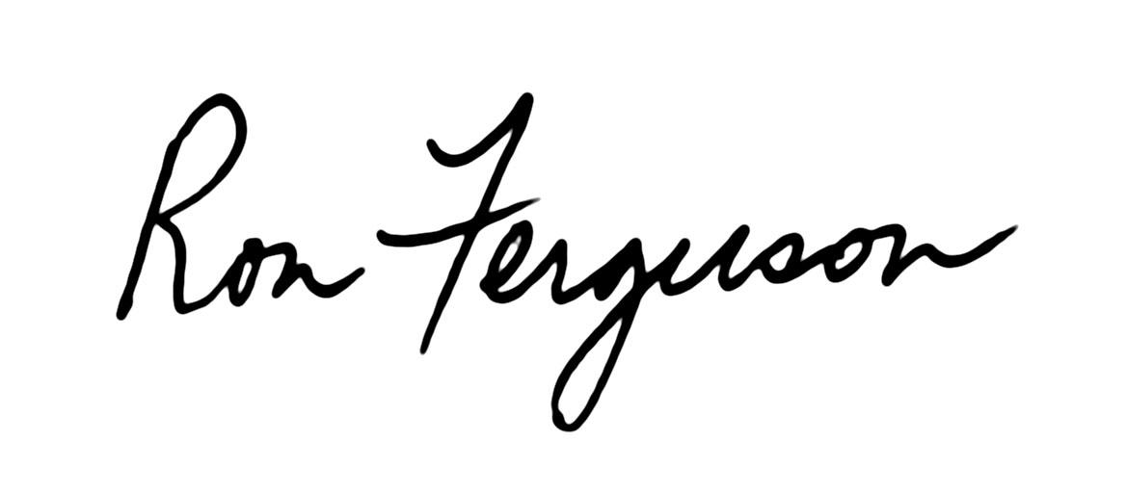In peace,

Ron Ferguson

Clerk, FCNL General Committee

Pastor, Winchester Friends Church (IN)

**Friends General Conference**

**Lake Erie Yearly Meeting Representatives’ Report**

Friends,

Your 2019 – 2020 representatives to Friends General Conference, Sally Weaver Sommer, Valerie Groszmann, and Marvin Barnes, are pleased to report on events and circumstances in Friends General Conference.

For Friends who are not familiar with Friends General Conference, FGC is a North American Quaker association of 16 Quaker yearly and 12 monthly meetings in the United States, Canada, and Mexico, who choose to be members. FGC was founded in 1900. A key program of FGC is the annual Gathering of Friends held at a different college campus every July. The event usually attracts attenders from around the world, but most participants come from the United States and Canada. The event features 55-60 workshops and a slate of plenary speakers. Topics covered include Quaker faith and practice, arts and crafts, multigenerational programming, and opportunities for political dialogue and action. The Gathering hosts both Quaker and non-Quaker speakers focusing on messages of interest to Quakers. FGC also supplies Friends with programming and other resources such as Quaker Books at FGC to help Friends in their spiritual journeys.

During the past year FGC has had to deal with a number of events, both internal and external, that have had a profound effect on the organization. Recently, an update to the governing body of FGC, Central Committee, was published. This update [which follows] will give the reader an overview of the past year including the effects of COVID-19 on the organization.

**Update for Central Committee on FGC Actions & Status**

During the COVID-19 Crisis, FGC staff and committees seek to be of service in a myriad of ways. Here is a listing with links, followed by an update on our financial status.

**Compiling Yearly Meeting News & Actions**

COVID-19 Resources and news from monthly and yearly meetings: https://fgcquaker.org/news/coronavirus-prevention-your-quaker-community-fgc-events

**The FGC Gathering**

Gathering updates: *https://www.fgcquaker.org/connect/gathering/coronavirus-and-2020-gathering*

The 2020 in-person Gathering was cancelled for 2020 and rescheduled for 2021.

* Sites for 2021 (Radford University) and 2022 (Western Oregon University) were approved by Long Range Conference Planning Committee and sent forward to Executive Committee.
* Patsy and Tony Martin have agreed to serve as Gathering Co-Clerks for 2021 at Radford. FGC has received many notes of sadness, understanding, and support around the cancellation of the 2020 in-person gathering. A need for connection and community was clear, so the Gathering organized three worship opportunities for Friends to join together to release the 2020 Gathering. Between 25 and 55 Friends have participated at each worship.

**Planning has begun for a Virtual 2020 Gathering**

A virtual gathering committee has met twice to discern program and schedule.

A theme “Virtual Gathering 2020” rose organically from constituents and stakeholders. It became clear that FGC is the host and site of the Virtual Gathering.

Virtual Gathering schedule is in development.

There will be adult, Jr. Gathering, High School, and AYF programing available.

A young clerks training is being explored.

Tech training and online facilitation training will be available to program leaders. The appropriate digital infrastructure is being established.

**Opportunities for Friends to Worship and Share Virtual Fellowship**

• Many FGC Friends were seeking worship opportunities, so a weekly Saturday meeting for worship at 9pm EDT for FGC Friends was begun. Messages of gratitude come in weekly. Some Friends are attending who do not have weekly access to worship.

o Committee for Nurturing Ministry members are taking turns hosting this worship opportunity. Register at *www.fgcquaker.org/resources/online-worship-opportunities* to receive the Zoom link and phone numbers.

• Gathering staff is collaborating with various FGC groups, including Quaker Earthcare Witness, FLGBTQC, Nontheist Friends, Adult Young Friends, and Friends of Color, to offer worship sharing groups once a month in April, May, and June. There will also be an Open Worship Sharing Group.

**QuakerBooks of FGC**

• QuakerBooks is still fulfilling online orders. Spread the word!

• Publications & Distribution put together a collection of books and pamphlets to help Friends with grief and loss at *https://quakerbooks.org/collections/support-in-grieving*.

• We’ll be offering virtual author events through the online Gathering and at other times.

**Fund Raising Campaign Feasibility Study:**

• The feasibility study has shifted to online group sessions and Zoom/phone confidential interviews.

• We decided to finish the feasibility study and are close to completion; the report will be available by spring Executive Committee meeting. Prior to the crisis, there was much positive feedback.

• At this moment, our consultant sees campaign-related planned giving work as viable in the next several months, while a full campaign should not be launched until some level of economic recovery has been achieved. Some donors have independently echoed his recommendations.

**Development:**

• Conducting Pastoral Care of FGC donors – checking in our supporters and sharing updates. This will be ongoing. (We’ve been in touch with 35 of our top donors, and Development Committee members are checking in with another 20 donors.)

• Applying for small grants for new online programming. We are communicating with funders about grants already received for programs that are no longer being held in person and requesting opportunities to use funds in a different manner, since programs are moving online.

• Updated the annual report to reflect recent programmatic changes.

• Planning a special fundraiser focused around Gathering to help fill the gap from lack of registration income/challenges brought on by coronavirus in general.

**CNM/Religious Education**

• With many yearly meetings planning virtual instead of in-person annual session events, the Yearly Meeting Visitors Program is coordinating with FGC staff and Central Committee members to serve as "virtual visitors" to our affiliated yearly meetings. In addition to reporting about the technology and strategies that worked (or didn't work) in offering a virtual annual session, these visitors will prepare the traditional visitor report detailing the successes and challenges facing each yearly meeting. The YMVP serves a key role in helping yearly meetings learn from each other during this time of innovation.

• To serve the spiritual needs of Friends and newcomers experiencing social and spiritual isolation, the Spiritual Deepening eRetreat program quickly organized a Quarantine Calendar of online offerings, including an eRetreat, a weekly worship sharing group, and a book discussion group.

**The Ministry on Racism Program** has responded to the COVID-19 pandemic by:

• Adding to our monthly worship for Friends of Color a weekly one held Wednesday afternoon.

• Providing a virtual retreat for Friends of Color in Intermountain, North Pacific, and Pacific Yearly Meetings on April 18.

• Organizing weekly worship sharing, an open house for Friends of Color, and events for the summer virtual Gathering.

**The State of FGC Finances During the Crisis**

Like non-profits all over North America, FGC is financially impacted by COVID-19. There are steps we’re taking to try to mitigate the damage. Here is where we are, the actions already taken and next steps.

• With the cancellation of the in-person Gathering and the fact that Gathering registration fees would have covered costs already expended such as some staff salaries, the total net loss on the Gathering for 2020 could be as high as $275K. We are seeking ways to bring that number down.

• The bookstore usually sells $20–25K worth of books at the Gathering and more through Yearly Meeting annual sessions consignments. While online sales have been a little better than usual, the bookstore will likely require a larger than projected ministerial subsidy this year.

• The $275K Gathering net loss and additional bookstore subsidies are extra- budgetary. The 2020 budget was approved to be $67K beyond sustainable. Theoretically, we could therefore have to make draws beyond sustainable of almost $350K this fiscal year on what was originally a $2M budget.

• In terms of fundraising, we have not seen an appreciable decline in giving to this point. So we’re not lowering our expected fundraising total very much for the remainder of this year unless giving changes in the coming months. We are having discussions about what fundraising goals we should have for 2021. This may take time to see whether Friends continue to give, in order to come to a good estimate for 2021.

• Like everyone, our investments have lost value. Fortunately, Finance Commit-tee recommended pre-crisis that we move $300K from investments to a cash position. This means we do not have to liquidate depreciated stock at this time. However, the value of our portfolio in mid-July determines the amount of our recommended sustainable draw for 2021. We do not expect the stock market to have fully recovered by then and therefore we will likely have a lower draw available to us in 2021 vs 2020. This will negatively impact our budget projections.

• The Friends Pension Fund has also been negatively affected by the stock market decline. We will therefore likely have to pay more to the pension fund in the coming year vs. this fiscal year (last year we had to pay $0.20 on each dollar of salary into the pension, which was the highest ever). We will know more later in the year. This will also make the 2021 budget more challenging. The Pension Board will meet in June to talk options.

***What are we trying to do about all this?***

• We applied for a $200,200 loan from the federal relief CARES act, the maximum allowed based on our documentation. We were just approved to receive $200,200 to help cover payroll and keep staff employed. Expecting the loan to be later forgiven, this could help us significantly lower this year’s deficit and be close to the original projections approved by Central Committee in October 2019.

• Development staff is planning a special fundraiser to run in late April and early May in an attempt to help cover some of the Gathering losses. Please encourage Friends to be generous if they still have the resources to do so.

• We are in the process of determining a recommended (pay as led) attendance fee for the Virtual Gathering that we hope will make it accessible while providing some needed income.

• We continue to look closely at our expenses.

• Finance Committee had a video meeting this week and agreed FGC should stay the course on the FY 2020 budget for the moment. We should wait to see if loan forgiveness is approved and how fundraising and Gathering fees turn out before shifting course. Finance Committee’s full spring meeting will be on April 25. It will then make recommendations to the May Executive Committee meeting on how best to steward our resources during this crisis and for the 2021 budget.

*Authors: Barry Crossno, FGC General Secretary, and Frank Barch, FGC Clerk*

*Date: 04/16/2020*

**SeIn addition:**

The Institutional Assessment Implementation Committee is now staffed with a diverse team of volunteers and beginning the task of implementing recommendations of the FGC Institutional Assessment on Structural Racism.

During the 2019 Central Committee sessions, the IAIC asked and Central Committee approved:

1. An extension of the minute passed last year resolving that in all FGC decision-making processes each body shall answer the following query with respect to each decision: “How does this decision support FGC in its goal to transform into an actively anti-racist faith community?”

2. A minute to collect demographic information regarding race and age of Friends in FGC-affiliated Yearly and Monthly Meetings.

• In preparation for the completion of the second term of service for the cur-  
rent Presiding Clerk, Frank Barch, the Nominations Committee has made the recommendation that Marvin Barnes, the current Assistant Clerk, be the Rising Presiding Clerk. This nomination was approved.

• FGC is evaluating and planning to improve its “Connector” function. This function is key to keeping Friends informed of the many diverse activities and resources within the association and the Quaker community at large.

• To help in the support of the various programs of FGC, the FGC Nominations Committee has begun consultations with yearly meeting nominations committees to keep each yearly meeting informed of the volunteer needs of the organization.

Respectfully submitted by:

Sally Weaver Sommer, Valerie Groszmann, Marvin Barnes

LEYM FGC Representatives

**2020 Report from LEYM Liaison to Olney School**

Olney had a good but challenging year. The school started off with 35 students, 14 of those from outside the United States. A new class was offered in agricultural sciences, using the farm, greenhouse, and vegetable garden as laboratories. Sustainability and stewardship continue to play an important role at the school, taught in classes and practiced every day at Olney.

In March classes were interrupted by the COVID-19 pandemic, and all schools closed in Ohio. Fourteen international students were unable to return home and stayed on campus complying with the COVID-19 restrictions. Learning continued via computer and old-fashioned methods such as U.S. mail and the telephone. All 35 students finished the year. The School anticipates next fall’s enrollment to be higher than this year's, despite the pandemic's expected negative impact on enrollment. Olney is planning for students to return to campus in the fall, keeping up to date with guidelines from the state of Ohio for residential schools.

Olney successfully held graduation and an alumni meeting via Zoom. In both cases, more people were able to participate, and it is likely they will be using video conferencing in the future for these events. Class reunions were also conducted via Zoom and were quite successful. The school is in a stronger financial position than it's been in for years.

The annual fund reached its goal of $300,000 and that is good news for Olney.

Respectfully submitted,

Ellerie Brownfain

June 27, 2020

**Epistle to all Friends**

**Lake Erie Yearly Meeting   
of the Religious Society of Friends**

**July 30 – August 2 & August 12, 2020**

Greetings to Friends Everywhere!

We, Lake Erie Yearly Meeting of the Religious Society of Friends, gathered from July 30 through August 2, in Pennsylvania, Michigan, Ohio, and other locations including Maine and Honduras, with a final business session on August 12, 2020. Although our physical gathering was limited mostly to groups of one or two, collectively, 155 of us worshipped, carried out our business, and played together using the online platforms of Zoom and Minecraft. Our theme this weekend was “Letting Go: Listening with Whole Hearts and Open Minds.”

**Letting Go**

In the midst of a world health pandemic that separates us from each other and a new awakening to the depth and breadth of our long-standing racial pandemic, we found comfort in seeing each other through Zoom and in the LEYM routines we love. We began some days with Bible study and worship sharing, we delighted in our beloved talent show, and we envied our youngest children, who were able to gather in person. While familiar and comforting, letting go of the physically gathered nature of these routines also created new opportunities. A number of Friends who cannot normally attend a physical gathering, due to cost, mobility, time, or other reasons, were able to join us this year for the first (or first in a long) time. Our talent show this year included a number of favorite and familiar acts, among them several musical performances, but we were also treated to a video walk-through of one Friend’s garden, exploration of a Mine-craft world occupied by our Youth Program during Annual Sessions this year, paintings, an HTML animation, and some scrollwork pieces of art created during the talent show.

We are excited about the possibility that the technology we used out of necessity this year will enhance our work going forward. We are grateful for the skilled and cheerful wizardry that made Zoom our Bluffton this year, and for inspiring musical interludes from Playing for Change. We are also grateful for the thoughtful planning of a Minecraft world which held our Youth Program, and for the gifts and flexibility of all of those serving our community during this time of unexpected challenges. While we are eager to meet together physically in the future, letting go of the need to meet exclusively in person opens up exciting opportunities for ongoing Bible study, year-round Minecraft connections among our youth, and breathing new life into our Earthcare and Peace & Justice Committees as they explore offering a series of free-standing interest groups during the coming year.

**Listening with Whole Hearts**

Our Bible study group explored the biblical treatment of five words from our theme: listening, whole, minds, hearts, and being open. Participants shared their personal experiences, and also reflected on William Penn’s view that it is not our own salvation we are seeking, but that of the beloved community.

We heard, again, of brokenness in our beloved community. Racism is a pandemic that predates and exacerbates the COVID-19 pandemic; it is more deadly than COVID-19 to People of Color.

Friends of Color, in an epistle written to Friends everywhere, asked us for respite. “Friends of Color need respite from the insidious lie of white supremacy manifested in daily oppressive traumatic stressors (microaggressions) which have the effect of blaming the oppressed for our own oppression. Friends of Color need respite and support which our home meetings have not provided. Friends of Color are fatigued from being asked to teach white folks.” These dear friends ask us to “do work so that” Friends of Color in our midst “can BREATHE.”

Friends in the antiracism workshop expressed frustration with our meetings’ lack of meaningful progress in becoming anti-racist faith communities. The barriers Friends identified are cultural and finan-cial, some limiting our ability to attract attenders, some impacting   
our work in local communities. Those participating in the workshop expressed a commitment to this work and to continue to have brave conversations, set bold goals, and listen to our Black neighbors and Friends in order to understand our blind spots.

As one step toward becoming more anti-racist, we were encouraged in our bystander intervention workshop to listen with whole hearts to situations involving racism we encounter, to explore what makes us hesitant to intervene, to make our presence as a witness known, and to follow the lead of the individual(s) being harassed.

But we must do more. When our Friends of Color are exhausted not only from interactions in the world at large, but from being othered in Quaker space, we are not doing enough. We encourage all Friends, including those in our constituent monthly meetings, to read “the Outgoing Epistle of the 2020 Virtual Annual Pre-Gathering of Friends of Color and their Families,” to sit with the queries they pose to all Quakers, and to do more.

**Open Minds**

In the Listening through Relationship workshop, we were called to open our minds to explore what imprisons us – and to ponder where we might be led if we shifted our thinking about our relationship with the earth – to explore what would be different if we treated water and its interaction with land as sacred.

Our workshop on Connecting with Nature as a Spiritual Practice encouraged us to find more in nature than its beauty by exploring outdoor forms of meditation, from simply walking or sitting in nature to attentive observation, active listening, restoration work, gardening, play, and activism. We were reminded that among nature’s spiritual gifts is its profound *memento mori*, its reminder that all living things must die, and that in these “good deaths” new life is made possible.

A staff member from FCNL encouraged us to open our minds to the power of storytelling as political advocacy, leading us through the steps of identifying and crafting stories we might share as a step to building personal relationships with our members of Congress as we work to heal the world.

We were enriched by our time together, challenged to do more to explore and mend our relationship with the earth, and to more actively and more broadly address the historic and ongoing racial pandemic within our Quaker communities. We long for the physical connections that were absent this year, but leave excited by new possibilities for broadening and deepening our community using the tools that allowed us to meet this year.

In faith,

Jo Posti, Presiding Clerk

**LEYM Officers, Committee Members, & Representatives**

**Nominating Committee Report, 2020**

Approved 8-12-2020. *Terms begin and end at rise of Annual Sessions.*

* = Approved by Executive Committee after Annual Sessions.

*ExC* = serves on LEYM Executive Committee.

*To contact individual Friends listed below, see the Directory section, starting on p. 173.*

**Officers**

Role Name & Meeting Year of Service End Year

Presiding Clerk *ExC* Josephine Posti, Pittsburgh 3 2022

Assistant Clerk *ExC* Susan Loucks, Pittsburgh 1 2024

Recording Clerk *ExC* Kate Enger, Athens 1 2023

Treasurer *ExC* Tom Kangas, North Columbus 2 2021

**Communications and Other Workers**

Bulletin Editors Peggy Daub & Jeff Cooper, Ann Arbor 4 2023

Database Manager Lynda Rose, Athens 1 2023

Meeting Worker

& Web Master Bill Warters, Birmingham 2

Bookstore Valerie Groszmann, Kalamazoo 18

**Committees**

Name & Meeting Year of Service End Year

**Advancement & Outreach**

# of Members: 6 Years of Term: 3

Blair Ellis, Ann Arbor 4 2021

Sheila Johnson, Ann Arbor 4 2021

Ellen Barnes, Detroit Clerk *ExC* 6 2021

Kathie Hollingshead, Pittsburgh 3 2021

Carla Pratt-Harrington, Athens 2 2022

TBD 1 2023

**Committees (continued):**

Name/Meeting Year of Service End Year

**Earthcare** (For a trial run in 2020–21, becomes an interest group for Friends with concerns about Earthcare and Peace & Justice.) Normally 6 members plus interested Friends.

**Finance**

# of Members: 3 Years of Term: 3

Joseph Mills, Kalamazoo 4 2021

Joann Neuroth, Red Cedar Clerk *ExC* 3 2021

Seth Reichenbach, Unaffiliated 3 2021

Note: Treasurer serves ex officio

**High School Teen Retreat** (Committee is dormant)

Normally 3 adults with 3-year terms + 2 high schoolers with 2-year terms

**Ministry & Nurture**

# of Members: 6 + 1 Rep. from each monthly meeting encouraged Years of Term: 3

Lisa Klopfer, Ann Arbor 3 2021

Shelley Kotz, Broadmead Co-Clerk *ExC* 3 2021

Rebecca Morehouse, Ann Arbor Co-Clerk *ExC* 3 2021

Linda Mills, Kalamazoo 2 2022

David Snyder, Oberlin 2 2022

Maryann Concannon, Red Cedar 1 2023

**Nominating**

# of Members: 6 (appointed by YM through Naming Committee)

Years of Term: 3

Clémence Ravaçon Mershon, Erie WG, Clerk *ExC* 7 2021

Jo Steigerwald, Cleveland 4 2021

Janet Dando, Akron 6 2021

Mike Holaday, Grand Rapids 3 2021

Ellerie Brownfain, Birmingham 5 2022

**Peace & Justice** (For a trial run in 2020–21, becomes an interest group only, for Friends interested in Peace & Justice and Earthcare.) Normally 6 members plus representatives from monthly meetings.

*Continued on next page*

**Committees (continued):**

Name/Meeting Year of Service End Year

**Publications & Archives**

# of Members: 4 Years of Term: 3

Bob Roehm, North Columbus 4 2021

Peggy Daub, Ann Arbor Clerk *ExC* 2 2022

Rosemary Coffey, Pittsburgh 2 2022

George Hebben, Kalamazoo 1 2023

Note: Web Master and Bulletin Editors serve *ex officio*.

**Yearly Meeting Planning:**

***Adult & Family Program***

# of Members: 6 Years of Term: 3

Susan Hartman, Ann Arbor 4 2021

Thomas Taylor, Ann Arbor Clerk*, *ExC* 4 2021

Steve Morehouse, Ann Arbor 2 2021

Aran Reinhart, Broadmead 4 2022

Greg Mott, Broadmead 2 2022

***Arrangements & Site***

# of Members: 6 Years of Term: 3

Jon Sommer, Broadmead Clerk *ExC* 17 2021

John Templin, Broadmead 11 2021

Bill Warters, Birmingham 3 2021

Olwen Pritchard, Broadmead 6 2021

Mary Igoe Meyers, Broadmead 5 2022

Sally Weaver Sommer, Broadmead Registrar 5 2022

**Committees (continued):**

Name/Meeting Year of Service End Year

***Youth & Children’s Program***

# of Members: 12 Years of Term: 2

Christa White, Athens Clerk *ExC* 2 2021

TBD Assistant Clerk 1 2022

Ellerie Brownfain, Birmingham

Stephanie Charlot, Red Cedar

Alfred Clapp III, Athens

Cathy Clifford, Red Cedar

Conleth Crotser, Cleveland

Peter Crowley, Cleveland

Noah Molina, Athens

Diane Mott, Broadmead

Jenn Seif, Red Cedar

Diane Mott, Broadmead Fall retreat clerk

Ellerie Brownfain, Birmingham Fall retreat assistant

**Representatives to Other Quaker Organizations**

Organization Name & Meeting Year of Service End Year

AFSC Corp Claire Cohen, Pittsburgh 6 2021

AFSC Corp Bill Warters, Birmingham 3 2021

AFSC Corp Kathleen Helbling, Broadmead 2 2022

AFSC Corp Paul Helbling, Broadmead 2 2022

FCNL Gen Cmte David Snyder, Oberlin 6 2021

FCNL Gen Cmte Nancy Taylor, Ann Arbor 3 2021

FCNL Gen Cmte Thomas Taylor, Ann Arbor 3 2021

FCNL Gen Cmte John Howell, Athens 4 2022

FCNL Gen Cmte John Deikis*, Ann Arbor 1 2023

*Continued on next page*

**Representatives to Other Quaker Organizations (continued)**

Organization Name & Meeting Year of Service End Year

FGC Cntl Cmte Marvin Barnes, Detroit 3 2021

FGC Cntl Cmte Sally Weaver Sommer, Broadmead 3 2021

FGC Cntl Cmte Valerie Groszmann, Kalamazoo 2 2022

(LEYM Reps appoint Rep to FGC Executive Committee)

FWCC Jana Norlin, Grand Rapids 7 2021

FWCC Sam Milford, Pittsburgh 5 2022

FWCC Jo Posti, Pittsburgh 1 2023

FLGBTQC Nancy Reeves, Cleveland 6 2022

Olney Friends School Ellerie Brownfain, Birmingham 3 2021

Q Earthcare Witness Jonah Brownfain, Birmingham 1 2021