July 2020
To our Friends of Lake Erie Yearly Meeting:
Please welcome Sarah Freeman-Woolpert and Bobby Trice as they visit the 2020 Lake Erie Yearly Meeting. We are excited that they will have ample opportunities to hear your concerns and leadings while sharing in worship, holding your business meeting in the Light, and leading workshops, July 30-August 2. They are happy to be in faith and community with you.
Sarah is the Advocacy Teams Trainer. A native of Pembroke, New Hampshire, she was raised in the Concord Friends Meeting. Sarah is instrumental in helping Quakers expand a robust, self-sustaining network of grassroots advocates. Sarah is a strong support in helping Friends and friends’ build deep advocacy skills to lobby political leaders for peace and justice.
Bobby (Quaker Engagement Associate) fosters open channels of communication between FCNL and the wider Quaker world and coordinates FCNL staff engagement with Quaker communities. Bobby comes to FCNL from Swannanoa Valley Friends Meeting (NC) and currently attends Friends Meeting of Washington (Baltimore Yearly Meeting).
We at FCNL seek to strengthen our connection to Friends Meetings and Churches around the country and find areas where FCNL can offer opportunities for action on issues concerning Friends. We are supporting this virtual “travel” in the tradition of Friends’ intervisitation with hope to stir our spirits and open opportunities for understanding one another’s experiences of how the Spirit is working in the world toward peace and justice.
We send you greetings, hold you in our prayers, and trust that God will bless your time together in loving community.
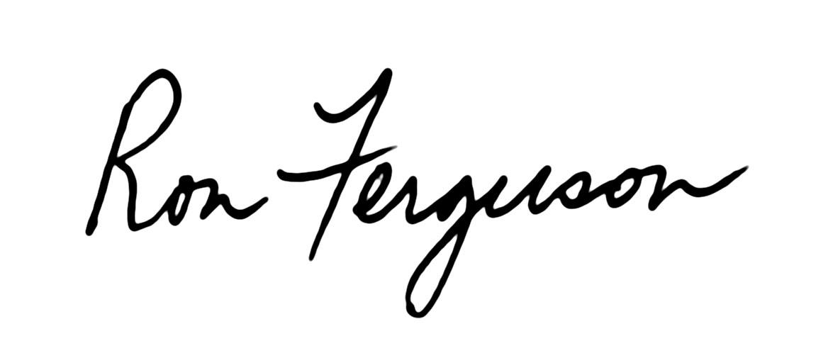
In peace,
Ron Ferguson
Clerk, FCNL General Committee
Pastor, Winchester Friends Church (IN)

