Quaker House
Residential
Community

Room available
starting August 2019
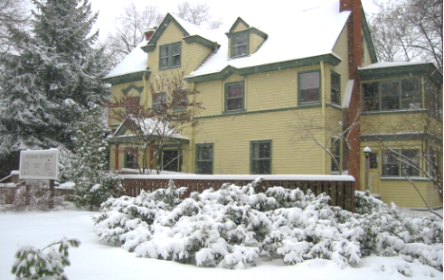

1416 Hill St.
Google “Quaker House Residential Community”

A small intentional community sharing a beautiful, six-bedroom house in downtown Ann Arbor.

We strive to embody our strong commitments to:
• Multi-cultural/racial/ethnic/LGBTQ inclusivity
• Simple, economical and environmentally friendly living
• Mature, stable and supportive relationships
• Open, forthright and honest communication
• Quaker principles of peace, social justice and respect for all
Quaker membership is not required. The house and grounds are smoke-free. No pets are allowed. Residents share cooking and cleaning responsibilities and regular attendance at house meetings; a monthly financial contribution is required. One-year minimum commitment preferred.

Contact the Resident Host: qhrc.contact@gmail.com
Quaker House
qhrc.contact@gmail.com

Quaker House
qhrc.contact@gmail.com
Quaker House
qhrc.contact@gmail.com
Quaker House
qhrc.contact@gmail.com
Quaker House
qhrc.contact@gmail.com
Quaker House
qhrc.contact@gmail.com

