Table of Contents

To go directly to a topic, click on it. If that does not work, try Ctrl+click. Otherwise, page down.

Minutes of Lake Erie Yearly Meeting

Annual Meeting

July 26 - July 29, 2018

Bluffton, Ohio
YM2018-01 Opening worship and epistle
YM2018-02 Introduction of the clerks table and roll call
YM2018-03 Welcoming visitors
YM2018-04 Acknowledgement of deceased Friends
YM2018-05 Epistle Committee
YM2018-06 Announcements
YM2018-07 Naming Committee
YM2018-08 Concern about sexual harassment
YM2018-09 Meeting Worker’s Report
YM2018-10 Concern about new Philadelphia YM Faith and Practice
YM2018-11 Worship and epistle
YM2018-12 Visitors and first-time attenders
YM2018-13 Nominating Committee Report (no. 1)
YM2018-14 Publications & Archives Committee Report
YM2018-15 Friends General Conference Report
YM2018-16 Peace & Justice Committee Report (no. 1)
YM2018-17 Worship and epistle
YM2018-18 Arrangements & Site announcements
YM2018-19 Naming Committee
YM2018-20 Adult & Family Program Committee Report
YM2018-21 Treasurer’s Report
YM2018-22 Finance Committee Report (no. 1)
YM2018-23 Worship and epistle
YM2018-24 Friends for Lesbian, Gay, Bisexual, Transgender, and Queer Concerns Report
YM2018-25 Children & Youth Committee Report
YM2018-26 Olney Friends School Report
YM2018-27 American Friends Service Committee Corporation Report
YM2018-28 Friends Committee on National Legislation Report
YM2018-29 Advancement & Outreach Committee Report
YM2018-30 Worship and epistle
YM2018-31 Earthcare Committee Report
YM2018-32 Ministry & Nurture Committee Report
YM2018-33 Spiritual Formation Program Report
YM2018-34 Ad Hoc Committee on Sexual Harassment
YM2018-35 Naming Committee Report
YM2018-36 Peace & Justice Committee Report (no. 2)
YM2018-37 Finance Committee Report (no. 2)
YM2018-38 Epistle Committee
YM2018-39 Nominating Committee Report (no. 2)
YM2018-40 Youth and Children Epistles
YM2018-41 Epistle
YM2018-42 Database Manager Report
YM2018-43 Appreciation
YM2018-44 Arrangements & Site

Minutes of Lake Erie Yearly Meeting

Annual Meeting

July 26 - July 29, 2018

Bluffton, Ohio
First Session: 7:30 – 9:00 pm, Thursday, July 26
YM2018-01 Opening worship and epistle
After a reminder that the land we are meeting on was originally the dwelling and hunting area of Six Nations and other indigenous peoples, we settled into open worship.
Mike Holaday, assistant clerk, read aloud an epistle from Great Plains Yearly Meeting 2018 Annual Sessions, a gathering encompassing a wide variety of spiritual approaches. Listening to and discerning leadings formed a focus of the gathering. Notable in this Yearly Meeting gathering was the presence of Lacina Onco, a Shinnecock and Kiowa Fellow with FCNL, who led several workshops addressing ways in which FCNL is focusing on programs affecting Indian welfare. Outreach and visitation was another strong concern reflected in session programs. Bible study reminded attenders that the Holy Spirit is available to all. Osage dancing and drumming formed part of the fellowship.
YM2018-02 Introduction of the clerks table and roll call
Nancy Reeves (Cleveland), clerk, introduced the clerks’ table: herself; Mike Holaday (Grand Rapids), assistant clerk; and Peter Wood (Red Cedar), recording clerk. She then invited attenders to identify themselves in a roll call.

Akron 2
Ann Arbor 18
Athens 15
Birmingham 6
Broadmead 16
Circleville Worship Group 0
Cleveland 7
Delaware 0
Detroit 4
Erie Worship Group 1
Grand Rapids 4
Granville 0
Holland 0
Indiana Worship Group 0
Kalamazoo 5
Kent 0
Manitou Worship Group 0
Mid-Ohio Valley 0
North Columbus 10
Oberlin 0
Pine River 0
Pittsburgh 14
Red Cedar 11
Somerset Worship Group 0
Tustin Worship Group 0
Waysmeet Worship Group 1
Wooster 1
Other/Unaffiliated 14
Total 129

Regular attenders who were absent this year were acknowledged: Flo Friender, Joyce and Phil Balderston, Joel and Sharon Ottenbreit, Valerie Groszmann, Richard Lee, Ruth Carey.
YM2018-03 Welcoming visitors
We welcomed visitors: Stephanie Crumley-Effinger, West Richmond Monthly Meeting, New Association of Friends, and Earlham School of Religion; Jerry Knutson, Orlando Monthly Meeting of Southeastern Yearly Meeting and Monongalia (West Virginia) Monthly Meeting of Baltimore Yearly Meeting; David Eley, Ohio Yearly Meeting and member of the Keystone Fellowship.
Nancy ready a traveling minute from Southeastern Yearly Meeting for Jerry Knutson.
YM2018-04 Acknowledgement of deceased Friends
Out of the silence, deceased Friends were named: Helen Horn (Athens), Rusty Sweitzer (Pittsburgh and Clear Creek), Art Wolfe (Ann Arbor), Fran Mendez (Grand Rapids), and Sue Leonard (longtime attender at North Columbus).
YM2018-05 Epistle Committee
We appointed Seth Reichenbach and Su Penn to join Mike Holaday (assistant clerk) on the Epistle Committee; Mike will clerk the committee.
YM2018-06 Announcements
Nancy Reeves, clerk, made several announcements:
- Announcements should be handed to the assistant clerk.
- Attenders are invited to “test drive” committees, especially Program, Ministry & Nurture, and Peace & Justice, which need members.
- We also will soon need a database manager, as well as a Meeting worker: consult with Mathilda Navias.
YM2018-07 Naming Committee
Nancy Taylor was approved to the Naming Committee. Another name will be brought forward later [see YM2018-35].
YM2018-08 Concern about sexual harassment
Jo Posti has raised the following concern: how to address sexual harassment among adult Friends, and the need to set policy regarding this. Jo is willing to convene an ad hoc committee to take up this concern. Claire Cohen volunteered to serve. We will continue to keep open the invitation to serve on this committee. (See YM2018-34.)
YM2018-09 Meeting Worker’s Report
Mathilda Navias reported that she spent three quarters of the time budgeted attending to a variety of tasks. Subscriptions to the website allow news posts to be automatically emailed to subscribers. There are 103 subscribers. Mathilda outlined the kinds of information that can be found on the website. Hits to the website come from all over the world. Mathilda also outlined the sorts of skills a Meeting worker will need. The time budget is at 100 hours a year. Some years the work is under this amount, some years over.
The full report follows.
Report from Mathilda Navias, LEYM Worker
July 2017 – June 2018
This year has gone fairly smoothly, and I have spent only about three-quarters of the time budgeted. As usual, maintaining and posting news to the website has taken the bulk of my time – about 40%. Maintaining the listservs and email accounts for Yearly Meeting officers has taken about another 30%. A little under 20% has been spent on administrative tasks like writing reports. Other tasks I have worked on are: updating the online registration for the 2018 Annual Sessions; formatting and uploading LEYM minutes to the website; vetting youth workers for Annual Sessions; and updating the Policies and Procedures manual. You can get the updated Policies and Procedures on LEYM’s website.
(Would Friends who are currently subscribed to the Yearly Meeting website please raise your hands?) When you subscribe, all news posts are emailed to you. There are few enough of these that they don’t get annoying, and it’s easy to do. Just follow the directions in the upper left corner of the Home page. Currently, 103 Friends are subscribed, about 10 more than last year.
Here is a chart showing the number of views and visitors to LEYM’s website since its beginning in 2013. Overall, it’s been pretty steady, with 8000 to 9000 views and 2500 to 3500 visitors each year. This year shows fewer because we are only three-quarters of the way through 2018.

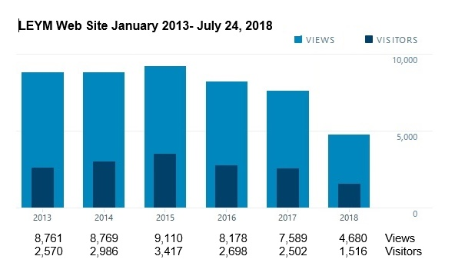

The most visited pages of the website include: the Home page, Annual Sessions, Meetings & Worship Groups, LEYM Bulletins, About LEYM, LEYM Contact Information, the Policies and Procedures Manual, and Spiritual Formation Retreats. Surprisingly, people who visit the website come from all over the world. While the vast majority are from the United States, we also get people from Canada, Europe, India, Australia, and China. People who live in 37 additional countries around the world have visited, including from former Russian provinces, South America, the Orient, and Africa.
We had some problems this year with online registrations for Annual Sessions not reaching the registrar, but got those resolved, so Sally received at least the names of everyone who registered online. I am working with technical support from the software vendor to figure out what went wrong, so it doesn’t happen again.
I am looking into changing the LEYM officers’ email accounts from Gmail to a different utility that will allow users to log in with just the email address and password. Gmail has started making people answer security questions if they log in from a different computer from mine, which has caused people delays in getting access to their emails.
The tasks I have performed during the 2017–2018 year are detailed below.
LEYM Website 30:59 hours (30.98) (41%)
Do annual updates following Yearly Meeting
Post Bulletins
Post news of interest to LEYM Friends
Maintenance
Listservs (Exec. Cmt., MM Clerks, MM Reps, GPQM) & Gmail 22 hours (29%)
Annual updates of lists following Yearly Meeting
Forward messages to lists
Maintain & update
Maintain Gmail accounts for officers
Administration (emails, prepare reports, misc.) 11:44 hours (11.73) (17%)
Other:
- Update online registration for 2018 Annual Sessions 4:41 hours (4.68) (6%)
- Format & upload minutes 3:23 hours (3.38) (4%)
- Update Policies and Procedures 0:55 hours (0.92) (2%)
- Vet youth workers for Annual Sessions 0:25 hours (0.42) (1%)
Total: 75:12 hours (75.2)
Total budgeted for year: $2000 for 100 hours of work.
YM2018-10 Concern about new Philadelphia YM Faith and Practice
A Friend raised a concern about the new Philadelphia Yearly Meeting Faith and Practice. Our Yearly Meeting recommends this Faith and Practice (among others) in its Policies and Procedures, since LEYM does not have its own Faith and Practice. Such a concern might need to be seasoned in more than one committee. Suggestions entertained were to assign the discernment task to individual monthly meetings, to create our own Faith and Practice, to have the Yearly Meeting as a whole take up the concerns about the Philadelphia Yearly Meeting Faith and Practice to help inform member monthly meetings, or to have Representative Meeting outline and take up the concerns. We are reminded that we can address not only what we critique, but also what we want.
The sense of the meeting is to have Representative Meeting take up the concern, with Marvin Barnes (Birmingham) presenting his specific concerns in writing in advance so that they can be seasoned. Marvin will give his document to the Executive Committee meeting at the end of these sessions, but have an outline available by Saturday afternoon.
Representative Meeting has not been truly representative in recent years because of the number of meetings that don’t send representatives. It was suggested that we actively reach out to meetings to ask them to appoint representatives and see that they attend. Suggestion: When we invite representatives, send them the agenda.
Second Session: 11:00 am – 12:30 pm, Friday, July 27, 2018
YM2018-11 Worship and epistle
The assistant clerk read the epistle from Southeastern Yearly Meeting, held in March 2018 in Florida. The gathering was focused on an experiential presentation on “roots of injustice” in the experience of native peoples in North America. The Doctrine of Discovery was formally repudiated by the SEYM gathering. This was followed by a presentation on how injustice has been addressed in Ramallah on the West Bank, and how we as Quakers can address violence and oppression. A minute on repudiating gun violence was approved by that meeting.
This Epistle, and all Epistles read at these sessions, can be found on the FWCC website.
YM2018-12 Visitors and first-time attenders
New visitors introduced themselves:
- Mary Comfort Ferrell, representing Friends Committee on National Legislation. The clerk read a letter of introduction from FCNL.
- Lily Rockwell, Ohio Yearly Meeting Conservative. The clerk read a letter of introduction from Ohio Yearly Meeting.
- Melissa Stoner, representing the American Friends Service Committee.
First-time attenders introduced themselves: Heather Paris and son Grady Buehler (Red Cedar); Kathie Hollingshead and son John Irv Hollingshead (Pittsburgh); Ally Day (Broadmead); Susan and Bob Towner-Larson (North Columbus); Carolyn Holland and son Marcos Carbary (Ann Arbor); Robert Berardi (Athens); Grace Anne Gasperson (Athens); and Ann Kangas (North Columbus).
YM2018-13 Nominating Committee Report (no. 1)
Clémence Ravaçon-Mershon, Nominating clerk, observed that we need volunteers to fill 90 positions, and the usual adult attendance at LEYM summer sessions is also about 90. Vacant positions exist in the following committees: Advancement & Outreach, Peace & Justice, Publications & Archives, Finance, Adult & Family Program, and Arrangements & Site (a technical person); we also need representatives to AFSC and FGC Central Committee. Friends are encouraged to approach the Nominating Committee members: Clémence Ravaçon-Mershon, Bill Warters, Linda Mills, Janet Dando, Jo Steigerwald, and Ellerie Brownfain.
YM2018-14 Publications & Archives Committee Report
Bill Lefler, Committee clerk, reported. Members include Bob Roehm and Seth Reichenbach, with ex-officio members Jeff Cooper, Peggy Daub, and Mathilda Navias. The Bulletin is being sent out in paper form, which is expensive; it is also produced in a variety of electronic forms to be more economical. Paper copies go only to individuals requesting them and to Monthly Meetings and worship groups. Annual Records is still produced yearly in hard copy, but not online. Submissions for the Annual Records need to go to Jeff Cooper by September 4, 2018. There is an October 1 deadline for Fall Bulletin submissions.
The Committee has examined the possibility of publishing memorial minutes on the website. Other yearly meetings have this practice, and descendants seem comfortable with it. The Meeting approved the publication of future memorial minutes on the website; publication of memorial minutes already received will need approval by monthly meetings. There was a suggestion that monthly meetings could benefit by having guidelines for the writing of memorial minutes.
The full report follows.
Publications & Archives Committee Report
The members of the Publications & Archives Committee this year are Bill Lefler, Seth Reichenbach, and Bob Roehm, with ex-officio members Bulletin editors Jeff Cooper and Peggy Daub, and LEYM worker Mathilda Navias.
We continue to distribute the Bulletin primarily in paper form, but during the past two years we have moved toward more electronic distribution. The cost of these paper copies has escalated due to printing and mailing expenses. We now offer the content in several ways, namely, an email with a link to the Bulletin page on leym.org, a pdf copy to your email, multiple paper copies sent to a monthly meeting, and a single paper copy to an individual’s address. The electronic method is of course more ecologically responsible. Please let us know which is best for you.
The Annual Records continues to be distributed in multiple hard copies to the monthly meetings, libraries, and archives. Submissions for the 2018 Annual Records are due by September 4. Jeff Cooper will serve as editor, with help from others on the committee. Annual Records submissions should be sent to Jeff at cooperdaub@hotmail.com. If your meeting is receiving more or fewer copies than you need, please let us know.
The Bulletin editors invite more content from our member meetings. This can include monthly meeting news and events, workshop reports, and meeting participation in local and regional special interest groups. The deadline for submissions for the Fall LEYM Bulletin is October 1; these may be sent to Jeff and Peggy at bulletinleym@gmail.com.
For the past year we have been studying whether we should publish memorial minutes on LEYM's website. These have already been published in the Annual Records. Questions were raised about privacy issues, so we checked with other yearly meetings and found that they do publish them either directly on their website or in their online Annual Meeting minutes. We also talked with a couple of descendants of our departed members and they were delighted.
Therefore:
Publications and Archives recommends publishing future memorial minutes online. In addition, we would like to add past minutes from the Annual Records.
Are we ready to proceed with publishing memorial minutes on LEYM's website or do we need to consult further with our monthly meetings?
YM2018-15 Friends General Conference Report
Carolyn Lejuste, LEYM representative to FGC, listed the names of LEYM representatives to FGC. FGC is in a serious financial position.
Highlights of last year include:
- Executive Committee has to balance the budget by 2020. That task is halfway accomplished.
- FGC has received a $50K grant to fund spiritual deepening e-retreats.
- Exploration of dynamic governance as a model for reorganizing Central Committee. This model encourages all voices to be heard.
- Institutional assessment on racism is in full swing. A report with recommendations will be submitted to Central Committee in October 2018.
Assistance in “digital training,” e.g., use of social media, is now available. A variety of other resources are also available through the FGC website.
FGC is interested in hearing from monthly meetings on how it can better serve them.
The FGC Gathering in Toledo seemed to have made some progress in addressing concerns of Friends of color.
The full report follows.
FGC Representative Report to Lake Erie Yearly Meeting 2018
Representatives: Robb Yurisko, Sally Weaver Sommer, Carolyn Lejuste, Claire Cohen. Also serving FGC: Mathilda Navias, FGC Recording Clerk, and Marvin Barnes, Assistant Clerk.
The general tone is that FGC is in a very serious financial situation. We have, for a number of years, drawn from our unrestricted fund to cover shortfalls. If major changes are not undertaken with our current budget and structure, we risk running out of money within the next four years.
With that caution, here follows a list of highlights of the last year.
- Executive Committee has been charged with the task of balancing the budget by 2020.
- We recently received a $50,000 grant to support Spiritual Deepening E-Retreats.
- A process of reorganization of Central Committee. One model is called Dynamic Governance, which encourages all voices to be heard.
- Institutional Assessment on Systemic Racism is in full working mode and will submit a final report to CC in October.
FGC is currently training a cohort on digital outreach training, including developing a social media presence and local Facebook ads. Information regarding a September cohort can be found on the FGC website at https://www.fgcquaker.org/digital-outreach-opportunity-quaker-meetings.
FGC is moving toward building better relationships with yearly meetings, especially the smaller meetings. Therefore, it welcomes requests from both yearly meetings and monthly meetings in ways it can better serve us. We all are encouraged to use the current resources on the website.
The recent gathering in Toledo was highly successful. The Gathering was housed in an urban environment for the first time in many years. Our Friends of Color report appreciation of sharing a campus with other people of color (students and local community). We are not finished with identifying our unexamined racism but the 2018 Gathering was a start. A shout out to LEYM Planning Committee.
YM2018-16 Peace & Justice Committee Report (no. 1)
Co-clerk Shelley Kotz reported. The results of a survey of what monthly meetings and worship groups are doing in the area of peace and justice are summarized in a display at this gathering. Resources in peace and justice work can be shared and found on the LEYM website.
Instead of developing a minute on immigration, the Committee is working to provide resources. The New York Declaration for Refugees and Migrants is especially valuable.
A just and sustainable economy is another concern being addressed through a proposal available on the website for monthly meetings to use in their own discernment.
The Executive Committee has charged the Peace & Justice Committee with looking for ways to acknowledge the lands that have been taken from indigenous peoples.
Peace & Justice is proposing a minute on nuclear weapons. Nancy Taylor read aloud the proposed minute, based on the Ann Arbor minute in support of a treaty developed in the United Nations. Action on this proposed minute will be taken at a future session.
A full report follows.
Peace & Justice Committee Report
July 27, 2018
The primary work of the Committee during the last year was a survey of what monthly meetings and worship groups in LEYM are doing in the area of peace and justice. The survey was available on the internet; meetings that did not do the survey online were contacted by phone. Twelve meetings in all responded to the survey. The results of the survey were summarized and are on display upstairs in the loft.
The final question of the survey asked what input from the Peace & Justice Committee of Lake Erie Yearly Meeting monthly meetings and worship groups would like to have. Many of the responses indicated that meetings would like more information on how other meetings address topics. They are interested in the nuts and bolts of actions taken: if a retreat was held on a given topic, what specific topics were addressed, who was the presenter, what kind of materials or activities were used? If queries on a topic were used, what were they? How do community collaborations come about? These are the kind of details that will help other meetings in their own actions to address concerns.
All of these can be shared with other meetings by way of the LEYM website, which has a section for Peace & Justice resources. The Peace & Justice Committee will consider ways to make meetings and worship groups aware of this resource, and to encourage them to share information from their meetings.
The Peace & Justice Committee discussed proposing a minute on immigration. Due to the wide reach of the topic, the constantly changing situation both in the United States and in other parts of the world, and the sparse Committee attendance at this year’s Annual Sessions, we decided that for now we will share some of the resources we have been using; these will be available on the LEYM website, under the “Resources” heading. Of particular value is the New York Declaration for Refugees and Migrants, a statement that resulted from the United Nations Summit for Refugees and Migrants in 2016, as well as ongoing information from the United Nations in their work to establish an international compact of refugees and migrants. Other resources include minutes from various monthly meetings on the topic of immigration.
The Peace & Justice Committee encourages all meetings and worship groups to continue their concern for issues surrounding immigration, to study and take action, and to share their activities with all of us.
Ann Arbor Meeting has brought forward a concern regarding nuclear weapons and is proposing a minute on the topic. The minute and supporting material are attached (see Minute YM2018-36). If approved, this minute will be distributed to other yearly meetings; monthly meetings are also encouraged to share the minute with their local community and newspapers.
The Committee has received a proposal for studying the priorities for establishing a just and sustainable economy. The proposal addresses the problems of sustaining life within the limits of a planet with finite resources. It was developed as part of a Summer Research Seminar of the Quaker Institute for the Future (quakerinstitute.org) and is intended for use by monthly meetings in considering input to the Friends Committee on National Legislation. The proposal will be avail-able on the website; we encourage meetings to read this information and use it for their own exploration of these concerns.
The Executive Committee has asked Peace & Justice to consider ways in which Lake Erie Yearly Meeting can acknowledge and honor the native peoples who previously lived on this land. The Committee will be considering this matter in the coming year.
Third Session: 1:45 – 3:15 pm, Friday, July 27, 2018
YM2018-17 Worship and epistle
The assistant clerk read the Epistle from the gathering of Friends Association for Higher Education, held at Wilmington College on June 14–17, 2018; the theme was “Keeping Faithful in a Time of Rapid Change.” Issues of class and homelessness were explored. Attenders were challenged to be authentic and vital and to welcome transformative experience. Idols such as technology and personal comfort must be relinquished in favor of the beloved community. We must be both custodians and critics of culture, emphasizing the power of the positive in addressing idolatry.
YM2018-18 Arrangements & Site announcements
Sally Weaver Sommer reported. The Arrangements & Site Committee is seeking to make meals greener by reducing paper use through provision of cloth napkins, composting uneaten food, which can be put in buckets provided in the cafeteria, and cutting back on the amount of meat provided. Feedback is welcome on these efforts.
YM2018-19 Naming Committee
The clerk proposed that Erika Smith be added to the Naming Committee, to serve with Nancy Taylor. This name was approved.
YM2018-20 Adult & Family Program Committee Report
Claire Cohen, Committee clerk, started by introducing and thanking current Committee members for their stellar service.
This year’s theme is “Building the Beloved Community: Who Is my Neighbor?” Our plenary speaker is Yvette Shipman. Once again, this year the talent show will rock. Solicitations for next year’s theme are sought. The Committee wishes to raise the budget for the honorarium for the plenary speaker. Bible study is back; its leader receives the same honorarium as workshop leaders.
Raising the honorarium budget for the plenary speaker from $400 to $500 was approved.
YM2018-21 Treasurer’s Report
Treasurer Mike Hinshaw reported.
Receipts: Meeting contributions amounted to $16,531. Two meetings sent contributions too late to be counted in this year’s receipts, amounting to about $4600. They will be added to next year’s income.
Expenses: The total amount spent was $21,551.98. Representatives to organizations are encouraged to submit their expenses. An unusually large amount was budgeted to support travel this year to the FGC Gathering and the White Privilege Conference. Most of the budgeted amount in this line item was spent. Youth and children funds are very actively used, as is the spiritual formation fund. Some funds are over their ceilings.
Assets: Present assets amount to $69,561.77.
The full report appears below.

Treasurer’s Report
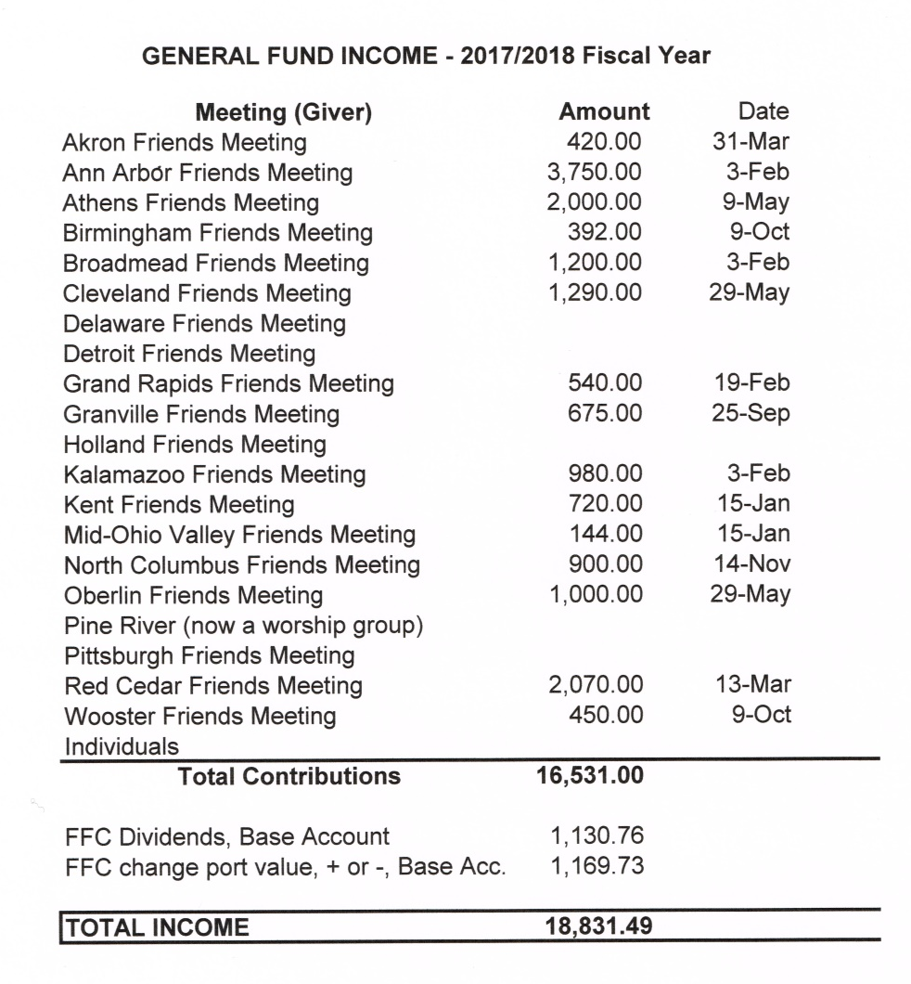

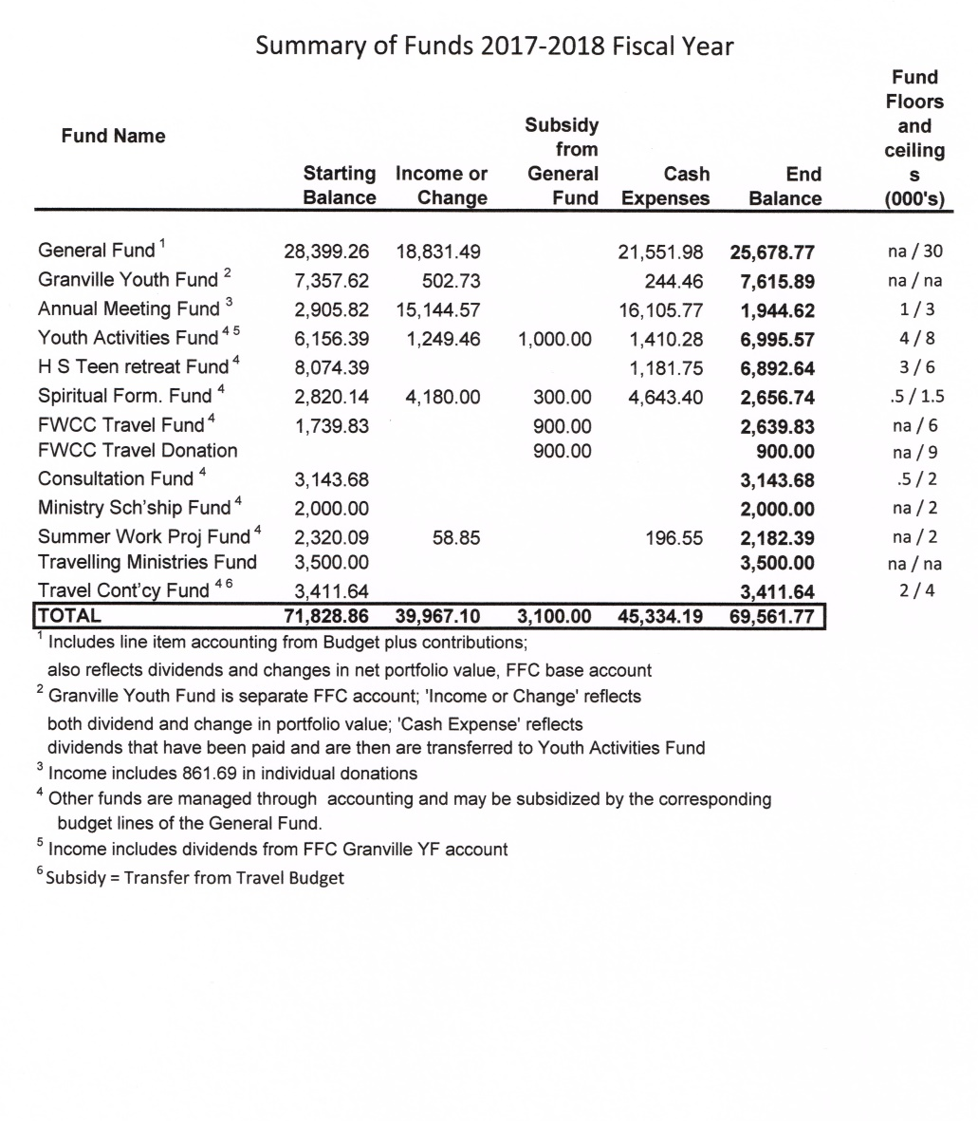

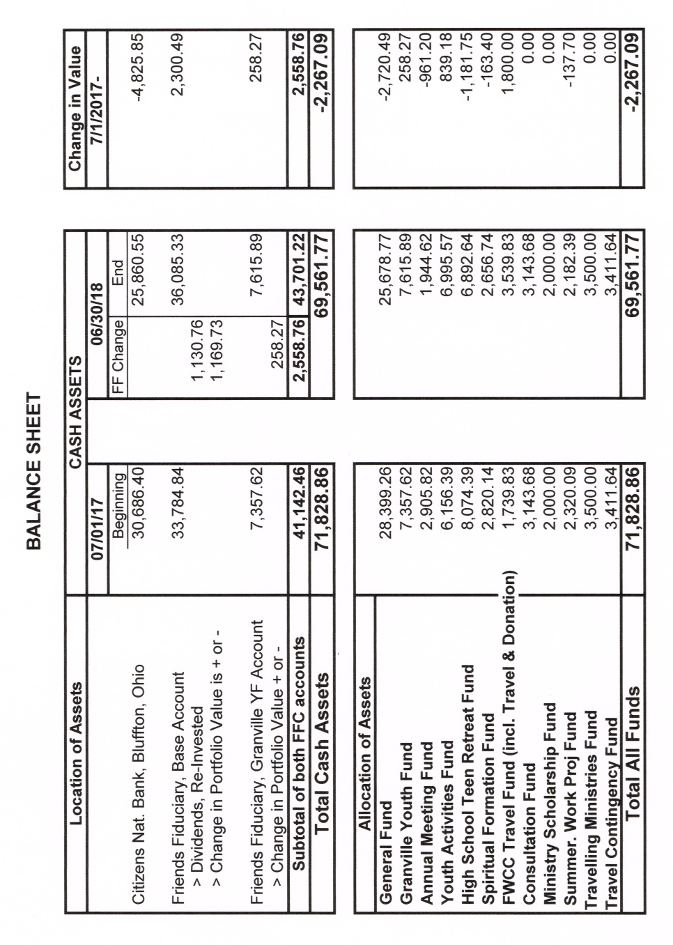
YM2018-22 Finance Committee Report (no. 1)
Joe Mills, Committee clerk, outlined the proposed budget of $22,050 for next year, explaining the rationale for some changes from last year’s budget.
The Finance Committee made several recommendations: eliminate the travel contingency fund; create a new line item for attendance at conferences compatible with Quaker values; combine several line items into one line item to cover administrative needs. The mileage reimbursement will remain the same (45¢ per mile) but may need review in instances when the mileage exceeds 500 miles.
The report appears below.
A suggestion was made to support the Quaker legacy by supporting Quaker education through contributions to Quaker colleges such as Earlham or scholarships to Quaker educational institutions. Concern was also raised
about the financial needs of FGC, in thinking about how we allocate our contributions. Friends with budgetary concerns or ideas should approach Finance Committee as it formulates its final budget.
Report of Finance Committee
7/27/2018
The Committee recommends the following changes to the Yearly Meeting’s budgetary structure to promote simplicity without sacrificing meaningful detail:
- Eliminating the Travel Contingency Fund. This has been rarely used and all travel expenses can be handled through the budget line without a supporting fund. The treasurer can pay in excess of budget in consultation with the clerk or Finance Committee.
- Establishing a line item without a supporting fund for Conference Attendance. This would be for conferences such as White Privilege, conferences sponsored by Friends organizations, and others in keeping with Quaker testimonies and values.
- Combining budget line items for Clerk’s Fund, Office, and Finance into one line item titled “Administration.”
The mileage reimbursement remains at 45¢ per mile. Reimbursement for over 500 miles should be reviewed and approved by the Finance Committee.
A request for support of a Friends organization was received. The policy of the Yearly Meeting is to support only FGC, of which the Yearly Meeting is an organizational member, and rely on monthly meetings and individual Friends to support other Friends organizations.
Fourth Session: 9:45 – 11:45 am, Saturday, July 28, 2018
YM2018-23 Worship and epistle
After a period of open worship, the clerk read the Epistle from the FLGBTQC gathering, held at Toledo, Ohio, during the 2018 FGC gathering.
YM2018-24 Friends for Lesbian, Gay, Bisexual, Transgender, and Queer Concerns Report
Nancy Reeves, LEYM representative to FLGBTQC, outlined its history. It has found increased difficulty in filling committee roles, leading to a reduction in duties of the group. The group processed and mourned feelings of loss of its traditional functions and energy. The group cherishes its legacy, citing the many contributions of members of FLGBTQC to the Religious Society of Friends, and values recent developments in society. Its future, however, is unclear.
YM2018-25 Children & Youth Committee Report
Greg Mott, Committee clerk, reported. The 2017 fall youth retreat was filled with fun and fellowship, with educational moments at the Balderston farm, and with worship. Registration for the 2018 fall youth retreat is open for K–12 youth. The retreat will be held at Templed Hills, Ohio.
Twenty-nine children are attending this year’s gathering. Children investigated houses of worship in LEYM by asking adults to identify pictures of them.
The full report follows.
Children & Youth Committee
July 28, 2018
It is my pleasure to report on an exciting year for the Children & Youth Committee. Our first event occurred from September 29 to October 1 of 2017 as 13 youth and 7 adults gathered at Pilgrim Hills in Brinkhaven, Ohio, for our annual fall youth retreat. The weekend was full of silkscreening, hiking, Ga-Ga ball, and, most importantly, fellowship. One highlight of the weekend was our visit to the Balderston farm, where we were treated to a lesson in identifying different types of wood and soil, followed by a nice hike through the woods with a few moments of silence atop a large rock surrounded by trees. We concluded the weekend with a Sunday morning worship beside a small pond. We are thankful for the financial support from LEYM, which helps make the retreat possible. Registration for the fall 2018 retreat has begun, and the weekend is set for September 28–30. This year, it will be held at Templed Hills, in Bellville, Ohio. Registration forms can be found at the LEYM registration table, or by contacting Diane Mott. At the April 2018 Executive Committee meeting, a motion was approved to allow the youth retreat to expand from K–8 to K–12.
Currently, we are enjoying the company of 29 youth, including 6 who were not in the program last year. Their ages range from 18 months old to 18 years old. The Meeting should know that it has a very talented and dynamic group of youngsters. I would like to thank the group leaders, the volunteer drivers, parents, and the LEYM support network that make the weekend special.
YM2018-26 Olney Friends School Report
Greg Mott, LEYM liaison to Olney, reported on the degree of financial risk facing Olney. Olney was able to address financial problems successfully enough to stay open this year. It has a new Director, Christian Acemah, starting August 1, 2018. Olney will work with a consulting firm to ensure continued viability.
The organic farm on campus is a central part of Olney, helping to provide part of the 40% of the campus food which is locally grown.
How to help Olney stay open and vital: Come visit, sponsor a workshop or class, contribute to the annual fund, and give word of mouth.
The full report follows.
Olney Friends School Report
July 28, 2018
On February 10, 2018, Olney Friends School sent a mass email to its alumni and friends that began with the statement “Olney Friends School is at risk.” A variety of financial concerns have led to a time of desperation: Raise $250,000 by March 30, or close the school in fall.”
This gave the Olney community a little more than one and a half months to raise this money.
The sources of the financial crisis are many: The recession negatively impacted the last major funding campaign, financial aid is over-distributed, and refusing to sell mineral rights to fracking companies is a missed source of income, but preserves the integrity of Olney’s commitment to creating a healthy world.
Despite the ongoing concerns and challenges, I am pleased to report that Olney has already raised $360,000, and has announced it will remain open in 2018-2019, its 181st year. Several steps are being taken to address its financial concerns, including a reduction of administrative staff and possibly combining the students into one dorm.
The Olney board has hired Christian Acemah as head of school. Christian is an Olney Alumnus. He is a former Director of the Uganda National Academy of Sciences and has extensive work experience in university and non-profit organizations. His leadership for Olney begins August 1, 2018.
In addition to new leadership, the school has engaged the services of EMD Consulting, who specialize in working with nonprofits to improve their develop-ment and business models.
The farm program at Olney continues to be key to its identity. It remains the only USDA-certified organic campus in the nation. The farm has 52 beef cattle, 8 goats, 150 laying chickens, 800 meat chickens, 2 beehives (looking to add 5 more), and the occasional pig. Olney also grows hay, fruit, numerous vegetables, and herbs. The school derives 40% of its food from the farm and local area, aided in part by the 28,500 eggs gathered from the chickens.
How LEYM can help:
- Come visit
- Sponsor a workshop or a class
- Contribute to the Annual Fund
- Word of mouth is still the most effective recruitment for Olney. Help spread the word.
- Please keep Olney Friends School in your prayers, and offer assistance as you feel led.
YM2018-27 American Friends Service Committee Corporation Report
Claire Cohen, an LEYM representative to AFSC, reported on the AFSC Corporation meeting held in Philadelphia this year. AFSC has a new Director, Joyce Ajlouny. Immigration concerns were at the forefront of the plenary speech, as well as being a central concern of AFSC because of the current political climate. AFSC has gone through a painful downsizing, but is now in a stable financial state, though it has approved a deficit budget for the coming year in order not to cut programs. It remains vital, with 60 varied programs in the U.S. and worldwide.
AFSC supports the abolition of Immigration and Customs Enforcement (ICE).
A current aim is to strengthen relationships with monthly meetings. A strategic planning process is underway to reassess goals and structure as AFSC enters its second century.
Melissa Stoner, visiting AFSC representative, gave a report on some of the programs important to the Midwest region: immigration concerns, youth work, ending discrimination, addressing the school to prison pipeline, and mass incarceration. The Dayton office has been focusing on African refugees.
YM2018-28 Friends Committee on National Legislation Report
John Howell, an LEYM representative to FCNL, listed the other LEYM representatives: Nancy Reeves (at large), Al Connor, Richard Shaw, Jim Crowfoot, Michael Fuson, and David Snyder.
The aims of FCNL were reviewed, and we were reminded that FCNL de-pends for its direction on input from members of the Religious Society of Friends and monthly meetings. The Annual Meeting this fall will recommend FCNL priorities based on the input it has received.
“The World We Seek” capital campaign has been successfully completed, leading, among other things, to the creation of the Quaker Welcome Center, where common ground can be sought by people with political differences.
FCNL is quite successful in bringing youth into advocacy programs to establish ongoing relationships with local politicians and their aides. At this election time, it is important to speak to candidates, and FCNL has produced a pamphlet called “Questions for Candidates.”
FCNL staff visitor Mary Comfort Ferrell will be offering a workshop at this gathering and there will be an open table at dinner where she can talk over FCNL concerns with those interested.
It was noted that there will be a 75th anniversary celebration of FCNL this year; it is the oldest religious lobby organization in the U.S.
YM2018-29 Advancement & Outreach Committee Report
Mathilda Navias, Committee clerk, reported. A display called “Resources for Inclusiveness” is available at this gathering. It aims to help meetings to learn ways to be more welcoming to varieties of people, and suggests other resources. These resources are now or soon will be available on the website. Some QuakerSpeak videos appropriate for newcomers are also available through links on the website.
The Committee wishes to explore how to better use social media. Ideas for this should be addressed to Ellen Barnes.
Fifth Session: 1:30 – 3:30 pm, Saturday, July 28, 2018
YM2018-30 Worship and epistle
After a period of open worship, the assistant clerk read the Epistle from Britain Yearly Meeting, held in Coventry, England, on 29 July to August 5, 2017.
A consistent recent theme at BYM has been “Living Out our Faith in the World – how we work with others to make a difference in the world.” How do bonds form out of concern for the common good? We are increasingly and urgently aware of increased insecurity and environmental degradation, of injustice in the world. How do we respond?
Many examples come forth in our meeting of ways of addressing such issues as homelessness. We can focus on listening, both to others and to the Holy Spirit. This listening will lead us to right action in a variety of venues, small and large. Sometimes our simple presence may be enough.
As ever, in many ways, we are called to be instruments of change.
YM2018-31 Earthcare Committee Report
Phil Clampitt reported. Climatic problems are on the increase leading to increased suffering around the world. Phil read from an article titled “Is Earthcare a Quaker Value?” The answer to this question is clearly in the affirmative.
The full report follows.
Report of the Earthcare Committee
2018 Annual Sessions
As we enjoy a perfect, lovely summer day here in Northwest Ohio, we are mindful that in many places around the world the situation is less idyllic – floods, fires, drought, high temperatures, and water shortages are affecting millions. These situations will only become more widespread.
We urge Friends to consider ways we might help ease the suffering of those in need and to find joy in the small and large gifts we receive each day.
We wish to pass on the wisdom of the following two paragraphs of Shelley Tanenbaum’s article, “Is Earthcare a Quaker Value?” (published by Western Friend in 2018).
What are our assumptions about environmental concerns? Why isn’t this prioritized in our lives as much as our traditional “peace and justice work”?
We understand that climate change poses a mortal threat, but when do we start taking action? Why haven’t we? What needs to change in our assumptions, lifestyle, worship, and in our meetinghouses to embrace Earthcare as a core part of our faith and practice as a Friend?
Here is the good news. First of all, there is tremendous joy in embracing our oneness with the universe. We are made of stardust and the stars are us – how beautiful is that! Many of us find our deepest connection with Spirit when we are in nature. We are facing an existential crisis. We need to embrace as much spiritual guidance as we can get.
YM2018-32 Ministry & Nurture Committee Report
Carla Pratt-Harrington reported. Attendance at M&N meetings at this Annual Meeting threatened to be sparse because of many absences of regular members of the Committee, but many gathering attenders have stepped forward to help.
Thirteen monthly meetings and two worship groups sent in “State of the Meeting” reports. Several meetings report joy, hope, and vitality. But others report significant troubles due to aging and loss of members to death. Seekers and new attenders revitalize meetings. Many find refuge and nourishment in meeting activities. There is a rhythm like breathing which gives many a sense of the life in the Spirit. Dealing with change can be an opening to growth.
“State of the Meeting” reports are published in the Annual Records. Friends are encouraged to read them.
The annual query for meetings to consider in the coming year, developed in collaboration with the Earthcare Committee, will be:
As we face ongoing degradation of our planet and the general lack of political will to address this, we ask: What are the connections we experience between earthcare and our traditional Quaker concerns for peace and justice? How do we use spiritual guidance to respond with a sense of abundance and hope?
If you are called to travel in the ministry, supportive funds can be sought through M&N.
The full report follows.
Ministry & Nurture Report
July 28, 2018
Ministry & Nurture Committee met with only one co-clerk and one member this year during Annual Sessions. Other members of our committee have been experiencing health concerns and were unable to attend. We were grateful to have Lisa Klopfer step up and join us in reading State of the Meeting reports, drafting a summary, and considering queries. We also had help from Su Penn Dierauer, Eric Dierauer, and David Eley. Thank you to all for your mindful assistance.
Ministry & Nurture Committee received State of the Meeting reports from 13 monthly meetings and two worship groups. A few themes were common to many of these reports, although there was, of course, diversity among the meetings in the specific challenges, practices, and activities the reports described.
Several meetings described an experience of joy, hope, and vitality. Birmingham Monthly Meeting, for example, described the spiritual condition of the Meeting being on the upswing and named significant signs of this. Akron referred to their meeting as “small but vital” and other meetings described themselves as “vibrant.” There were significant struggles for many meetings in the past year and an ongo-ing awareness that we are an aging community. Several reports also mentioned deaths of members and the experience of grief resting heavy in many meetings. Despite this side of reality, we also heard in the Grand Rapids report about the “dedication and commitment of a core group of Friends,” and Red Cedar spoke about the efforts of their members that “provided the spiritual energy to support our Blessed Community.” Seekers, new attenders, and new members continue to enrich our Meetings.
A second theme we heard was that meetings are serving as places of refuge and rest for many. These are unsettling times. Meetings also described struggles specific to their own communities and situations. Meeting for worship has become even more a mainstay and treasure because of this. Several reports also described efforts to nourish community through increased fellowship activities, establishing Friendly Eights, and sharing spiritual journeys. Friends read books to educate themselves on various issues such as White privilege and spiritual life. Ann Arbor’s report used the metaphor of breath: “the rise and fall, expansion and contraction, the energy of the Spirit as it is expressed in organic life.” We turn to the meeting for refuge and comfort and, in turn, find energy to go into the world, following diverse leadings.
A third theme we discerned was that many meetings have experienced growth and spiritual deepening through experiences of struggle. Irritations can also function in us, as the Detroit report states, like “the softening and rounding of stones.” Unexpected and unwanted changes also bring unexpected growth and blessing. Learning to listen deeply and continuing loving one another are a great gift if we are able to persevere.
As always, we feel uplifted and educated by the opportunity to read these reports that provide a window into the life of the meetings. State of the Meeting reports are published in the Annual Records, and we encourage Friends to read them.
This year we had a suggestion from Earthcare Committee to work with them on a query. It was delightful to have a chance to overlap with another committee on our concerns and desires to do that which we are called to do. The following query is the result of this work and will be sent to meetings this fall to consider and to respond. May it be useful to your spiritual growth.
Query
As we face ongoing degradation of our planet and the general lack of political will to address this, we ask: What are the connections we experience between earthcare and our traditional Quaker concerns for peace and justice? How do we use spiritual guidance to respond with a sense of abundance and hope?
Traveling Ministry Fund
Funds for traveling are available for LEYM Friends traveling in a ministry that has been recognized by their monthly meeting and LEYM through a travel minute. Information is available on the LEYM website under “resources.”
YM2018-33 Spiritual Formation Program Report
Mathilda Navias, clerk of the Spiritual Formation Planning Committee, reported. The spiritual formation program is a semi-autonomous group under M&N. Sue Regen led two retreats on “Forgiveness as a Spiritual Practice.” Individual meetings held their own ongoing gatherings to deepen their exploration of this theme.
The theme for next year is “A Spiritual Spa.” Activities will help attenders center, relax, and be nurtured – exploring spirit/body connections. The fall retreat will be held September 7-9 at Adrian, Michigan; on May 4, 2019 a one-day retreat will be held at a place to be announced.
The full report follows.
LEYM Spiritual Formation Program
Report to LEYM Ministry & Nurture Committee
July 2018
The Past Year (2017-18)
LEYM’s Spiritual Formation Program held two retreats this year. Sue Regen gave a weekend workshop on “Forgiveness as a Spiritual Discipline” in September, and followed up on a Saturday in May hosted by Red Cedar Meeting. These were rich experiences. In between the retreats, groups of Friends in local meetings held regular gatherings for spiritual deepening.
The Upcoming Year (2018-19)
This coming year, we are offering something a bit different in light of the distressing times we are living through. For the September retreat, you are invited to relax and get grounded with a weekend of activities to both help you move to your spiritual center and to relax and pamper your body. You can deepen your spiritual life doing activities that help you center and that gently use your body to help reach a deep spiritual place. The weekend will be relaxing, varied, challenging, centering, and nurturing. Activities include body prayer, guided meditation, centering techniques, walking meditation, and mindful eating of chocolate. Overall, we’ll explore spirit-body connections.
A team of Friends will lead the exercises: Mathilda Navias (Broadmead), Kate Enger (Athens), Della Stanley-Green (Plainfield Meeting, Western Yearly Meeting), Aran Reinhart (Broadmead), and Ellerie Brownfain (Birmingham). [I have flyers & registration forms here and there are more upstairs in the display area. Please take a flyer with you and help get the word out to people at your meeting. Additional forms and information on the Spiritual Formation Program are available on the Yearly Meeting’s website.] Did I mention that there will be chocolate?
The fall retreat is scheduled for September 7-9 in Adrian, Michigan (close to Ann Arbor and Detroit). There will be a follow-up retreat on Saturday, May 4. We need a meeting to volunteer to host it.
Planning Committee
The committee that plans the program and the retreats currently consists of Mathilda Navias, clerk (Broadmead), Aran Reinhart (Broadmead), Rebecca Hatton (Ann Arbor), Ellerie Brownfain (Birmingham), and Olwen Pritchard (Broadmead). Mathilda will step down as clerk in May. We ask Ministry & Nurture to once again find one of their members to serve on the planning committee as liaison between our committee and M&N. We also encourage members of the Ministry & Nurture Committee to participate in the program.
YM2018-34 Ad Hoc Committee on Sexual Harassment
The clerk reported that Jo Steigerwald has agreed to serve on the ad hoc committee to address sexual harassment (see YM2018-08).
YM2018-35 Naming Committee Report
Nancy Taylor reported. The Naming Committee, comprised of Nancy and Erika Smith, brought forward two names for approval to serve on the Nominating Committee through 2021: Janet Dando and Mike Holaday.
Friends approved these appointments.
YM2018-36 Peace & Justice Committee Report (no. 2)
Shelley Kotz reported. The Peace & Justice Committee brought back for consideration a minute on nuclear disarmament (see below). Friends approved.
Minute Urging U.S. Support for the United Nations Treaty Banning Nuclear Weapons
Lake Erie Yearly Meeting (LEYM) of the Religious Society of Friends (Quakers) supports the United Nations Treaty on the Prohibition of Nuclear Weapons. We urge the United States to drop its opposition and ratify this legally-binding treaty and to persuade other nuclear-armed nations to do the same. We are deeply concerned about the catastrophic humanitarian consequences of an accidental or intentional nuclear strike, as well as the waste of economic and human resources on programs for the production, maintenance, and modernization of nuclear weapons. We believe that dialogue, trust-building, and enlightened leadership provide a more effective and responsible path to peace.
This minute was approved by Lake Erie Yearly Meeting at its Annual Sessions on July 28, 2018.
This minute would be distributed by the clerk to all meetings and to Nikki Haley (current U.S. Ambassador to the UN), and could be made available to news outlets.
A background statement appears below. It was recommended that this statement be included in communications with monthly meetings.
Background
Concerned about the slow pace of nuclear disarmament, the United Nations formally adopted a treaty banning nuclear weapons last year on July 17, 2017. (The text of the Treaty is available at www.icanw.org/ treaty-on-the-prohibition-of-nuclear-weapons/). The treaty was endorsed by 122 countries over strong opposition from the United States and all other nuclear-armed nations and their allies. The legally binding treaty would go into effect after ratification by at least 50 countries. Signatories must agree not to develop, test, manufacture, or possess nuclear weapons or threaten to use them or to allow any nuclear weapons to be stationed on their territory. The treaty does not affect the “inalienable right” of signatory nations to develop, research, produce, and/or use nuclear energy for non-military purposes.
YM2018-37 Finance Committee Report (no. 2)
Bob Orr reported. Yesterday’s report outlined the financial state of LEYM, as well as giving some suggestions for change as part of a proposed budget.
Recommendation to consider contributing to Quaker universities or colleges. The Finance Committee does not recommend this at this time, feeling it needs more discussion, and observing that there are no Quaker colleges in the LEYM catchment area.
Proposal to add a scholarship line item for LEYM members who wish to go to Quaker post-secondary educational institutions. The Committee recom-mends adopting this proposal, suggesting a $1000 line item to begin with. Criteria to select recipients remain to be worked out.
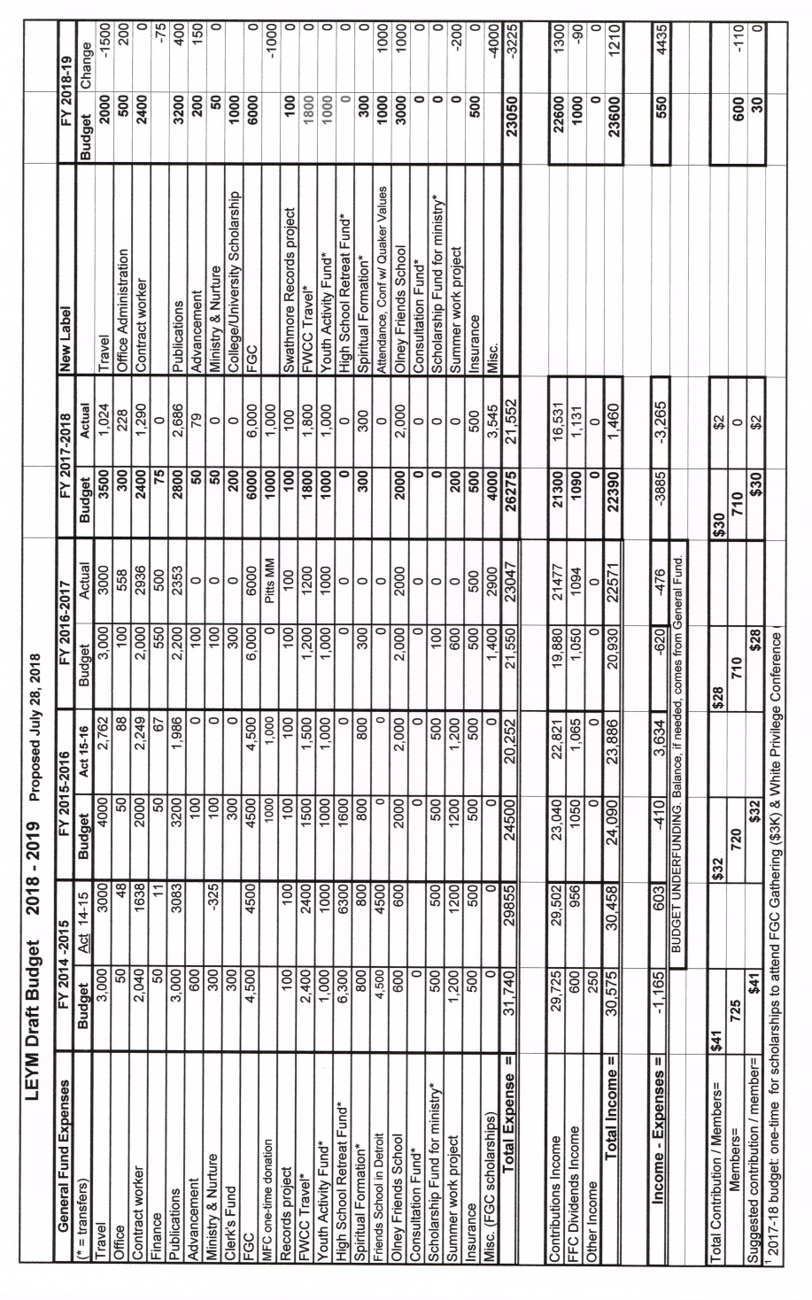
The Committee retains the proposal to have a $30 donation per meeting member to support LEYM activities.
Friends approved this budget, but without the $1000 contribution to Quaker universities or colleges. It was suggested that Executive Committee season the scholarship proposal and ultimately develop appropriate criteria for scholarship disbursement. Quaker-related activities and service might be an alternative use of the funds. Friends further asked EC to develop criteria for attendance at “Conferences with Quaker Values.”
Sixth Session: 8:45 – 9:30 am, Sunday, July 29, 2018
YM2018-38 Epistle Committee
Mike Holaday reported. Eric Dierauer was an active contributor to the Epistle Committee. Mike asked that his name be added to the Epistle Committee. The Meeting approved this addition.
YM2018-39 Nominating Committee Report (no. 2)
Clémence Ravaçon-Mershon reported, with assistance from Bill Warters. Clémence explained the format of the report, and outlined the clerks’ rotation.
The following vacancies remain: Database manager, Advancement & Outreach (1 person), Earthcare (young Friend), Peace &Justice (2 persons, including a clerk), Publications & Archives (1-2 persons), Adult & Family Program (2 persons), Youth & Children (assistant clerk), and LEYM Representatives to AFSC and to FGC Central Committee (1 person each). Some people have not yet been reached to see whether they will serve an additional term, and the Committee will continue to work at contacting them. They are also working to reach people not in attendance at these sessions as they seek to fill remaining roles.
The Meeting approved the names brought forward to serve LEYM at this time.

LEYM Officers, Committee Members, & Representatives

Approved 7-29-2018.
Terms begin and end at rise of Annual Sessions.
* Approved by Executive Committee after Annual Sessions
^ Serves on LEYM Executive Committee
Officers
Role Name & Meeting Year of Service End Year
Presiding Clerk ^ Nancy Reeves, Cleveland 2 2020
Assistant Clerk ^ Josephine Posti, Pittsburgh 1 2022
Recording Clerk ^ Peter Wood, Red Cedar 2 2020
Treasurer ^ Mike Hinshaw, Wooster 7 2019
Communications and Other Workers
Bulletin Editors Peggy Daub & Jeff Cooper, Ann Arbor 2 2020
Web Master Mathilda Navias, Broadmead 8 2019
Database Manager Mathilda Navias, Broadmead 14 2019
Bookstore TBD

Committees
Name & Meeting Year of Service End Year

Advancement & Outreach
# of Members: 6 Years of Term: 3
Erika Smith, Ann Arbor 6 2019
TBD 1 2019
Blair Ellis, Ann Arbor 2 2020
Sheila Johnson, Ann Arbor 2 2020
Ellen Barnes, Birmingham, Clerk ^ 4 2021
Kathie Hollingshead, Pittsburgh 1 2021

Earthcare
# of Members: 6 Years of Term: 3 Others interested welcome
Ken Lawrence, Broadmead 2 2019
Phil Balderston, Wooster 5 2019
Mey Hasbrook, Kalamazoo 2 2020
Richard Hogan, Athens 2 2020
Russ Adams, North Columbus, Clerk ^ 4 2021
Jonah Brownfain*, Birmingham 1 2021

Finance
# of Members: 3 Years of Term: 3
Joseph Mills, Kalamazoo, Clerk ^ 2 2020
Joann Neuroth, Red Cedar 1 2021
Seth Reichenbach 1 2021
Note: Treasurer serves ex officio

High School Teen Retreat (Committee is dormant)
3 adults with 3-year terms + 2 high schoolers with 2-year terms
Jenn Seif, Grand Rapids, Adult 3 2019

Ministry & Nurture
# of Members: 6 + 1 Rep. from each monthly meeting encouraged Years of Term: 3
Flo Friender, Kalamazoo, Co-Clerk ^ 6 2019
Ann Sprague, Detroit 3 2019
Carla Pratt-Harrington, Athens, Co-Clerk ^ 6 2020
Lisa Klopfer, Ann Arbor 1 2020
Shelley Kotz, Broadmead 1 2021
Rebecca Morehouse, Ann Arbor 1 2021

Nominating
# of Members: 6 (Appointed by YM through Naming Committee) Years of Term: 3
Ellerie Brownfain, Birmingham 3 2019
Bill Warters, Birmingham 3 2019
Clémence Ravaçon Mershon, Erie WG, Clerk ^ 5 2020
Jo Steigerwald, Cleveland 2 2020
Janet Dando, Akron 4 2021
Mike Holaday, Grand Rapids 1 2021

Peace & Justice
# of Members: 6 + 1 Rep. from each monthly meeting encouraged Years of Term: 3
Others interested welcome
Linda Beaty, Akron 3 2019
Helen Fox, Ann Arbor 2 2019
Joel Ottenbreit, Detroit, Clerk* 2 2020
TBD 1 2020
John Howell, Athens 1 2021
Nancy Taylor*, Ann Arbor 1 2021

Publications & Archives
# of Members: 4 Years of Term: 3
Bill Lefler, Pittsburgh, Clerk ^ 4 2019
Bob Roehm, North Columbus 2 2020
TBD 1 2020
TBD 1 2021
Note: Web Master and Bulletin Editors serve ex officio.

Yearly Meeting Planning:
Adult & Family Program
# of Members: 6 Years of Term: 3
Claire Cohen, Pittsburgh, Clerk ^ 6 2019
Aran Reinhart, Broadmead 2 2019
Susan Hartman, Ann Arbor 2 2020
Thomas Taylor, Ann Arbor 2 2020
Steve Morehouse*, Ann Arbor 1 2021
TBD 1 2021

Arrangements & Site
# of Members: 6 Years of Term: 3
Mary Igoe Meyers, Broadmead 3 2019
Sally Weaver Sommer, Broadmead Registrar 3 2019
John Templin, Broadmead 9 2019
Bill Warters, Birmingham 1 2019
Jon Sommer, Broadmead, Clerk ^ 15 2020
Olwen Pritchard, Broadmead 4 2021

Youth & Children’s Program
# of Members: 15 Years of Term: 2
Greg Mott, Broadmead, Clerk ^ 3 2019
Kate Enger*, Cleveland, Assistant Clerk 1 2019
Ellerie Brownfain, Birmingham
Stephanie Charlot, Red Cedar
Alfred Clapp III, Athens
Conleth Crotser, Cleveland
Peter Crowley, Cleveland
Diane Mott, Broadmead
Jenn Seif, Grand Rapids
Marc Smith, Ann Arbor
Kate Spry, Cleveland
Christa White*, Athens
Diane Mott, Broadmead, Fall retreat clerk
Ellerie Brownfain, Birmingham, Acting fall retreat assistant

Representatives to Other Quaker Organizations
Organization Name & Meeting Year of Service End Year

AFSC Corp Claire Cohen, Pittsburgh 4 2020
AFSC Corp Bill Warters, Birmingham 1 2021
AFSC Corp John Deikis*, Ann Arbor

FCNL Gen Cmte Jim Crowfoot, Ann Arbor 2 2019
FCNL Gen Cmte John Howell, Athens 2 2019
FCNL Gen Cmte Al Connor, Ann Arbor 2 2020
FCNL Gen Cmte Nancy Taylor*, Ann Arbor 1 2021
FCNL Gen Cmte Thomas Taylor*, Ann Arbor 1 2021
FCNL Gen Cmte David Snyder*, Oberlin 4 2021

FGC Cntl Cmte Robb Yurisko, N. Columbus 5 2020
FGC Cntl Cmte Sally Weaver Sommer, Broadmead 1 2021
FGC Cntl Cmte Marvin Barnes, Birmingham 1 2021
(LEYM Reps appoint Rep to FGC Executive Committee)

FWCC Sam Milford, Pittsburgh 3 2019
FWCC Jana Norlin, Grand Rapids 5 2019
FWCC Mey Hasbrook, Kalamazoo 3 2020

FLGBTQC Nancy Reeves, Cleveland 4 2019
Olney Friends School Ellerie Brownfain, Birmingham 1 2021
Q Earthcare Witness Russ Adams, N. Columbus 4 2021
Wm. Penn House Greg Mott, Broadmead 1 2021

Visitors to Neighboring Yearly Meetings
Yearly Meeting Name & Meeting Year of Service
EFI Eastern Region TBD 1
Ohio (Conservative) TBD 1
Ohio Valley (FGC) TBD 1
Wilmington (FUM) Alan Connor, Ann Arbor 9

* Approved by Executive Committee after Annual Sessions
YM2018-40 Youth and Children Epistles
Epistles were presented by the children and youth groups.
Epistle from the Toddler/Pre-schooler Group
We watched: band marching, flags twirling.
We listened: stories read, band playing, big kids rushing by.
We laughed: “This Little Piggie” caused fits of giggles and demands for “more!”
We ate: lots of grapes, sandwiches, animal crackers, and, of course, ice cream! Even for breakfast!
We learned: we took a nature walk and made prints on photo-reactive paper.
We were neighborly: We sang our “Hello, Neighbor” song, read “The Good Samaritan,” had snacks with the bigger kids; Zeke searched for (and found!) friend John Howell from his home meeting at every meal!
We shared: bubbles and ride-on scooters – our favorite toy – with the other children, and Zeke got to try one of the big-kid scooters.
We didn’t let being tired slow us down! We had fun!
Epistle from the Lower Elementary Program
We are the Lower Elementary Group of Lake Erie Yearly Meeting. We are kindergarten through third grade. We come from Athens, Bowling Green, Cleveland, and Columbus, all in Ohio. We talked about neighbors and decided that a neighbor is a person who lives by you. Snakes can be neighbors. Your mom and dad are neighbors, and anybody in your neighborhood and community are neighbors. We know that neighbors are people who appreciate and like you. While at LEYM, we had fun swimming, playing with friends, riding scooters, playing games in Bob’s Place, singing, sleeping, eating ice cream, playing games with Kate, and making stained glass windows. We liked being with each other.
Andrew Mott, Adrianna Clapp, Starr Clapp, Bradley Clapp, Matthew Vacheresse, Conleth Crotser, and Diane Mott
Epistle from the Middle Group, Grades 4-8
We hugged trees, rode scooters, played music, went swimming, played four square, went to the farmers market, and played with the little kids.
Popcorn Peter, Elisabeth Elephant, Amanda Panda, Jello Jesse, Dodge Douglas, YOLO Yev, Ethan Eagle, Finn Fish Filet, and Jen Hen.
Epistle from the High School Group
Written by Samantha Smith
Summary of our experience at LEYM 2018 in the teen program.
Thursday
Gabe
Arrived at the Bluffton college campus from long drives
We were very excited to meet with old friends again
Excited for the upcoming week
Alex
We were still settling in
Some of us walked down to the store to buy some snacks
Waited for others to arrive
Friday
Samantha
Had our first breakfast together
Played icebreaker games
Go to know each other better
Sophie
Ate our first lunch together, and it was delicious
Went to the pool, ate grapes and popcorn
Attempted to get the water slide to work (Alex succeeded)
Brianna
Played tag
Attended the plenary
Got the chance to see Mars!
Saturday
Jonah
Blind dates with trees (activity):
- Grace Anne and Noah blinded us with bandanas and took each of us to our own tree
- The bandanas were removed, and we had to find the tree we were assigned to
Carl
Bought a pint of cherries, some ripe peaches, and pizza to share in the lounge from the farmer’s market
Micah
Bought a little too much food, and didn’t eat all of it
Went to dollar store and thrift store
Jayson
Unfortunately, we didn’t enjoy the new lake as much as the old one; no dock, had a tiny slide, etc.
Skylar
After dinner, we had an all-night party – it was a blast!
YM2018-41 Epistle
Mike Holaday, assistant clerk, read the LEYM Epistle. Friends made suggestions for revision or addition before the final version was approved with deep gratitude.
YM2018-42 Database Manager Report
Mathilda Navias requested and the Meeting gave approval for the database manager to get updated information on members and attenders in order to bring the LEYM database up to date.
YM2018-43 Appreciation
LEYM attenders expressed appreciation to Bluffton University for its hos-pitality, friendliness of staff, and welcoming atmosphere.
YM2018-44 Arrangements & Site
Jon Sommer, Committee clerk, reported. 129 people attended the Annual Meeting, including 29 young people from 18 months to 18 years and 5 young adult Friends.
A fully functioning online registration system is still a work in progress.
Next year’s Annual Meeting is scheduled for July 25-28, 2019. Construction on campus will be in progress at that time. 2020’s Annual Meeting is scheduled for July 30 to August 2.
Attenders are reminded to fill in paper evaluations. Online versions may be available in future years.
Nancy Reeves, Presiding Clerk
Peter Wood, Recording Clerk

