Table of Contents

To go directly to a topic, click on it. If that does not work, try Ctrl+click. Otherwise, page down.

Minutes of Lake Erie Yearly Meeting

Representative Meeting

April 1, 2017

Kalamazoo Monthly Meeting

RM2017-01 Worship
RM2017-02 Roll Call
RM 2017-03 Clerk’s Announcements
RM 2017-04 Pittsburgh Monthly Meeting Request
RM 2017-05 FGC Institutional Racism Assessment
RM2017-06 Meeting Worker’s Report
RM2017-07 Treasurer’s Report
RM2017-08 Finance Committee Report
RM2017-09 Ministry & Nurture Committee Report
RM2017-10 Earthcare Committee Report
RM2017-11 Publications & Archives Committee Report
RM2017-12 Peace & Justice Committee Report
RM2017-13 Advancement & Outreach Committee Report
RM2017-14 Nominating Committee Report
RM2017-15 Adult &Family Program Committee
RM2017-16 Children & Youth Program Committee Report
RM2017-17 Arrangements & Site Committee Report
RM2017-18 Minute of Appreciation

Minutes of Lake Erie Yearly Meeting

Representative Meeting

April 1, 2017

Kalamazoo Monthly Meeting

RM2017-01 Worship
Representative Meeting opened with a period of open worship near the appointed hour of 1:15 pm. Clerk Mike Holaday welcomed Friends and requested the roll call.
RM2017-02 Roll Call

Akron 2
Ann Arbor 5
Athens 2
Birmingham 4
Broadmead 11
Chelsea Allowed Mtg. 0
Circleville Worship Group 0
Cleveland 3
Delaware 0
Detroit 2
Erie Worship Group 1
Fremont Worship Group 0
Grand Rapids 3
Granville 0
Holland 0
Indiana Worship Group 0
Kalamazoo 7
Kent 0
Manitou Worship Group 0
Mid-Ohio Valley 0
North Columbus 2
Oberlin 1
Pine River 0
Pittsburgh 2
Red Cedar 0
Somerset Worship Group 0
Tustin Worship Group 0
Waysmeet Worship Group 0
Wooster 3
Total 48

RM 2017-03 Clerk’s Announcements
The clerk announced the LEYM ad hoc Committee on Racial Justice, formed at the direction of LEYM at our 2016 Annual Sessions. The Committee consists of Marvin Barnes and Carolyn Lejuste. The Committee will be inviting our Monthly Meetings to join in this work in our lives, our meetings, and our communities.
Friends General Conference has selected Toledo as the site of the 2018 Gathering of Friends. There will be many opportunities for service in connection with their presence within our region.
The debt that was incurred by a teacher in Friends School in Detroit has been liquidated as a result of contributions by many individuals and Meetings.
LEYM will sponsor a service project just before our Annual Sessions at the Habitat ReStore in Lima, Ohio. Please let Olwen Pritchard or Peggy Daub know if you are interested in participating.
A reprint of the LEYM Advices and Queries is available. The document is also available online.
RM 2017-04 Pittsburgh Monthly Meeting Request
We have received a request from Pittsburgh Monthly Meeting to assist in work they are undertaking to make their Meeting House accessible. Pittsburgh Meeting has been in discernment for a number of years to determine how to move forward. The Meeting House is a center for activity in Pittsburgh and is used by hundreds of people each week, but cannot currently meet the needs of some local organizations because it is not physically accessible to all. The upgrade will cost approximately $1 million. The majority of the funding will come from private contributions by members, supplemented by a relatively small bank loan.
Although we have not supported renovations undertaken by individual Monthly Meetings before, we did give $1000 for the renovation of the Michigan Friends Center in Chelsea, a site that similarly has broad community use.
Friends approved a gift of $1000 to the Pittsburgh Monthly Meeting to assist in its renovation. This amount will be included in next year’s budget, and be paid after July 1, 2017.
RM 2017-05 FGC Institutional Racism Assessment
The clerk reported that the Central Committee of Friends General Conference has approved undertaking an Institutional Assessment on Racism. The assessment will be in two parts. The first part will involve a contractor working with staff and officers of Friends General Conference to develop the tools. The second will train Friends from around the country to use the tools to engage in this work on an ongoing basis. The anticipated date for an initial workshop is September, which it is hoped will involve 70–100 people.
The cost for the overall project is $60,000, and FGC needs an additional commitment of $30,000 by May 1 in order to hold the initial workshop in September. LEYM has already committed $1,400 toward this effort in its current budget.
Friends approved contributing an additional $1,500, as an unbudgeted amount this fiscal year to support the second portion of this effort, to be paid before May 1, 2017.
RM2017-06 Meeting Worker’s Report
Mathilda Navias reported on her work as Meeting worker for the fiscal year beginning July 2016.
Mathilda has organized our website to make it more accessible and added a new robust resources section, including sections for religious education, information on LEYM scholarships and financial help, and committee descriptions.
Our seven listservs are now hosted via a paid service at a cost of $180/ year, minimizing the challenges associated with keeping us in contact with each other.
We have budgeted her work for 100 hours a year. She has spent 106 hours thus far, and will be over budget by the end of the fiscal year. There is ample money to pay her.
The full report follows.

Report from Mathilda Navias, LEYM Worker
July 1, 2016 – March 29, 2017
LEYM Website
This year, I’ve added a Resources section to the yearly meeting website. Please check it out. There are new sections with resources for Religious Education, information on LEYM Scholarships & Financial Help, and LEYM Committee Descriptions. The other sections are:
- Contact Information
- LEYM Calendar
- Links to other websites of interest to Friends (this is particularly robust and well worth checking out)
- Resources for Earthcare
- Resources for Outreach
- Resources for Peace & Justice
- Resources for Committees
- Resources for Meetings & WGs
Documents:
- LEYM Queries & Advices
- LEYM Minutes
- LEYM Epistles
- Policies & Procedures manual
- Financial Policies & Reimbursement Forms
Other parts of the website have been reorganized. Green Pastures Quarterly Meeting now has its own tab on the menu at the top of the screen. All the information that used to be on the website is still there. Information that used to be on committee pages has been moved to the resources section or the contact information page. The committee pages are no longer there.
E-mail Lists
Over the past few years, I became increasingly unhappy with the free listserv providers I had been using for e-mail lists for various groups in the yearly meeting. With Executive Committee’s approval, I have begun using a paid listserv provider for the e-mail lists I maintain. There are seven of them:
- Clerks of meetings and conveners of worship groups
- Named representatives from meetings to the yearly meeting
- Executive Committee
- Green Pastures Quarter officers and meeting clerks
- Past participants in LEYM’s Spiritual Formation Program
- Current participants in LEYM’s Spiritual Formation Program
- Prior to Annual Sessions, Friends who have registered on-line for Annual Sessions
The cost for Electric Embers is $15 a month, which is $180 a year.
Policies & Procedures
Since Annual Sessions, I have updated the Policies & Procedures manual with changes approved by Friends. It is posted on our website.
Time Spent
My work during this fiscal year currently totals just over 100 hours, which is the amount budgeted for all the year. Additional work through Annual Sessions will increase that. Finance Committee appears to be fine with that, and Jeff Cooper says they had anticipated that I would go over the budgeted amount.
The hours spent on the tasks I have performed and the percentage of the total time are detailed below (the number of hours are rounded off).
LEYM Website 32 hours (30%)
Annual updates following Annual Sessions
News posts
Updates and maintenance

Format 2016 minutes & upload to web 10 1/2 hours (10%)
Listservs 14 hours (13%)
Annual updates of lists following Annual Sessions
Moving lists to Electric Embers
Updates
Administration (e-mails, prepare reports, misc.) 11 1/4 hours (11%)
Special projects: 38 1/2 hours (36%)
Update Policies & Procedures
Edit “Resources for LEYM Committee Clerks”
Total hours: 106:09 hours (106.25) @ $20 = $2125.00
RM2017-07 Treasurer’s Report
Mike Hinshaw, treasurer, reported on our finances. Our fiscal year runs from July 1 to June 30. Nearly all Meetings, and one individual, have made contributions for this year so far, totaling $17,125.40.
Although it appears that we have spent only 29% of the money we have budgeted for travel on behalf of the yearly meeting, approximately $1300 more has already been incurred. People who travel for yearly meeting work are encouraged to request reimbursement for their expenses.
We currently have $72,486 in assets. These assets include the Granville Youth Fund, a donation from the Granville Monthly Meeting. The dividends earned on this fund, which is invested in Friends Fiduciary, are transferred to the Youth Activities Fund.
The complete report follows.
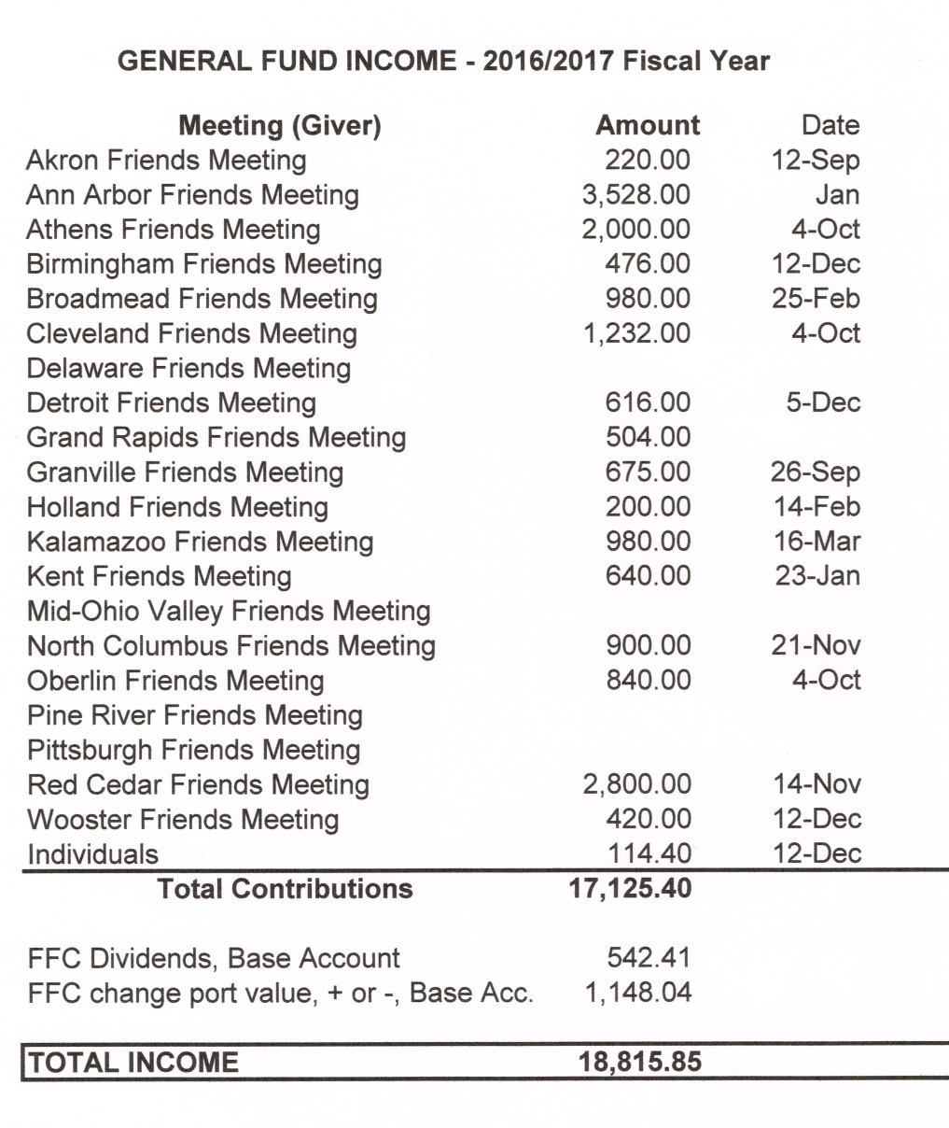

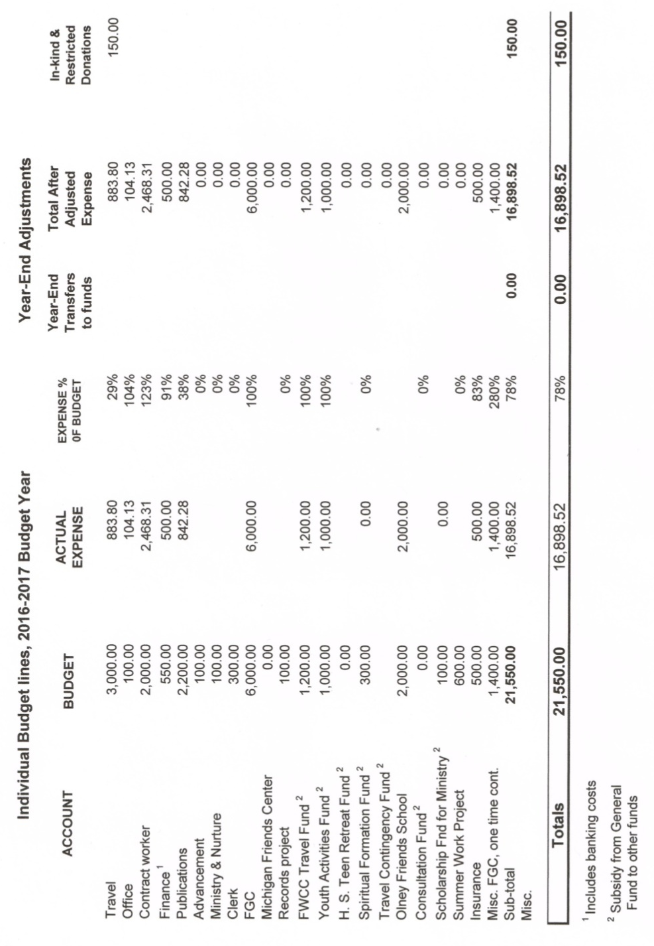

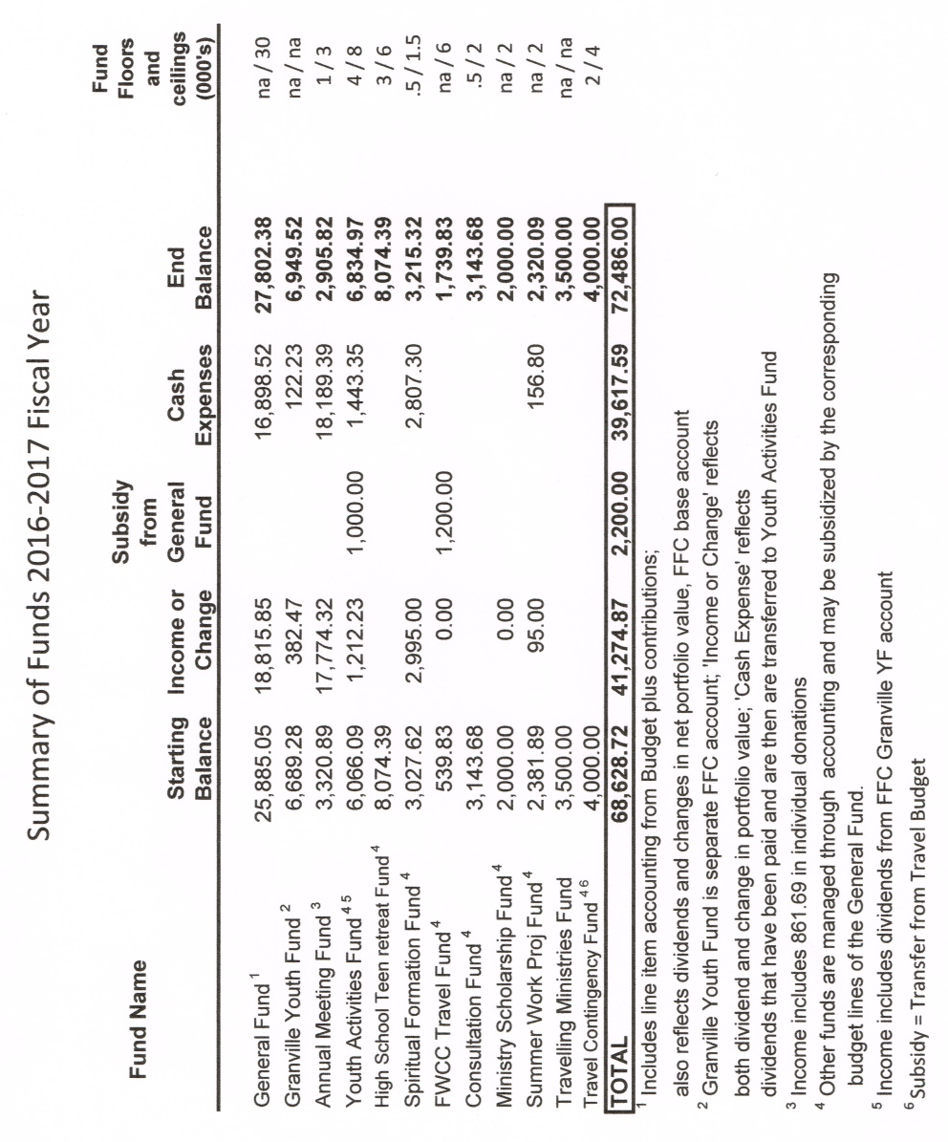

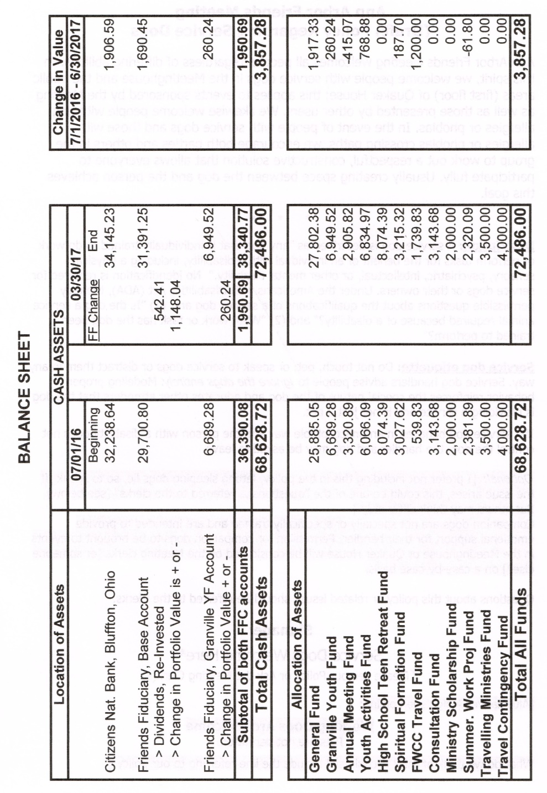
RM2017-08 Finance Committee Report
Jeff Cooper, clerk, reported for the Finance Committee.
Susan Hartman audited our books 2014–2016. The books appear to be accurate, in good order, and well-kept. She made minor suggestions for improvement, and noted that nearly all of her suggestions in the last audit have been implemented.
The Finance Committee has the task of setting registration fees and scholarships for our Annual Meeting. LEYM will continue the one-third discount on all costs for first-time attenders and the partial discounts for children. Registration and lodging for children are free, and children receive a two-thirds discount on meals. This will bring the total cost for bringing a child to Annual Meeting to $20–$25 per child. Registration for young adults (ages 19–35) will be free this year in order to encourage attendance.
The Finance Committee will also increase the honoraria for the plenary speaker to $400 and for workshop leaders from outside LEYM to $100.
To accommodate the changes, the adult registration fee will increase for the first time in years. It is set at $55 for early bird registration and $65 for later registration. Friends who are able are still encouraged to donate above their costs to offset the discounts for children and young adults.
The draft budget was presented and is attached. In recent years we have set aside money not only for our own travel to FWCC gatherings, but also to support Friends from less affluent areas. This budget includes an increase of $1800, to be divided equally between LEYM and Friends from less affluent regions.
Total proposed expenses are $21,200, down $350 from the current fiscal year. The per-member contribution of $28 will continue. This will give us a $520 deficit. It should be noted that, even though we have budgeted for a deficit for the past few years, we have always come out ahead.
The full report follows.
Finance Committee Report, Representative Meeting, April 2017
Today we bring you three items.
A. Audit
Last fall Susan Hartman (Ann Arbor Meeting) completed a thorough audit of our books for the years 2014–2016, following suggestions provided in the QuakerPress pamphlet Friendly Audits, by Elizabeth Muench. Susan wrote, “The books appear to be accurate and in good order,” and “My overall conclusion is that the books are well-kept.” She made some minor suggestions concerning easier tracing of past transactions – mostly providing cross references between paper and email documents, but also noted that most suggestions she made in the previous audit, four years earlier, have been adopted. All in all, she was pleased with the treasurer’s work, and we were pleased with her careful audit.
B. Registration Fee and Scholarships for Annual Meeting
Our Committee has the responsibility to set registration fees and standard scholarships for the Annual Meeting. (Costs the Yearly Meeting is charged for meals, lodgings, and linens are determined by Bluffton University.)
The standard (early bird) registration fee for Annual Meeting has been $50 for the past four years. This year it will increase slightly for two good reasons:
1) The Finance Committee and the Program Committee have agreed to double the honoraria for the plenary speaker (now $400) and workshop leaders from outside LEYM (now $100). This is the first increase in either since 2006. Other honoraria and guidelines concerning discounts for those who undertake work at Annual Meeting remain the same; notably, those who work fulltime with the children’s program have their registration, meals, and room costs covered. (All of this is explained in Policies & Procedures, Appendix E.)
2) In an effort to attract more Young Adult Friends to Annual Meeting, we have decided to eliminate their registration fee. This will apply to Friends ages
19–35.
To cover these additional expenses, the registration fee for those of us who wish we were still young adults will increase $5, up to $55, for early bird registration, and $65 for those who miss the early bird deadline. A 1/3 discount for first time attenders will continue from last year, as will discounts for children: free registration, free lodging (including linens), and a 2/3 discount on meals. (Thus, the total cost for bringing a child is only 1/3 of the standard cost for meals, or about $20–$25 for the weekend.)
The Annual Meeting fund has a balance of $2906, so if the discounts result in a loss, we can afford it. For the past several years the registration form for Annual Meeting has invited contributions to help cover the costs of children’s discounts; perhaps this year it can also be put toward discounts for Young Adult Friends. These contributions are much appreciated.
C. Draft Budget for 2017−18
Budgets always try to reflect recent spending patterns, in our case low-spending patterns. We are also in the fortunate position of having substantial funds supporting several budget lines, which enables us to budget small amounts, confident that if expenses increase we can cover the costs.
Looking at the projection, we see expenses and revenue for the past 3½ years on the left and, on the far right, proposed budget lines for next year, along with the difference from the current year. The recent spending patterns have brought about changes in lines such as Travel (down $500 to $2500, but supported by $4000 in a corresponding fund), Contract worker (up $400 to $2400), and Publications & Archives (up $500 to $2700). I want to draw your attention to one more line among the expenses, FWCC Travel.
This budget line was established to subsidize a fund for sending LEYM Representatives to international gatherings. It builds year by year, leading up to each gathering, when most of it is spent. Recently we have budgeted additional amounts to support attendance at these gatherings by Friends from less affluent parts of the world. In the current year we specified that the budgeted $1200 would be divided into $900 for our own representatives and $300 for Friends from other parts of the world. Following a suggestion a Friend made last year, this year we propose increasing the line to $1800, to be divided equally between LEYM Friends and other Friends.
The budget as presented has total expenses of $21,200, down $350 from the current year. Leaving the suggested contribution per member at $28 and assuming 700 contributing members suggests that our contributions income would be $19,600, with total income of $20,680. This would leave a deficit of $520. We have approved deficit budgets for the past several years, and each year have come out ahead. Finance Committee would be delighted if the Yearly Meeting actually spent all or more of the budget, and we have ample money in the General Fund and other funds to cover expenses if our pattern of under-spending should suddenly change.
Your comments and suggestions on the draft budget are invited.

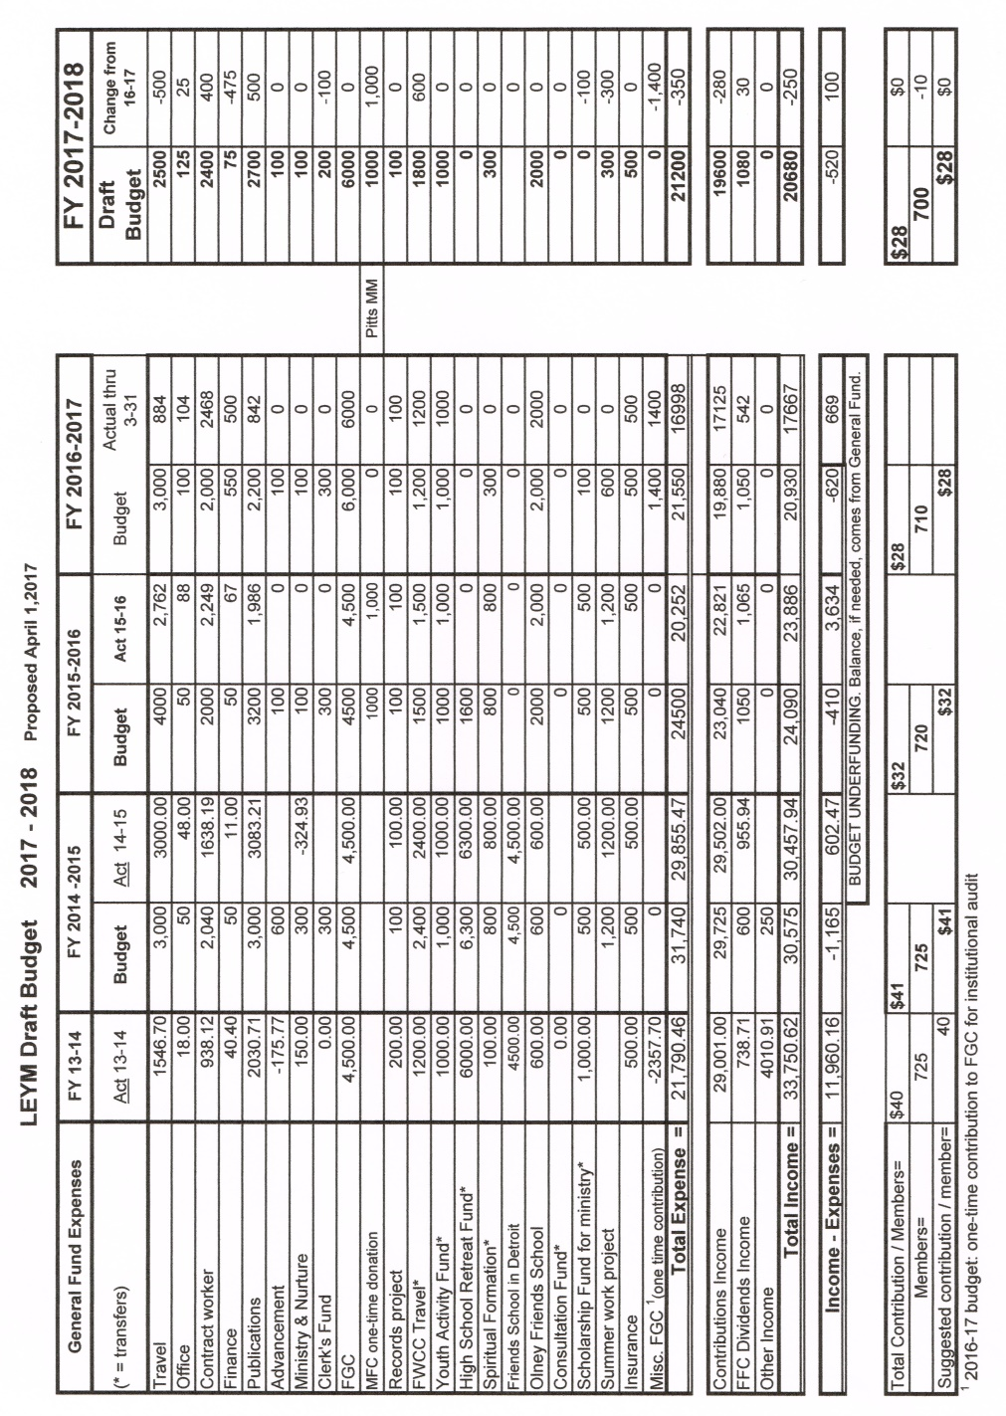

RM2017-09 Ministry & Nurture Committee Report
Carla Pratt Harrington, co-clerk, reported for the Ministry & Nurture Committee.
The Committee is in the process of creating an invitation to travel in the ministry. It joyfully drafted a letter of support for Lucia Ann Kalinosky for the Cooper Scholarship and to attend Earlham School of Religion.
LEYM’s Spiritual Formation spring retreat will be held on May 13 at Kalamazoo Meeting. Next year’s Spiritual Formation topic is Practicing Forgiveness as a Spiritual Discipline, to be led by Sue Regen.
The Committee received responses from 15 Monthly Meetings to this year’s Query, which was: “All Meetings have a welcoming message, whether they know It or not. What is yours?”
Concerns were expressed for welcoming racial minorities, the religiously oppressed, and others often considered disadvantaged; some other Meetings struggled to welcome individuals in military uniforms or those with political views that are less traditional among Friends. Some Meetings approached the query mechanically, addressing the practical question of familiarizing new members with the nuts and bolts of finding or participating in Meeting. Sorrow was expressed by many at the lack of age, gender, or racial diversity within their Meetings. For many, the query also generated additional queries that will help them continue the discernment process going forward.
The full summary follows.
Report on Responses to the LEYM Annual Query for 2017
There were expressions of appreciation for the LEYM Query and one stated: “We appreciate LEYM bringing up this query because it has prompted us to discuss our welcoming message that may be more imperfect than we would like. This discussion has enriched our community and has prompted us to work on improving our welcoming message.” Others are looking in depth at what they want their welcoming message to be.
Some Meetings have struggled with how to respond to visitors in military uniform, those who identify as Trump supporters, or are fundamentalist Christian, and then quickly identify the need for openness, acceptance, and non-judgmentalism. The following statement, approved by one Meeting and distributed to media, churches, and community organizations, states: “Political rhetoric has sown divisiveness, fear, and distrust; some of this is directed at those of Muslim faith, the black community, immigrants and refugees, women, the LGBT community and many others among us…. [Our] Meeting is led by the Divine Spirit to open our doors and provide a welcoming space for all in our community including those who are oppressed and persecuted.” One Meeting made this statement: “Part of the way of Friends is how we live our lives seeking the truth. Though politics is not what our faith is about, faith leads us to values which in turn affect our politics.” A Meeting asks themselves, “Are we fully ‘Quaker’ if we are not willing to engage people and opinions with which we don’t agree?” Two Meetings recognized the need for better signage so that newcomers can find their way to refreshments, First Day School, and potluck.
Many Meetings have greeters welcoming visitors and explaining Quaker unprogrammed worship to attenders unfamiliar with Friends worship. One Meeting is asking themselves, “Should we have a greeter?” Most Meetings expressed the importance of engaging newcomers after worship, welcoming them, and expressing joy at their presence in meeting. Some also use websites, Quaker Cloud, and Facebook to inform people about their Meeting and to invite them. One Meeting has a welcoming “Invitation to worship” printed and given to newcomers – in part it reads “The … Friends Meeting welcomes you to this meeting for worship. We gather in worshipful silence, intending to open ourselves wholly to the Divine Spirit, which we believe is within and beyond each person. Our worship has no human leader and no planned program.”
Most Meetings invite visitors to rise and introduce themselves after meeting for worship.
Many stated their Meeting’s lack of racial, gender, or age diversity. Some expressed a desire to openly acknowledge white privilege and implicit bias. One stated a retreat on racism and white privilege is being planned for the spring. Another is considering possibilities of how to engage with people of color in their community. One asks, “Could individual Friends make a greater effort to invite people of diverse backgrounds to visit our meeting?”
Some Meetings have no children attending. Others are grateful for Friends in their Meeting who volunteer as teachers and “adult presence” in First Day School. One said they cherish and appreciate children and take care to incorporate them into the Meeting’s practices and activities. One response expressed joy that a welcomed visiting family kept coming back.
In many Meetings, the LEYM Query gave rise to meaningful questions and some are included here:
- How would a visitor know about our wish to get past our biases?
- What do we expect of people walking in the door?
- Why do people not come back after a few visits?
- How can we insure that all who worship with us feel truly seen?
- How do we meaningfully engage with differences within our community?
An expressed worry that a visitor might perceive its message as “You are welcome here if you are like us” and wondering what responses might be to asking, “Please join us and help us listen to Spirit,” or “Welcome, and how might you change us?”
We ask ourselves what it would be like if our Meeting were significantly more racially or culturally diverse?
A concern was expressed that the location of the Meeting House can have an impact on who comes to meeting for worship.
One Meeting is offering monthly midweek meeting at a public library hoping to provide a “quiet and peaceful respite” for anyone interested. More than one Meeting raised for themselves the concern about explaining “insider knowledge and jargon” so that newcomers feel included.
RM2017-10 Earthcare Committee Report
Alan Connor, Peggy Daub, and Mey Hasbrook reported for the Committee. Peggy reported that Michigan Quakers for Environmental Action (MQEA) plans to work with the Michigan legislature to provide more environmentally friendly laws for the state. If you live in Michigan, expect to be contacted!
Alan reported that FWCC adopted the Shared Quaker Statement on the Environment and encouraged all other Quaker Meetings to support it. Mey reported that a more focused report was produced by the Sustain-ability Group Meeting at FWCC, Section of the Americas, in March 2017. This document will also be available to Friends as they consider the Shared Statement. The document follows.
Report on Sustainability Group Meeting at FWCC, Section of the Americas, 3/2017
On Friday, March 24, 2017, 17 Friends met at the Friends World Committee for Consultation (FWCC) gathering in Stony Point, NY, to discuss the sustainability minute approved at Pisac. We had three working groups, and here is a report on what transpired. We’d like to begin with a quote from Isaac Penington:
“Sink down to the Seed … and thou shalt find by sweet experience that the Lord knows … and will lead … to the inheritance of Life.”
Powerful though it was in many ways, we felt the Sustainability minute at Pisac dealt mainly with mitigating anticipated climate disruption. We strongly feel Friends need to go further. Since climate disruption is already adversely affecting the earth as well as the lives of people and other living beings, we need to consider how we can act in solidarity with communities affected by climate disruption as they strive to respond, resist, or adapt. We also need to consider ways in which we can help to restore the damage caused to the Earth.
We see a need for a collective as well as personal spiritual awakening leading to transformative spirit-led action. To be effective, we need to express joy in the changes we have made in our lives and share our joy with others. To be spiritually grounded, we need to deepen our relationship with nature and connect with God’s creation. We suggest that Friends traveling in the ministry through FWCC share FWCC’s material on sustainability and collect stories about the effects of climate disruption on local communities and how they are responding. We urge each one of us to carry out our Quaker testimony on earth care and lift it up to all the bodies we are part of.
Queries:
How are we as Quakers living our lives as if climate disruption is real and really matters?
How are we showing solidarity with indigenous and marginalized peoples affected by climate disruption?
RM2017-11 Publications & Archives Committee Report
Peggy Daub, clerk, reported for the Publications & Archives Committee.
Berch and Susan Carpenter are stepping down as Bulletin editors. A job description was circulated at the meeting. Anyone led to serve LEYM in this role should speak with Susan and Berch.
May 15 is the deadline for submissions for spring Bulletin. Jeff Cooper has agreed to edit and compile the Annual Records for 2017.
The Committee is working on making more information available on our website. Natalie Finegar, our 2016 plenary speaker, has granted permission to put her talk online. The Committee plans to seek permission to include plenary addresses going forward, and to contact past plenary speakers for consent to include past talks.
The Committee recommends that the Nominating Committee report be posted on our website immediately at the end of Annual Sessions. Friends approved. The directory will not be online until privacy issues on our website are addressed.
The full report is attached.
Publications & Archives Committee: Report to Representative Meeting, April 1, 2017
Our Bulletin editors, Berch and Susan Carpenter, are stepping down after serving three years in that position. They have compiled a brief overview of their work, which Susan will distribute now. We appreciate their service and invite you to consider whether you might be led to take up this work. During the past year, they have broadened use of color printing of the Bulletin, allowing the paper copies and electronic copies to look more nearly the same at a modest increase in cost. Offsetting the cost of the color printing, the issues of the LEYM Bulletin have been reaching more people electronically. In fact, we have a number of ways in which we offer delivery, so that you can now choose from direct email, downloading from the website, paper copy delivered to the Meeting, or paper copy mailed directly to you. If you don’t like the way you are receiving the Bulletin now, let us know and we can change it.
Content for the spring issue should be sent to Susan and Berch by May. 15. We are grateful for the work of Rosemary Coffey of Pittsburgh Meeting in com-piling and editing the Annual Records for 2016. Jeff Cooper of Ann Arbor Meeting has agreed to compile and edit the Annual Records for 2017. Printing, binding, and distribution will be overseen by the Committee.
The three issues of the Bulletin are all made available through our website, but the Annual Records as a whole is not. Various sections of the Annual Records are distributed across different tabs in the website. Minutes from Representative Meeting and Annual Sessions are there, along with the Yearly Meeting history and chronology, guidelines for State of the Meeting Reports, and contact information for monthly meetings.
In thinking about which other sections of Annual Records would be usefully accessed from our website we considered questions of both content and privacy. We intend to begin a practice of putting our plenary talks at Annual Sessions online. Last fall we were charged with seeking permission from Natalie Finegar to put the transcription of her 2016 plenary talk online. We now have permission to do this and plan to go back several more years and seek permission to put additional plenary talks online, as well as adding future talks. We recommend that the Nominating Committee report be posted on the website immediately after the end of Annual Sessions each year. This will fill the gap between the end of Annual Sessions and when the Annual Records appear in print, which take a few months to compile, print, and distribute. As for other sections of the Annual Records, we are clear that we do not want the Directory online until we have some privacy protection, and will continue to consider other sections as to their online propriety and utility.
RM2017-12 Peace & Justice Committee Report
Lucia Anne Kalinosky, clerk, reported for Peace & Justice Committee.
The Committee plans to create a resource packet to assist Meetings who are discerning their leading to become involved in sanctuary or other forms of direct action with respect to immigrants. The packet will include information on actions that may be taken such as sanctuary, accompaniment, and resisting collaboration, as well as the associated legal ramifications. They hope to include phone numbers of lawyers willing to provide legal support. They are discerning whether to recommend to the Yearly Meeting that it provide financial support to Meetings facing legal consequences as a result of offering sanctuary to immigrants.
The Committee reports its concern with the lack of truth and integrity in the public sphere, not just from a political perspective, but also with respect to the spiritual causes and effects of untruths. To the extent we believe in a creator God, untruths in the political realm distort those underlying truths and create spiritual unwellness.
The Committee created a Peace & Justice Roundup in the latest Bulletin. Friends welcomed this, and the practice will continue.
RM2017-13 Advancement & Outreach Committee Report
Mathilda Navias, clerk, reported for the Advancement & Outreach Committee. The Committee continues to reach out to Worship Groups and small Meetings to check on their wellbeing and offer assistance. Erie Worship Group is doing well and is offering a community movie night that is increasing its visibility within the community. The Committee is working on an article for the Bulletin and samples of outreach materials to be shared at Annual Sessions.
RM2017-14 Nominating Committee Report
Clémence Ravaçon Mershon, clerk, reported on behalf of the Nominating Committee. The Committee is committed to presenting a full slate of officers before our Annual Sessions. If you are serving on a particular committee but are led to serve on a different committee, please let the clerk of the Nominating Committee know.
RM2017-15 Adult &Family Program Committee
Claire Cohen, co-clerk, reported for the Adult & Family Program Committee. The theme for our Annual Meeting is, “Quakers into the New Millennium.” Our plenary speaker will be Greg Woods. Greg currently works in Outreach to Quaker college students on non-Quaker campuses. There will be ten workshops. The talent show will be back, by popular demand, and there will be a movie night on Thursday. The Committee plans a spring push to encourage young adults to attend Annual Meeting. Monthly Meetings are asked to make a special effort to encourage attendance, particularly among young adults.
RM2017-16 Children & Youth Program Committee Report
Joe Mills, clerk, reported for the Children & Youth Program Committee.
The Committee reported it will adopt a practice of “collection” new to LEYM: there will be a brief period of silence and announcements each morning in Ramseyer. Broadmead Youth will send invitations to youth of all monthly meetings inviting them to attend Annual Meeting. It is expected that the program will design a youth t-shirt this year. The Committee reviewed, and is considering, suggestions made by last year’s teens.
RM2017-17 Arrangements & Site Committee Report
Jon Sommer, clerk, reported for the Arrangements & Site Committee.
New this year at Bluffton, the control systems in the air-conditioned residences have been updated. Food services is aware of our special dietary needs, and changes will be made to accommodate them. The non-air-conditioned dorm this year will be Bren-Dell, approximately the same distance from Marbeck Center as Ramseyer.
RM2017-18 Minute of Appreciation
Clerk Mike Holaday offered the following minute of appreciation to our hosts, Kalamazoo Meeting.
Lake Erie Yearly Meeting expresses its deep appreciation to the Friends of Kalamazoo Friends Meeting for hosting our Representative Meeting for 2017, for opening their homes to traveling Friends, and for providing sustenance for our work together. We wish them much happiness and the many blessings of the Spirit.
Friends approved this minute. The 2017 Representative Meeting of Lake Erie Yearly Meeting was adjourned.

Mike Holaday, Clerk
Nancy Reeves, Recording Clerk

