Table of Contents

To go directly to a topic, click on it. If that does not work, try Ctrl+click. Otherwise, page down.

Representative Meeting of Lake Erie Yearly Meeting
Cleveland, Ohio
Third Month 1, 2003
RM03-1 Roll Call
RM03-2 Executive Committee report
RM03-3 Adult Program Committee report
RM03-4 Youth and Children Committee report
RM03-5 World Gathering of Young Friends
RM03-6 Site Committee report
RM03-7 Advancement and Outreach Committee report
RM03-8 Treasurer's report
RM03-9 Contributions from meetings
RM03-10 Friends Music Camp Scholarships
RM03-11 Ministry and Oversight Committee report
RM03-12 Travel Minute for James Satterwhite
RM03-13 Query responses
RM03-14 Nomination from Naming Committee
RM03-15 Nominating Committee report
RM03-16 Publications and Archives Committee report
RM03-17 Earth Care Committee report
RM03-18 Report from our FGC representatives
RM03-19 FWCC Triennial next January
RM03-20 Weekend worskshops at Michigan Friends Center

LEYM Executive Committee minutes

Reports
Report of the Youth and Children Committee
Advancement and Outreach Committee report
Treasurer's report
Report on Religious Education in Friends General Conference
Responses to Peace Queries
Publications and Archives Committee report

Representative Meeting of Lake Erie Yearly Meeting

Cleveland, Ohio

Third Month 1, 2003

Lake Erie Yearly Meeting Representative Meeting gathered in Cleveland, Ohio, on Third Month 1, 2003. We began with worship. We heard epistles from Northern Yearly Meeting and Ohio Valley Yearly Meeting.
RM03-1 Roll Call
We have responded to the roll call, and find 56 adults present for our sessions today. There is no one here from any of the worship groups.
There are no visitors.

Akron 2
Ann Arbor 11
+ 1 infant
Athens .4
Birmingham 3
Broadmead 8
Cleveland 3
+ 2 children and 4 adults
working in the kitchen
Delaware 0
Detroit 0
Grand Rapids 0
Granville 3
Kalamazoo 3
Kent 5
Mid-Ohio Valley 0
Monongalia 0
North Columbus 2
Oberlin 3
Pine River 6
Pittsburgh 6
Red Cedar 0
Wooster 0

RM03-2 Executive Committee report
We have heard the minutes from the Executive Committee, which met last evening. They are attached.
RM03-3 Adult Program Committee report
We have heard from the Adult Program Committee that the theme for this year is Engaging Fear with Spirit. Instead of a plenary speaker there will be a panel discussion on our theme Friday evening, followed by worship sharing. Saturday morning will continue with more worship and worship sharing. Longer-time yearly meeting attenders are asked to host and welcome new attenders. We ask that these two designations (host and new attender) be included on the registration form. There will be six workshops, four of which will be on healing, addictions, Islam, and racism. Two have not yet been selected. After some discussion, and the consideration of several suggestions offered by Friends, we ask the Committee to revisit its decision to replace one hour of committee time with worship sharing.
Additional suggestions and comments can be sent to Dale Pratt-Harrington <dphdo@aol.com>.
RM03-4 Youth and Children Committee report
The report from the Youth and Children Committee has been received and is attached. There will be five age groups this year, with the high school group expected to be the largest. The Committee supports the concept of a part-time paid youth secretary to build on the work Kri Anderson is currently doing.
RM03-5 World Gathering of Young Friends
We have heard Kri Anderson's letter to Ann Arbor Meeting and Lake Erie Yearly Meeting regarding the planning committee for a World Gathering of Young Friends to be held in northern England in 2005. Friends appreciate the work Kri is doing and await a request from her for specific and feasible assistance. We ask the clerk to communicate with Kri.

RM03-6 Site Committee report
We have heard from the Site Committee that Marbeck Hall has been remodeled to provide more room. The Committee has worked to revise the registration form. Elena Tuhy has volunteered to be the registrar. May 28 is the deadline for registration. In order for children to participate they must be registered by this date. Clerks who want committee space Thursday afternoon should contact Judy Greenberg in a timely fashion at <judywpg@buckeye-express.com>.
RM03-7 Advancement and Outreach Committee report
We have received a report from the Advancement and Outreach Committee, which is gratefully attached. Various monthly meetings and Green Pastures Quarterly Meeting have the care of worship groups, some of which have changed their status within the past year. These changes should be included in the monthly meeting state of the meeting reports. Friends are reminded to keep references to times and places of meetings for worship updated on the LEYM web page and other places.
RM03-8 Treasurer's report
Our Treasurer's report has been received, with gratitude for her careful stewardship of our finances. It is attached.
RM03-9 Contributions from meetings
An oral report from Finance and Budget Committee informs us that not all monthly meetings are promptly paying their suggested contribution of $26 per adult member. Our travel funds are already over budget (as suggested last year), because we are encouraging Friends to travel on LEYM business.
But Friends are reminded to please travel as economically as possible. The yearly meeting expects to pay all necessary travel expenses. The yearly meeting may be asked to increase the suggested donation per adult member from $26 this year to $28 next year to cover the higher costs of travel.
If the yearly meeting decides we should spend $5,000 per year for the service of a youth secretary, we would raise the suggested per adult donation an additional $5.50. Another possibility might be to establish a fund to which individuals could contribute, perhaps with matching funds. A more specific proposal will be brought to our annual meeting. Additional comments and suggestions may be sent to Zig Dermer at <RKCZLD@aol.com>. We are informed that new so-called security measures to be instituted on a trial basis at three airports call for flagging anyone who does not pass a government background check. This is likely to incur additional travel expenses for Friends who are active in peace and justice work.
RM03-10 Friends Music Camp Scholarships
We have heard a letter of thanks from Erin Diffenderfer for our support of her attendance at Friends Music Camp last summer. She asks for help to attend next summer. The letter is attached.
RM03-11 Ministry and Oversight Committee report
We have heard an oral report from Ministry and Oversight Committee.
The Committee sent peace queries to monthly meetings last July. Seventeen meetings (out of 20) returned responses, although seven of them were late.
M&O and Peace Committee met together this morning and summarized the responses. The Committee intends to send out another query this year with a deadline of 12/31/2003. The topic will be integrity, and the wording will be worked on during yearly meeting.
Because of the pain and uneasiness around the words "overseer" and "oversight," the Committee is wrestling with its name. Suggestions include Nurture, Ministry and Counsel, Oversight, Ministers and Elders, and retaining Ministry and Oversight. This will be considered further at yearly meeting time.
RM03-12 Travel Minute for James Satterwhite
Broadmead Monthly Meeting has approved a travel minute for James Satterwhite in support of his work with the Christian Peacemaker Teams and his leading to travel among Friends with a concern for peace in the Middle East. Representative Meeting approves the following minute:

Dear Friends,
We commend to your loving care and attention our beloved Friend, James Satterwhite. James will be traveling to various Friends Meetings and gatherings and to other groups interested in peace issues in the Middle East under a concern for current events in the Israeli/ Palestinian conflict.
James is a member of Broadmead Monthly Meeting in western Ohio and Lake Erie Yearly Meeting. He is currently serving on the Lake Erie Yearly Meeting Peace Committee and as a representative from Lake Erie Yearly Meeting to the American Friends Service Committee Corporation.
James also is a member of the reserves of the Christian Peacemaker Teams (CPT). Since 1998 he has spent several months each summer in Hebron as part of the Hebron CPT team. His involvement in CPT comes out of a leading to participate in this witness, as does the imperative to share with others his experiences, observations, and concerns.
Lake Erie Yearly Meeting unites with and lovingly supports this leading. We believe this commitment to be a gift of the Spirit, and his witness to Friends and other interested groups a valuable source of insight on this conflict, which he articulates with thoughtfulness, perception and the clarity of experience.
We hold James and his witness in the Light.

In peace and love,
Sally Weaver Sommer
Clerk, Lake Erie Yearly Meeting
We look forward to occasional reports from Jim on his own work and experiences. These might appear on our web page.
RM03-13 Query responses
We have heard an oral report from the Peace Committee that met with Ministry and Oversight Committee to consider the query responses. Peace Committee approved an additional paragraph about conscientious objection to military taxation (COMT) and war tax resistance that they hope will be appended to the summary of query responses. It reads as follows:
War tax resistance is a form of nonviolent civil disobedience that requires us to endure various forms of oppression that governments or other "powers" often impose on those who "engage the powers" (to use Walter Wink's term).
But working to change the nation's laws so as to grant legal recognition of the right to conscientious objection to military taxation (COMT) is a perfectly legal endeavor, aiming to extend our right of conscientious objection to military service to COMT. In meetings' responses to this query, it appears that many persons speak of general tax resistance, when in fact they are thinking of war tax resistance (an important distinction to be made). It also appears that many who think about the topic of COMT think that this refers only to war tax resistance. While COMT includes war tax resistance (at present "illegal"), it also includes efforts at legislative change (not illegal).
Local meetings are encouraged to use the letter against impending war drafted by the Peace Committee at Representative Meeting last year (pp. 10-11 of the Annual Records 2002) and sent to each monthly meeting to send to local newspapers and members of Congress.
Friends are asked to encourage Senators and Representatives to become sponsors of the bill to permit COMT.
RM03-14 Nomination from Naming Committee
The Naming Committee brings forth the name of Verne Bechill to serve a three-year term on the Nominating Committee. Friends approve with gratitude.
RM03-15 Nominating Committee report
The Nominating Committee reports it worked well today. Nevertheless, Advancement and Outreach, Youth and Children, Arrangements and Site, and Publications and Archives committees need additional Friends who feel led to serve in these ways. We are encouraged to think of ways to include people from our monthly meetings who may not yet be actively involved in the yearly meeting. A form will be included in the LEYM Bulletin which can be used to let the Nominating Committee know of anyone's interest in serving on a specific committee.
RM03-16 Publications and Archives Committee report
Publications and Archives Committee presented its report, which is attached. The Archives part of the Committee has written a complete chronology of the yearly meeting and association. Now it is charged with getting written reminiscences of our stories. Please send them to Leonora Cayard at <cayard@fyi. net>.
RM03-17 Earth Care Committee report
The Earth Care Committee gave an oral report informing us of the earth democracy movement as it has been articulated by some farmers in India. The Committee is seeking additional folks who are deeply energized and committed to the fundamentally interrelated issues of justice, sustainability, and peace. The Committee has assembled some good resources to help monthly meetings become more informed and to move toward radical change in the way we live on the earth and with each other. As the Committee currently has two members, it hopes that monthly meetings will encourage people to become active in this work. We have also heard an update on Greenfire and its many exciting activities.
RM03-18 Report from our FGC representatives
We have received a written report from one of our representatives to Friends General Conference (FGC), which will be printed in the LEYM Bulletin.
The FGC Religious Education Committee and Pendle Hill are co-sponsoring a workshop April 4-6 on Nurturing Young Friends: Coming of Age in the Quaker Community.
RM03-19 FWCC Triennial next January
Margaret Kanost and Zig Dermer expect to represent LEYM at the next Friends World Committee for Consultation (FWCC) Triennial in New Zealand next January. Monthly meetings are encouraged to explore the study booklet, Being Faithful Witnesses: Serving God in a Changing World, and respond to Margaret.
RM03-20 Weekend worskshops at Michigan Friends Center
Michigan Friends Center is sponsoring a series of transformative weekend workshops and retreats this spring and next fall. Visit their web site for the full schedule.

There being no further business the meeting closed with a short period of worship.

Sally Weaver Sommer, clerk
Marty Grundy, recording clerk

LEYM Executive Committee minutes
The Executive Committee of Lake Erie Yearly Meeting met in Cleveland, Ohio, on Second Month 28, 2003. We began with worship. We are grateful for the faithfulness that brings us together to do God's work at this time when we are aware of the fragility of human relations.
We considered if it is time for LEYM seriously to consider funding a part-time youth worker. Does Kri Anderson put in so much time that she needs some actual compensation for her time, as well as her out of pocket expenses (which are mostly paid by Green Pastures Quarterly Meeting)? Are there benefits to our youth, and to the Religious Society of Friends, from building a strong and vibrant YM youth program? We have the foundations in place with the elementary school fall retreat and the activities Kri has been organizing. What is the next step? What more are we called to do?
Friends are in unity with the importance of supporting our youth, especially in high school and just beyond. We discussed the possibility of funding a youth secretary, perhaps something similar to Ohio Valley Yearly Meeting, which has invested in a part-time youth secretary. We are informed that the renewed energy put into their youth has galvanized and energized the entire yearly meeting. Among the things we need to decide are the relation with the Youth and Children Committee, how much money and time we expect at first, and how to build on what we have now. We ask Marty Grundy to meet with the Youth and Children Committee tomorrow morning to bring a rough proposal to Representative Meeting, to put something in writing for the spring LEYM Bulletin, and to prepare a more polished proposal for our Yearly Meeting sessions if way opens.
Our clerk expressed her considerations about how our committees function, the impact of this on our time together at yearly meeting, and how this shapes the spiritual life of our yearly meeting. One aspect involves each committee's collective memory of its work and process. In this regard, last year Bill Hummon did a lot of work for the Nominating Committee on its collective memory of who served in what capacities and for how long.
Publications and Archives Committee notes they have only four members (although there are six places); three of these are from Pittsburgh and all four have served for three years. Their issue is bringing in and teaching capable new people and gracefully releasing those who have served considerable time. The clerk of Ministry and Oversight Committee has written to each monthly meeting clerk asking who is their representative to LEYM's Ministry and Oversight Committee. In this way that Committee is slowly enlarging. We note that the pool of Friends who attend yearly meeting and are active and available to participate in committee work seems to be slowly shrinking. Each of us needs to draw newer members of our monthly meetings into the yearly meeting, to invite them to attend LEYM with us. We discussed a variety of possible ways the Nominating Committee might encourage more Friends to serve God through the yearly meeting. We are reminded that service is an important part of one's spiritual life and growth. We ask the Nominating Committee to send to the Bulletin editor short descriptions of the various committees with a request that folks consider how each of us may be led to serve. We want to encourage monthly meeting clerks to keep announcing the upcoming yearly meeting sessions in order to increase interest and attendance.
We considered the length and process of our yearly meeting business sessions. Some of the unseasoned conversations could be avoided if all new items of business are seasoned first either in a yearly meeting committee or by a monthly meeting before being presented to the yearly meeting.
We closed with a short period of worship.
Sally Weaver Sommer, clerk
Marty Grundy, recording clerk

Reports

Report of the Youth and Children Committee
There are five groups: preschool, early elementary, upper elementary, middle school, and high school. Our anticipated largest group (ca. 15 kids) is the High School age group.
We are aware that Nominating Committee continues to seek co-clerks for Children and Youth Committee, clerk and assistant clerk for fall youth retreat, and assistant for the high school group.
We support the concept of a part-time, paid youth secretary to build on the work Kri Anderson is currently doing.
Joyce Callahan, Donna Hawkins, co-clerks
Olwen Pritchard, Jon Sommer, and Conleth Crotser

Advancement and Outreach Committee report
Advancement and Outreach is blessed with wonderful committee members and thoughtful visitors whenever we meet. We continue to evolve as a committee, and seek new ways to serve Lake Erie Yearly Meeting.
Advancement and Outreach has renewed its commitment to publishing articles on outreach-related topics in each LEYM Bulletin. Topics are discussed and seasoned several issues at a time.
Committee members continue to visit meetings within and outside LEYM, and have assembled a variety of outreach materials published by meetings. A display of those materials will be offered at the LEYM sessions in June 2003.
Advancement and Outreach has received news of a number of status changes within LEYM meetings and worship groups. This news prompted us to review the guidelines for our review of status changes. This news also reminds us to extend words of greeting and light to meetings and worship groups.
Advancement and Outreach has received and considered the statement prepared by Don Nagler and published in the Winter 2003 Bulletin as Our Faith Community. We find ourselves in unity with the statement and are comfortable with its addition to the LEYM web page.
We are grateful for the spirit and faithfulness of our committee members and visitors. We look forward to our continued work.
Deb Kociszewski, clerk

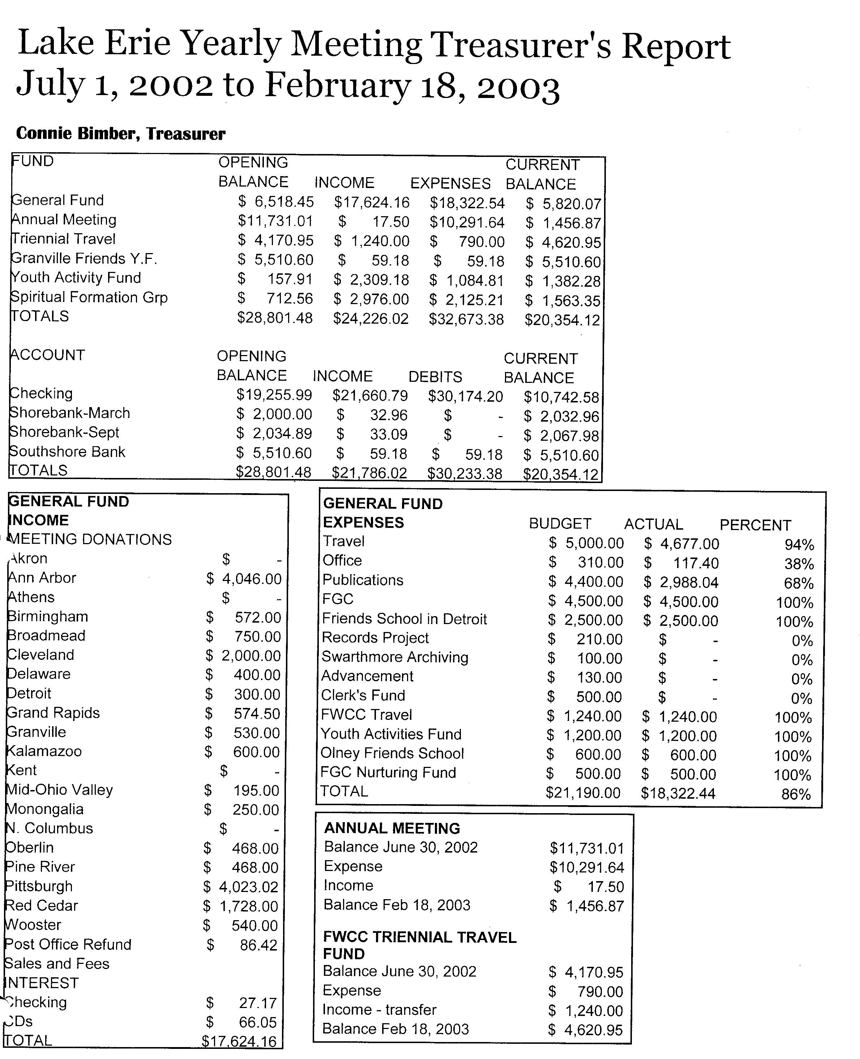
Treasurer's report
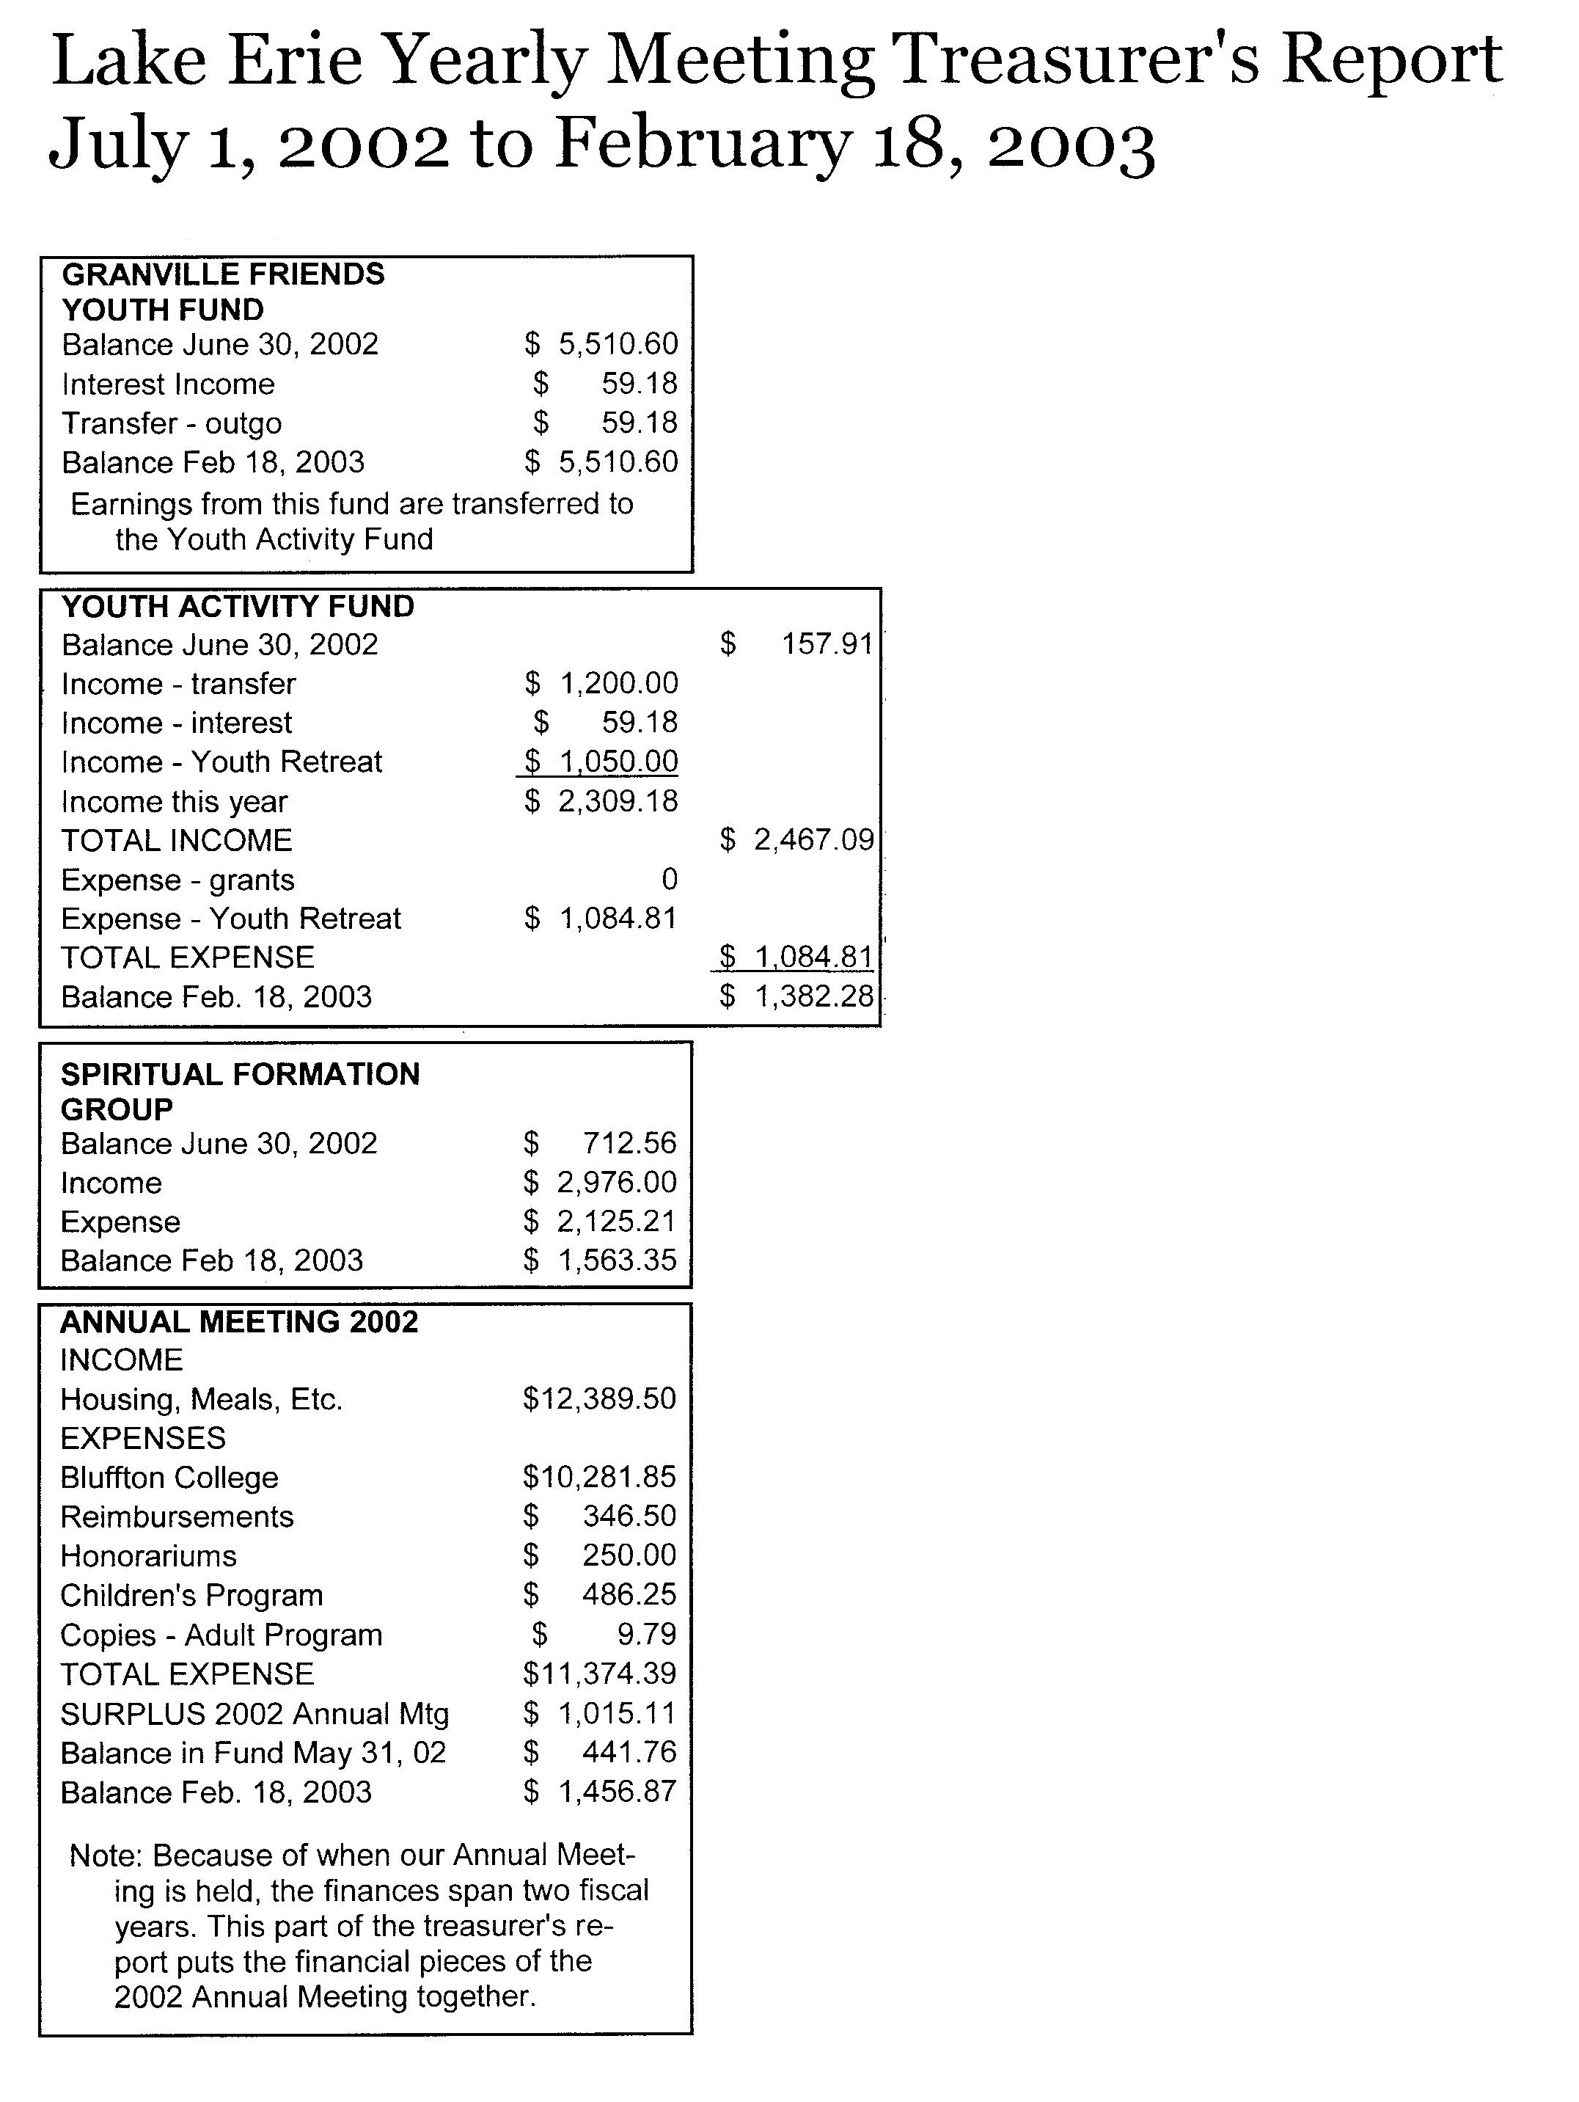

Report on Religious Education in Friends General Conference
by Leonora Cayard
I would like to preface my report with a statement I heard during the 2002 Central Committee meeting of FGC.
Quaker Religious Education is not [just] teaching about Quaker history or about Quaker heroes. It is opening the door to the Spirit, the Light -- it is witnessing, ministering, modeling.
The Religious Education Committee of Friends General Conference, on which I serve, provides spiritual nurture, guidance and resources for teachers of all age levels. There are a number of exciting books and curriculum materials in development, in addition to those already available from the Quaker Bookstore of FGC, www.quakerbooks.org. By the way, our Quaker Bookstore is not breaking even -- it needs more business, and all books, in print or not, are available from Quakerbooks!
Two important events for religious educators are offered by the Religious Education Committee. The first one is a weekend co-sponsored by Pendle Hill called Nurturing Young Friends: Coming of Age in the Quaker Community. Its leaders are our own Kri Anderson and her mother, Johanna Anderson. This will take place April 4-6, 2003, at Pendle Hill, and a few spaces may still be open. The web site www.fgcquaker.org gives access to a more detailed description and to a registration form to be filled out electronically.
The other one is the Religious Education Institute which takes place every four years. The next Institute will be offered in August 2004 and is titled Illuminating our Divine Connections. It will help us to deepen our own spiritual lives so that we can help our children and young people develop theirs.
I was quite impressed by the suggestion that we include our younger Friends in the committee work of the monthly and yearly meeting. Nothing can motivate a person more than being involved in the work of the Religious Society of Friends, serving the Light!
The term "young Friends," as it became clear to me, includes "Children" (from infancy though middle school), "Young Friends" (High School age) and "Young Adult Friends" (age 18 to 35). The rest of us are just "Friends."

Responses to Peace Queries
Ministry & Oversight and Peace Committee
by Thomas Taylor
Summary approved by Committees on Peace and M&O, 01 Mar 03
The following set of queries were agreed to at Annual Meeting in June 2002 and sent to all meetings in the YM with the request that a written response be returned to the clerk of M&O before the end of the year. Seventeen meetings had at least one gathering to consider and respond to the queries, several of them including accounts of actions they are taking on behalf of peace. The meetings that responded are listed at the bottom of this summary report. Our discussions were colored by intensely shared concern about the direction of our government toward war on Iraq. We were all called to be truthful; the call to action against this and all war is clear. These actions have included writing letters and calling representatives, senators, the White House and the press, organizing vigils, marches, witnessing to peace in places of conflict such as Palestine and Iraq, tax resistance, bumper stickers and buttons. North Columbus meeting has creatively placed a "peace tree" on its annual table at the Ohio State Fair, on which people were encouraged to hang letters of peace. Great response -- in the end over 300 letters had been written!
At this time when many in society show fear of "the other," reaching out to Muslim, Jewish and other religious and cultural groups is important for building bridges of peace. Friends often help to organize most of the above activities. Our impact tends to be greater than our numbers.
The queries we considered were as follows:
1. How do I live "in the virtue of that life and power that [takes} away the occasion of all wars"?
A consistent theme was finding and fostering peace within. To be grounded in the Spirit is a necessary first step. Prayer, spiritual discernment, worship, slowing the pace of life and being open to God's will should follow. Since the seeds of war lie in greed and acquisition of material goods beyond one's basic needs, a return to simpler living seems important. In consuming less, we will be able to provide more to others. Small daily acts of compassion help develop a culture of peace around us.
2. How do I and my Meeting community witness to the peace testimony and work to build institutions of peace?
Here is where the activities mentioned above come in. Many organizations we work with and through were mentioned, such as AFSC, FCNL, Friends' schools, Fellowship of Reconciliation, Michigan Peace Team, and Women in Black. We have reached across racial lines, national boundaries and religious affiliations to reconcile differences, and support the development of all peoples. Many participate in social justice and peace organizations within their local communities. Some meetings financially support members' travel and other costs associated with peace work which "informs and provides experiences that give perspective and transform our attitudes and understandings." (Broadmead)
3. Do I consider that paying for war is a form of participation in war? What are our alternatives to paying for war?
We know this to be the case and so the answer is yes, but most are hard-pressed to avoid such participation. Friends are struggling with this issue and many express guilt over their compromises. Render unto Caesar that which is Caesar's is one easy answer -- we have responsibilities to support legitimate governmental functions in a democracy. However, Wear thy sword as long as thou canst takes us deeper: as Friends, we are called to stand on faith -- what does our conscience -- our God, require of us? We honor those who are clear that they are conscientious objectors to military taxation and must refuse to pay for war. Relatively few of us are clear on this matter, nor willing to suffer the fines and hassles that often follow war tax resistance.
In response to the second part of the query, a number of alternatives were suggested:
- to live below a taxable income
- to be generous with our charitable giving
- to take a number of other legal deductions (such as State Tax Free Bond Funds or Roth IRAs)
- to engage in socially responsible investing
- to express our views on these issues to our friends and neighbors
- to use our own organizing and voting power to bring into office those who support and are in harmony with what we believe.
We all support FCNL's and other peace networks' efforts at writing and passing legislation to move the government from military spending to the funding of human needs, supporting social justice, and living at one with the environment. These legislative efforts include working for passage of the Religious Freedom Peace Tax Fund bill. Some suggested that the query needs to show both sides of the coin: how do we avoid paying for war, and how do we pay for lasting peace?
4. How do I maintain my testimony to peace when a mood of war and violence prevails in the land?
The mood of violence and fear is of great concern to Friends in this country. Although the U.S. is bristling with guns, they do not make us safe. We must work to change ourselves first, carrying a vision of a peaceful world. We must live this vision of peace at home, in our community and nation.
This takes us back to living simply so that others may simply live. John Woolman was right -- we need to ensure that we use only our fair share of the world's resources, and we must work to ensure that all others share equally. An important witness to the Peace Testimony is how we teach our children, including learning to mediate and deal with conflict in creative ways, and in regard to conscientious objection to war.
There are many paths to peace and all of them are peaceful. We are led in different ways to bring about a just and peaceful world. Through our meeting communities we can encourage and support one another through discernment, prayer, and practical support so that our lives and actions reveal God's love for all.
Friends in LEYM remain steadfast in our testimony to peace. General satisfaction was expressed for LEYM's timely request to meetings to discuss the peace query in this way. Several groups noted that such query reviews are an on-going function to stimulate ideas, reading and action, and take us more deeply into the spiritual basis of our Peace Testimony. The advices and excerpts which accompanied the queries helped in the process and deepened our responses.
Responding meetings: Wooster, Pittsburgh, Pine River, Oberlin, North Columbus, Monongalia, Kent, Kalamazoo, Granville, Grand Rapids, Detroit, Cleveland, Broadmead, Birmingham, Athens, Ann Arbor, Akron.
Thomas Taylor, clerk, Ministry & Oversight Ctee, 07/00 - 06/03
David Bassett, clerk, Peace Ctee, 07/01 - 06/02
Jim Satterwhite, clerk, Peace Ctee, 07/02 - 06/03

Publications and Archives Committee report
LEYM Representative Meeting, March 1, 2003
Committee members present: Leonora Cayard, Rosemary Coffey (clerk), Joe Mills, Eric Starbuck
1. Web Site
We reviewed the LEYM web site -- which includes a calendar, list of LEYM Meetings, copies of the quarterly Bulletin (but not the Annual Records), and our Policies and Procedures -- and made several suggestions for minor improvements, which Eric Starbuck will undertake to make. In general, we found it easy to navigate and expressed our appreciation to Eric for setting it up, maintaining it, and updating it.
2. Annual Records
a. Number printed: We reduced the run from 500 copies in 2000, to 400 in 2001, and to 175 in 2002. It turned out that the last run was short, so we propose raising the number for 2003 to 250.
b. Content: We are pleased with the new chronological format, which comprises an Introduction, Representative Meeting notes, Annual Meeting notes, and Monthly Meeting information. We are aware of some formatting problems in the last issue regarding discrepancies between the Nominating Committee report and the list of committee members in the back, and the unintentional shortening of an obituary, and will take special pains to see that these mistakes are not repeated.
c. Meeting reports: Nearly all Meetings turned in their State of the Meeting reports, but many failed to submit their statistical forms in time to be included. To encourage more Meetings to participate, there will be a reminder in the Spring Bulletin, and Eric will send out follow-up e-mails in April and in May. At that time he will also ask for copies of any obituaries that are to be printed in the Annual Records.
d. Timing: All content has to be in Eric's hands by the time of Annual Meeting, except for Minutes and Reports from Annual Meeting itself; these are to reach him by June 30, the end of our fiscal year, with an extra few days allowed for the Treasurer to balance the books. We plan to mail copies of the Annual Records to Meetings, LEYM officers, and committee clerks by the first week in August; given the interposition of the FGC Gathering, it is not realistic to expect publication any earlier.
e. Fall activities: As we did in 2002, Eric will give an updated list of Meeting contact people to the leaders or representatives of the Youth Retreat, the Spiritual Formation program, and the FWCC Regional Gathering, so that they can e-mail their registration forms directly to Meeting Clerks with a request that they print them in local newsletters or have multiple copies made for local distribution. Rosemary will also send reminders to Clerks to look for the forms.
3. LEYM Directory
We hear that the Directory has been well used and propose, as previously indicated, to hold off on a new version until 2004. In the meantime, we will see if it is possible to produce a page or two of updates, to be distributed at Annual Meeting. In a future edition, we will consider just listing names of members and attenders under the Meeting headings, with full contact information to be placed in the alphabetic listing only.
4. LEYM Scrapbook
We wonder what happens to photos and other materials from each Annual Meeting. Should these be collected into a scrapbook that would then be available for perusal at subsequent Annual Meetings? Joe Mills will check with Donna Hawkins re past such endeavors and report back at Annual Meeting 2003.
5. Archives
Leonora reminded us that we continue to look for reminiscences of old-timers with regard to the early days of LEYM. Please check with some of your Meeting elders to see if they have memories to share for the Archives.

