Table of Contents

To go directly to a topic, click on it. If that does not work, try Ctrl+click. Otherwise, page down.

Minutes of Lake Erie Yearly Meeting
Representative Meeting
March 5, 2005
RM2005 3-1 Worship and Introductions
RM2005 3-2 Break; Worship and Epistle from Pacific Yearly Meeting
RM2005 3-3 Roll Call
RM2005 3-4 Death of Isabel Bliss
RM2005 3-5 Report from Executive Committee
RM2005 3-6 Program Committee
RM2005 3-7 Youth & Children Committee
RM2005 3-8 Arrangements & Site Committee
RM2005 3-9 Advancement & Outreach Committee
RM2005 3-10 Treasurer
RM2005 3-11 Finance Committee
RM2005 3-12 Nominating Committee
RM2005 3-13 Ministry & Nurture
RM2005 3-14 Publication & Archives
RM2005 3-15 Peace
RM2005 3-16 Earthcare Committee of Concern
RM2005 3-17 Noah Hogan's operation
RM2005 3-18 AFSC
RM2005 3-19 Travel minutes for Connie McPeak Green, Marty Grundy, and David Green
RM2005 3-20 Reaching out to local peace groups
RM2005 3-21 Closing worship; Date of next year's meeting

Reports
Children & Youth Committee Report
Arrangements & Site Committee Report
Advancement & Outreach Committee Report
Finance Committee Report and Proposed Budget
Ministry & Nurture Committee Minutes
The Earth Care Query: How Our Meetings Responded
Publications & Archives Committee Report
Peace Committee Report
Earthcare Committee of Concern Report
Treasurer's Report

Minutes of Lake Erie Yearly Meeting

Representative Meeting

March 5, 2005
Hosted by Ann Arbor Friends Meeting

RM2005 3-1 Worship and Introductions
Friends gathered soon after the appointed time, and the meeting opened with silent worship. Our Clerk, Michael Fuson (Granville), welcomed Friends and introduced those at the table: Sally Weaver Sommer (Broadmead, Asst. Clerk) and Thomas Taylor (Ann Arbor, Recording Clerk). Thomas talked about the ministry of hospitality, introduced Sheila Johnson (housing arrangements), and shared information about the arrangements for the day. Friends new to Representative Meeting were asked to introduce themselves.
RM2005 3-2 Break; Worship and Epistle from Pacific Yearly Meeting
We broke to meet in committees, and enjoyed a good lunch provided by Ann Arbor Friend Janice Summers and the Meeting’s Committee on Ministry and Counsel.
We reassembled in worship and heard the epistle from Pacific Yearly Meeting. While we met in worship for business, we held our Nominating Committee in the Light, since they felt led to continue their meeting with a large agenda yet to complete.
RM2005 3-3 Roll Call
The Recording Clerk called the roll of Friends from our constituent monthly and preparative meetings and worship groups. The count was as follows:

Monthly Meetings
Akron 0
Ann Arbor 14
Athens 2
Birmingham 5
Broadmead 5
Cleveland 3
Delaware 0
Detroit 0
Grand Rapids 0
Granville 4
Kalamazoo 3
Kent 2
Mid-Ohio Valley 0
Monongalia 0
North Columbus 2
Oberlin 3
Pine River 4
Pittsburgh 4
Red Cedar 3
Wooster 0

LEYM attenders: 54
Other attenders: 0
Total attenders: 54

Preparative Meetings and Worship Groups
Albion (under Red Cedar) 0
Indiana (Pittsburgh) 0
Erie (Pittsburgh) 0
Manitou (Grand Rapids) 0
Fremont (Grand Rapids) 0
Rio Grande 0
Holland (Grand Rapids) 0
Grand Traverse (Grand Rapids) 0

Pine River Friends tell us that there is a new worship group in Tustin near Cadillac, MI, with 8 current attenders.
RM2005 3-4 Death of Isabel Bliss
We mourn the death of Isabel Bliss, a member of Ann Arbor Meeting and previously of Cleveland Meeting. Isabel was Clerk of LEYM in 1957 and then again in 1983-86. She passed away at her home in Chelsea on June 24, 2004. Her memorial was printed in the Winter 2005 LEYM Bulletin.
RM2005 3-5 Report from Executive Committee
Executive Committee met last evening. The Recording Clerk read minutes on the four items they discussed: 1) the possibility of holding an LEYM Fall Retreat, 2) the High School Youth Program, 3) an audit or review of the YM accounts, and 4) the suggestion of developing an LEYM Book on Faith & Practice.
Friends spoke to the suggestion of holding a YM retreat in the Fall. There are a number of other Friends activities in the Fall, including Spiritual Formation retreats, which are available to any interested Friends, and so we feel it best not to plan a Fall retreat at this time. Perhaps another time of year would be more appropriate. Since interest in the idea continues, we ask the Clerk and Executive Committee to add two Friends to the existing planning committee, and ask them to develop a hypothetical program and then poll the MMs to see what interest develops.
RM2005 3-6 Program Committee
Nancy Nagler (Pine River) told us that the committee has done much of their work successfully by a combination of e-mail and conference call. The YM theme for this year is to be "The Ground of our Being; Listening to Earth & Spirit." Kim Carlisle of Swannanoa Valley Friends Meeting (SAYMA) has agreed to be the plenary speaker. His wife, Susan, will join us as well, leading us in consideration of our testimony to simplicity.
The Annual Meeting sessions will include small worship sharing groups and will have more time after lunch to allow space for relaxed conversation. Paul Tinkerhess (Ann Arbor) will lead us in song one evening as part of the ice cream social. We encourage greater involvement of representatives from the Quaker agencies the YM supports.
RM2005 3-7 Youth & Children Committee
Conleth Crotser (Cleveland) has reported to us. Their report is attached.
RM2005 3-8 Arrangements & Site Committee
Judy Greenberg (Broadmead) informed us about site arrangements at Bluffton University (sic) for our Annual Meeting this June 16-19. The committee's report is attached.
RM2005 3-9 Advancement & Outreach Committee
See attached report from Mathilda Navias (Broadmead). The committee asks whether Friends might be allowed to participate in the committee meetings on Thursday only, if their schedule prevents them from attending all of the YM sessions.
We ask the Clerk to consult with both the Advancement and Outreach and Arrangements and Site Committees in order to jointly develop a policy on the matter.
RM2005 3-10 Treasurer
Connie Bimber (Oberlin) commented on the attached Treasurer's Report. This year, the YM has been able to give scholarships for the Spiritual Formation retreats. Some representatives to Quaker organizations have not asked for reimbursement. Whether they are reimbursed or not, we encourage Friends to submit an expenses form. Donations are still coming in to enable Young Friends from economically deprived areas to attend the World Gathering of YFs. Kri Anderson encouraged us to include Youthquake in the YM budget. We encourage the Finance Committee to consider this request.
RM2005 3-11 Finance Committee
Linda Mills (Kalamazoo) reported. The committee report and preliminary budget for 2005-06 are attached. We ask Finance Committee to look over our past records and ascertain the commitments we have made to support high school youth programs and bring a recommendation to our Annual Meeting in June.
RM2005 3-12 Nominating Committee
Dolores Avner (Pittsburgh) reported that the following Friends have agreed to serve: Erika Smith (Ann Arbor, Treasurer), Connie Bimber (Oberlin, Assistant Treasurer), Jeff Cooper (Ann Arbor, LEYM Bulletin Editor), Leslie Walden (Detroit, Directory Editor). Friends are still being sought for many positions. We are encouraged to support this process and prayerfully consider how we might best serve our YM.
Four young people have indicated interest in attending the World Gathering of Young Friends (18- to 35-year-olds) to be held in England this August. These applicants are being asked to write a brief statement of why they wish to attend (due April 1). Recommendations will be presented to the clerk for discussion and decision with the Executive Committee.
RM2005 3-13 Ministry & Nurture
Merry Stanford (Red Cedar) reported to us that a summary of the responses to the query on earthcare will be printed in the Bulletin. Our query for this year will be on the theme, “Active Faith, Living Practice.” The queries and advices on the theme will be developed at our Annual Meeting.
Brochures were distributed for Spiritual Formation retreats to be held at the Leaven Center (near Lansing) Sept. 9-11, 2005, and May 5-7, 2006, led by Phil Fitz; and at Pittsburgh Meetinghouse October 14-16, 2005, and May 19-21, 2006, led by Bill Taber.
Visitation for the purpose of spiritual nurture brought visitors to Wooster Meeting and Albion and Fremont worship groups. The committee recommended that Friends visit other meetings and groups. Visits by our clerk would be welcome.
RM2005 3-14 Publication & Archives
Rosemary Coffey (Pittsburgh) reported. The written report is attached.
RM2005 3-15 Peace
David Lore (Granville) told us that the committee has sent letters to members of congress in Ohio, Michigan, Pennsylvania and West Virginia to protest constitutional amendments banning same-sex marriages.
The committee expects to address issues of conscientious objection and opposition to increased military recruitment in high schools. We encourage our meetings to document the religious convictions of our young people for the purpose of supporting their case for becoming conscientious objectors should this become necessary.
Other issues the committee is looking toward working on are the death penalty and prison conditions.
RM2005 3-16 Earthcare Committee of Concern
Dick Hogan (Athens) reported passionately for the committee. His written report is attached.
Al Connor (Ann Arbor) told us of action items concerning the privatization of water supply. The Central American Free Trade Agreement is reported to include the making of all surface and underground water into a tradable commodity.
We will need to consider the future of this “committee of concern,” a temporary status in the YM. These Friends have been working on important issues over the past three years. Clearly, Earthcare is of general concern to our YM community.
RM2005 3-17 Noah Hogan's operation
Our hearts go out to the Hogan family as Noah undergoes further operations on his legs.
RM2005 3-18 AFSC
Further Minute YM2004-31, Richard Taylor (Oberlin) told us of developments in the AFSC regarding concerns about governance and about the Ann Arbor AFSC office. Following our meeting in June 2004, a letter was written to the central offices. In July, AFSC Clerk Paul Lacey met with concerned Friends in Ann Arbor. While concerns about the Ann Arbor office and its programs have been alleviated for the short term, long term outcomes are not certain.
RM2005 3-19 Travel minutes for Connie McPeak Green, Marty Grundy, and David Green
We approve the Clerk's endorse ment of a traveling minute for Connie McPeak Green (Cleveland) and Marty Grundy (Cleveland) as well as one for David Green (Cleveland).
RM2005 3-20 Reaching out to local peace groups
Bill Bliss (Ann Arbor) reminded us to reach out to local peace groups in our areas. This has been successful in Chelsea, MI. A meeting is planned with FCNL national staff at Michigan Friends Center next month.
RM2005 3-21 Closing worship; Date of next year's meeting
Grateful for our time together and for God’s grace, we entered a period of silent worship to close the meeting. We next gather at Bluffton University in Ohio on 16-19 June 2005 for our Annual Meeting.

Reports

Children & Youth Committee Report
Five members of the committee were present. We still need two assistant leaders (for lower elementary & middle school groups) and one primary leader (for high school).
We discussed possibilities for nominating committee to consider: 1) asking recent high school grad/young adults back (those who have been out at least two years, 2) asking meeting reps to return to each of their monthly meetings and invite those they know who like working with children, 3) Kri Anderson and friend are willing to help with the high school group.
We will have a game/craft evening Thursday to which everyone is invited - during the opening meeting for worship. We await the Program Committee schedule so leaders will know what hours we will be responsible for the youth & children. We discussed suggesting each group might perform an earthcare-related service project. If fundraising is the chosen service project, we chose Greenfire as the beneficiary. We will plan on all the groups, except the nursery/preschool group, to attend the first few minutes of meetings for worship. We would like to give the children and youth report at the beginning of a meeting for business.
As in the past, we would like to have children & youth register by the deadline. If a child/family register late, we will negotiate with the appropriate teacher whether that child will join the class or not. This is because, in the past, teachers have felt overwhelmed with too many added children. The registration form should make it clear that a child does not have to be toilet trained to be in the program. This may entail hiring/recruiting one extra person for the nursery/preschool group as has been done in the past.
At the request of the meeting clerk, we are looking more closely at our committee finances.
We look forward to being with our children & youth during Yearly Meeting and invite others to enjoy this experience as well.
Conleth Crotser, Convener

Arrangements & Site Committee Report
Changes this year:
1) We will be using a new dorm (Neufeld) instead of Brendell. Ramseyer will be used as in the past.
2) Camping will be behind the new dorm rather than in the river bottom.
3) Fees: The university has given us a special price for lodging: adults, $19, children $12.
4) Meals have gone up $.25 apiece for adults, and children's meals will cost $.50 more for breakfast and $1 more for lunch and supper.
5) Registration fee is going up from $31 to $32 for adults and $6 for children.
We always need to confer with the Finance, Youth and Program Committees to clarify details regarding their needs. We thank these committees for their graciousness with these interruptions.

Advancement & Outreach Committee Report
Pamphlets for newcomers and those interested in becoming members
We are revising the list of pamphlets for newcomers that we recommend and distribute to monthly meetings.
A&O Workshop at Yearly Meeting
A number of meetings are interested in bringing in new people. A&O plans to host a workshop on outreach during the workshop session at Yearly Meeting. Dave French from Friends General Conference A&O will help facilitate. His workshop title is: “Is Outreach a Dirty Word?”
New worship groups
1) Worship Group in Tustin, MI: Don Ruswick (also of Pine River), www.tustinfriends.org.
2) Circleville Friends Worship Group (south of Columbus): Brad Cotton, roundtownquaker@hotmail.com, (740) 474-1837. Currently meets Sundays at 6:00 pm.
3) Bill Bliss is seeing if he can reactivate the Chelsea Worship Group.
Other changes:
Rock Run Worship Group (Mansfield, OH) has been merged into Wooster Meeting.
Report on project to help meetings set up or revise a web site
1) Sent mailing in October to clerks of all monthly meetings encouraging then to create a web site or check their current one. Included a page of suggestions for what to include, what not to include, etc.
2) Followed up in February with an e-mail to meeting contacts using a list provided by Eric Starbuck. Inquired about whether meeting had acted on mailing, found it helpful, and status of a web site. Received replies from a number of meetings, including several that would like to put up a web site but need help. A&O has a list of Friends currently serving as web masters for their meeting who have agreed to help others, and will follow up with those meetings asking for help.
The A&O Committee has been in touch with FGC’s A&O Committee on issues around meeting web sites.
LEYM Web Site
The A&O Committee and Publications Committee have joint oversight of LEYM’s web site. We met with the Publications Committee over lunch to discuss our mutual responsibility.
A&O proposed that there be two people to maintain the web site –– a web master who would handle the technical aspects and be an ex officio member of the Publications Committee, and one who would have a concern for content and format and be an ex officio member of the Advancement & Outreach Committee. Web sites can be set up in a way that makes it easy for someone other than the web master to edit them.
We will work to get monthly meetings to send their newsletter to the Editor of the Bulletin and the LEYM Clerk.

Mathilda Navias, Clerk

Finance Committee Report and Proposed Budget
The committee requests that Nominating Committee provide another member for Finance and Budget.
The Treasurer reported that fair share payments have been received from all but the following meetings: Akron, Athens, Broadmead, Cleveland, and Red Cedar. We ask that, if the full fair share amount per adult member cannot be met, that some amount be sent. The Youth Activity Fund has again not received the checks for the Fall youth retreat. We recommend that another person be put in charge of the handling of finances of that activity in the future.
A recommendation came to us for scholarships for YouthQuake. The committee recommends an increase in the line item in order to encourage LEYM youth to attend.
We will have the last two years of the books reviewed in the near future.
Linda Mills, Clerk

Proposed LEYM Budget for 2005-2006

Travel
Office
Publications
FGC
Friends School Detroit
Records Project
Advancement
Clerk’s Fund
FWCC Travel*
Youth Activity Fund*
Olney Friends School
FGC Nurturing Fund
High School Youth Fund*
Spiritual Formation*

2004-2005
$ 5500.00
300.00
4400.00
4500.00
2500.00
200.00
130.00
500.00
1240.00
1200.00
600.00
500.00
4000.00
500.00
26,070.00

2005-2006
$ 5500.00
300.00
3400.00
4500.00
2500.00
100.00
130.00
500.00
1240.00
2700.00
600.00
500.00
4000.00
600.00
$ 26,570.00

Ministry & Nurture Committee Minutes
MN-3/05-1: The committee received responses to the 2004-2005 query on Earthcare from the following meetings: Akron, Ann Arbor, Athens, Birmingham, Broadmead, Detroit, Grand Rapids, Kalamazoo, Kent, Oberlin, Pine River, Pittsburgh, and Red Cedar. Having reflected before Representative Meeting on these, the committee engaged in a worship sharing session to identify emerging themes from the meetings’ responses. With the help of Janet Smith, the committee’s summary will be published in the next Bulletin.
MN-3/05-2: The Clerk passed out a list of the query themes that have been used by LEYM for the past 19 years. The Executive Committee made the request that the Ministry & Nurture Committee consider a query for the coming year themed on the faith and the practice of the yearly meeting, in preparation for the time when the yearly meeting will consider the possibility of developing a written document that articulates our faith and practice. This was framed by the committee as: Who are we as a people? What are we about? How do our written words reflect this?
The value and reasons for developing a Faith & Practice were discussed. Concerns were expressed about the value of developing a query on this theme. After some discussion, the committee determined that the theme of the 2005-2006 query should be on the active faith and the living practice of our monthly meetings and our yearly meeting. We might also want to ask the meetings of the Yearly Meeting how they use written Faith & Practice(s) in their business and worship. We agreed that the queries should be framed in such a way as to invite Friends to inwardly engage in a transformational process, rather than responding from the intellect only.
MN-3/05-3: The committee affirmed our appreciation to the Program Committee for the past practice of providing small group worship sharing during Yearly Meeting. We request of the Program Committee that time be set aside during the 2005 and subsequent Yearly Meetings for specific times for worship sharing among small groups of Friends.
MN-3/05-4: A Spiritual Formation Program report was made by Shirley Bechill and Merry Stanford. Lake Erie Yearly Meeting Spiritual Nurture Program was presented as a potential new name for the Spiritual Formation Program. We deferred action on this for a later time. Announcements of the program for 2005-2006 were distributed. The program will occur in two sites this year: Leaven Center, in Michigan, September 9-11, 2005, and May 5-7, 2006, and Pittsburgh Monthly Meeting, October 14-16, 2005, and May 19-21, 2006. Leaders for the program will be Bill Taber (Pittsburgh) and Phil Fitz (Michigan), pending approval by Phil’s care committee. An updated brochure was also distributed and is attached. Funds provided by LEYM have been adequate for this year. Scholarship monies have been well used. A slight increase in participation fees to meet next year’s costs is being considered.
MN-3/05-5: One of the activities that the committee agreed to engage in, at its meeting in June, was visitation of worship groups and monthly meetings, for the purpose of spiritual nurture. Shirley Bechill reported on her visitation, with Verne Bechill, to the Fremont Worship Group. Fremont WG is a very active group, and expressed appreciation for the visit. As a result of the visit, two Friends from Fremont WG participated in the Spiritual Formation Program this year. Janet Smith reported on her visit, with Regula Kummer, to Wooster Meeting. Only three persons were present, but a rich worship time was experienced. Merry Stanford reported on her visit, with Peter Wood and two other Friends from Red Cedar Meeting, to Albion Worship Group. The worship group is quite small, and the addition of four Friends was very well received. Worship was deep. Additional requests for visitation have been received from Bluffton Worship Group and Oberlin Monthly Meeting. Fred Feitler offered to meet with Albion and Bluffton worship groups in the future.
The committee requests all members of Yearly Meeting to consider visiting other meetings for the purpose of spiritual nurture and social fellowship. The blessings that come to the visitor and the meeting are significant. The committee also commended to the presiding clerk of the YM the past practice of visiting monthly meetings. We deferred the suggestion of issuing a letter of introduction for visitors from the committee, and closed with a period of worship.

The Earth Care Query: How Our Meetings Responded
Ministry and Nurture Committee
March 2005
"How long, O God, how long must roe remain complacent. in our spiritual and physical relationships with earth and sun which sustain us?
How may we alter these relationships in a restorative way?"
This lamentation became an urgent. invitation for worshipful reflection and a reminder to once again return to and value the wisdom of Friends' testimonies. The testimonies speak to the sacredness of all life, to simplicity, justice and non-violence, and offer us spiritual guidance for the loving stewardship of our planet Earth.
We are deeply aware of the seriousness of the environmental crisis. The sense of our Meetings reflects "a heaviness of heart and a deep concern when recognizing the state of the environment in our nation and in our world. We acknowledge the decline in world grain harvests, global climatic change, inappropriate use of groundwater, loss of valuable topsoil, and inadequate government action to preserve our fragile environment." In our reflections we acknowledge the damage we have done and accept that we remain too complacent and unthinking in our life-styles. We do not pay enough attention to how we have contributed to the deep wounds inflicted on mother Earth through consumerism, the needless overuse and waste of the Earth's resources, violence, war, selfishness, greed, and human injustice.
There is a feeling among us, as individuals, that it is difficult to make an impact upon this assault. We speak of trying to make a difference, and feeling proud of our commitment. But we are frustrated that perhaps the difference we make isn't enough. Our questions reflected our frustration and revealed our anxiety about the future of our world. We asked, "Is restoration possible? Will human nature change sufficiently to accomplish this? Will our current administration admit to and deal with the many environmental problems and make policy changes? What will we leave for future generations?"
Yet we paradoxically live with a sense of hope and determination in the face of this anxiety.We offered each other scores of thoughtful ideas and practical ways to take personal responsibility. Both individually and corporately we consume less to use fewer of the earth's resources, and support Friends' and other earth care organizations. We are determined to show respect for the Earth, love it for its beauty, take responsibility for leaving a lighter human footprint, and support each other in carrying out this commitment. We feel led to "retain a spiritual fervor" about the care of the Earth and to let this fervor, part of our continuing spiritual growth, act as a catalyst for deeper caring and constant attention to what we can do and what we can accomplish.
We asked practical questions that demonstrated our commitment to change: "How much does the average consumer need to know about the environmental crisis in order to take ownership and respond'? How do we 'evangelize' our concerns to convince others to live more simply and consume less? How do we support each other in living against the tide of consumerism'?" One Friend reminded us that because the restoration of the earth is so critical to all life on this planet, we may need to be willing to die for it.
We remain "a hopeful people, not willing to give up hope that through our witness, someday, decision making in our country will change to better the possibilities of restoration." Our shared hope reflects the positive impact of those who are working to make the difference, and the recognition that "through darkness there is light." We are reminded that "with God, all things are possible," and that we must be willing to be led in the path of restoration.
Friends feel "deeply humbled" as we reflect upon the gifts received from the beauty and bounty of nature and the "past and present experiences" we have been given with earth and sun. We acknowledge the weight of our responsibility. We know that we must make choices, work to make changes, and use the best means at our disposal, including our modern technology, to propel ourselves and our society into loving and fruitful care of the Earth.
Our actions must continually affirm the whole of life as sacred. "Earth care remains our sacred stewardship, because it is through this care and love that we are in connectedness" with and strengthened by that Divine Power, the source of our being.

Publications & Archives Committee Report
I. Concerns raised by Advancement & Outreach Committee
Publications and Advancement & Outreach committee members met over lunch to discuss issues of interest to both, namely:
* Web site input: technical and content (Eric Starbuck may help here)
* Copyright procedures for LEYM documents
* Directory format for the future (still needs some fine tuning)
II. LEYM Bulletin. We discussed the preferred length of the Bulletin and decided to aim for 12-16 pages per issue, although aware that on some occasions more may be required. In the Fall issue we will try to summarize, highlight, or excerpt reports made to Annual Meeting, rather than duplicate what was previously printed in the Annual Records.
III. Annual Records
a. We noted that the 2004 edition had slightly fewer pages than the 2003 edition and that we've probably eliminated all the duplication that we can. We suggest reducing the font size from 12 to 11 point for 2005 to see if that saves significant additional pages.
b. We also noted that the timing of the printing of the Annual Records is really not urgent, and that getting it into Meeting hands by early August should be acceptable. That would reduce the anxiety of the editors during July, when they may be at the FGC Gathering right in the middle of the production period.
IV. Nominating Committee. The Clerk volunteered to inform Nominating Committee that the Publications Committee still needs two additional members. Moreover, Leonora Cayard and Rosemary Coffey, both of Pittsburgh Meeting, are ready to move on to other assignments as Way opens.
V. Future Commitments. Jeff Cooper valiantly volunteered to take over editing, compiling, and printing the LEYM Bulletin three times a year.
Rosemary Coffey reluctantly agreed to edit, compile, and print the Annual Records for the year 2005 only, though she would be glad to turn this task over to someone else as the Nominating Committee may suggest.

Peace Committee Report
On March 5, 2005, the Peace Committee met during Representative Meeting with three members present (David Lore, clerk; Nate Riley and Sadie Taylor), along with former committee member David Bassett and visitor David Green.
The status of the same-sex marriage issue was discussed. Under a resolution adopted last year at LEYM, letters had been sent to the Congressional delegations from our meeting’s four-state area urging rejection of state or federal constitutional amendments banning recognition or benefits for same-sex couples. While Congress has yet to act on such an amendment, 13 states last year subsequently enacted such constitutional barriers. Most if not all of these acts are now being challenged in the courts.
On the basis of written comments from monthly meetings and committee members, our discussion focused on three areas of principal concern for 2005: conscientious objection, the death penalty and prison reform.
In view of the war in Iraq and the possibility of a draft, we see a need to revisit and update our ability to promote the choice of conscientious objection. Such efforts, already underway in some meetings, should indeed begin within the meeting as Friends educate themselves on the law and document the faith background of their young men and women who in the future may need to seek CO status. Beyond that, we hope to help all meetings develop programs to work with schools, parents and youth in their communities and to make sure young people considering military service know their options and recognize the moral and economic ramifications of their decision.
Recent rulings by the U.S. Supreme Court in regard to the death penalty were discussed in relation to the larger concerns about the warehousing of prisoners across America.
While seeking an end to capital punishment, we recognize that this could lead to life sentences or long periods of incarceration for those convicted of murder. Friends have a long tradition of working for rehabilitative rather than punitive prisons. And so, while we continue to oppose the death penalty, we cannot lose sight of the need to treat all prisoners humanely and prepare them for an eventual return to society.
Before making further recommendations, committee members agreed to seek advice from AFSC offices in Ann Arbor, Michigan, and Dayton, Ohio, staffs already active on death penalty and prison reform issues.

Earthcare Committee of Concern Report
The Earthcare Committee is still seeking ways to draw LEYM into an awareness of the importance of taking care of our earth family as a primary element of the foundation for all our testimonies. We recognize that many LEYM Friends work on an individual basis to care for the Creation, of which we have been so blessed to be a part, but worry that every day brings new signs of deterioration –– even faster than predicted –– and that our witness on testimonies is missing the boat if we do not actively address this great danger of our time, a danger that early Friends could hardly conceive of.
Our committee had three representatives at the Quaker Earthcare Witness meeting in Burlington, NJ, in October 2004, and we were moved by the energy and spirit moving Philadelphia YM and other YMs concerning the care of our earth family.
We have met twice already this year and further refined our goals. They are:
1) To nurture the wholeness and integrity of the two bio-regions represented by LEYM, and
2) To work at local, state and federal levels of government toward sustainable policies that defer to the people affected, in accordance with the 10 principles of Earth Democracy.
We undertook an ambitious list of objectives for this year in support of these goals, including preparing a booklet on our goals and objectives, information about Earth Democracy and Bio-regions, a list of resources, and a few “beginning” suggestions for use in monthly and yearly meetings. Also, we expressed in our objectives the intention of communicating with the Peace Committee concerning Earth Democracy and how our committees might work together. We will present a workshop this June [at Annual Meeting] introducing the concept of Earth Democracy and focusing on our bio-regions.
Our committee wavers between excitement for this journey and discouragement with the difficulty of enlisting Friends in what we see as the greatest work of our time. “For we know that the whole creation groans.”

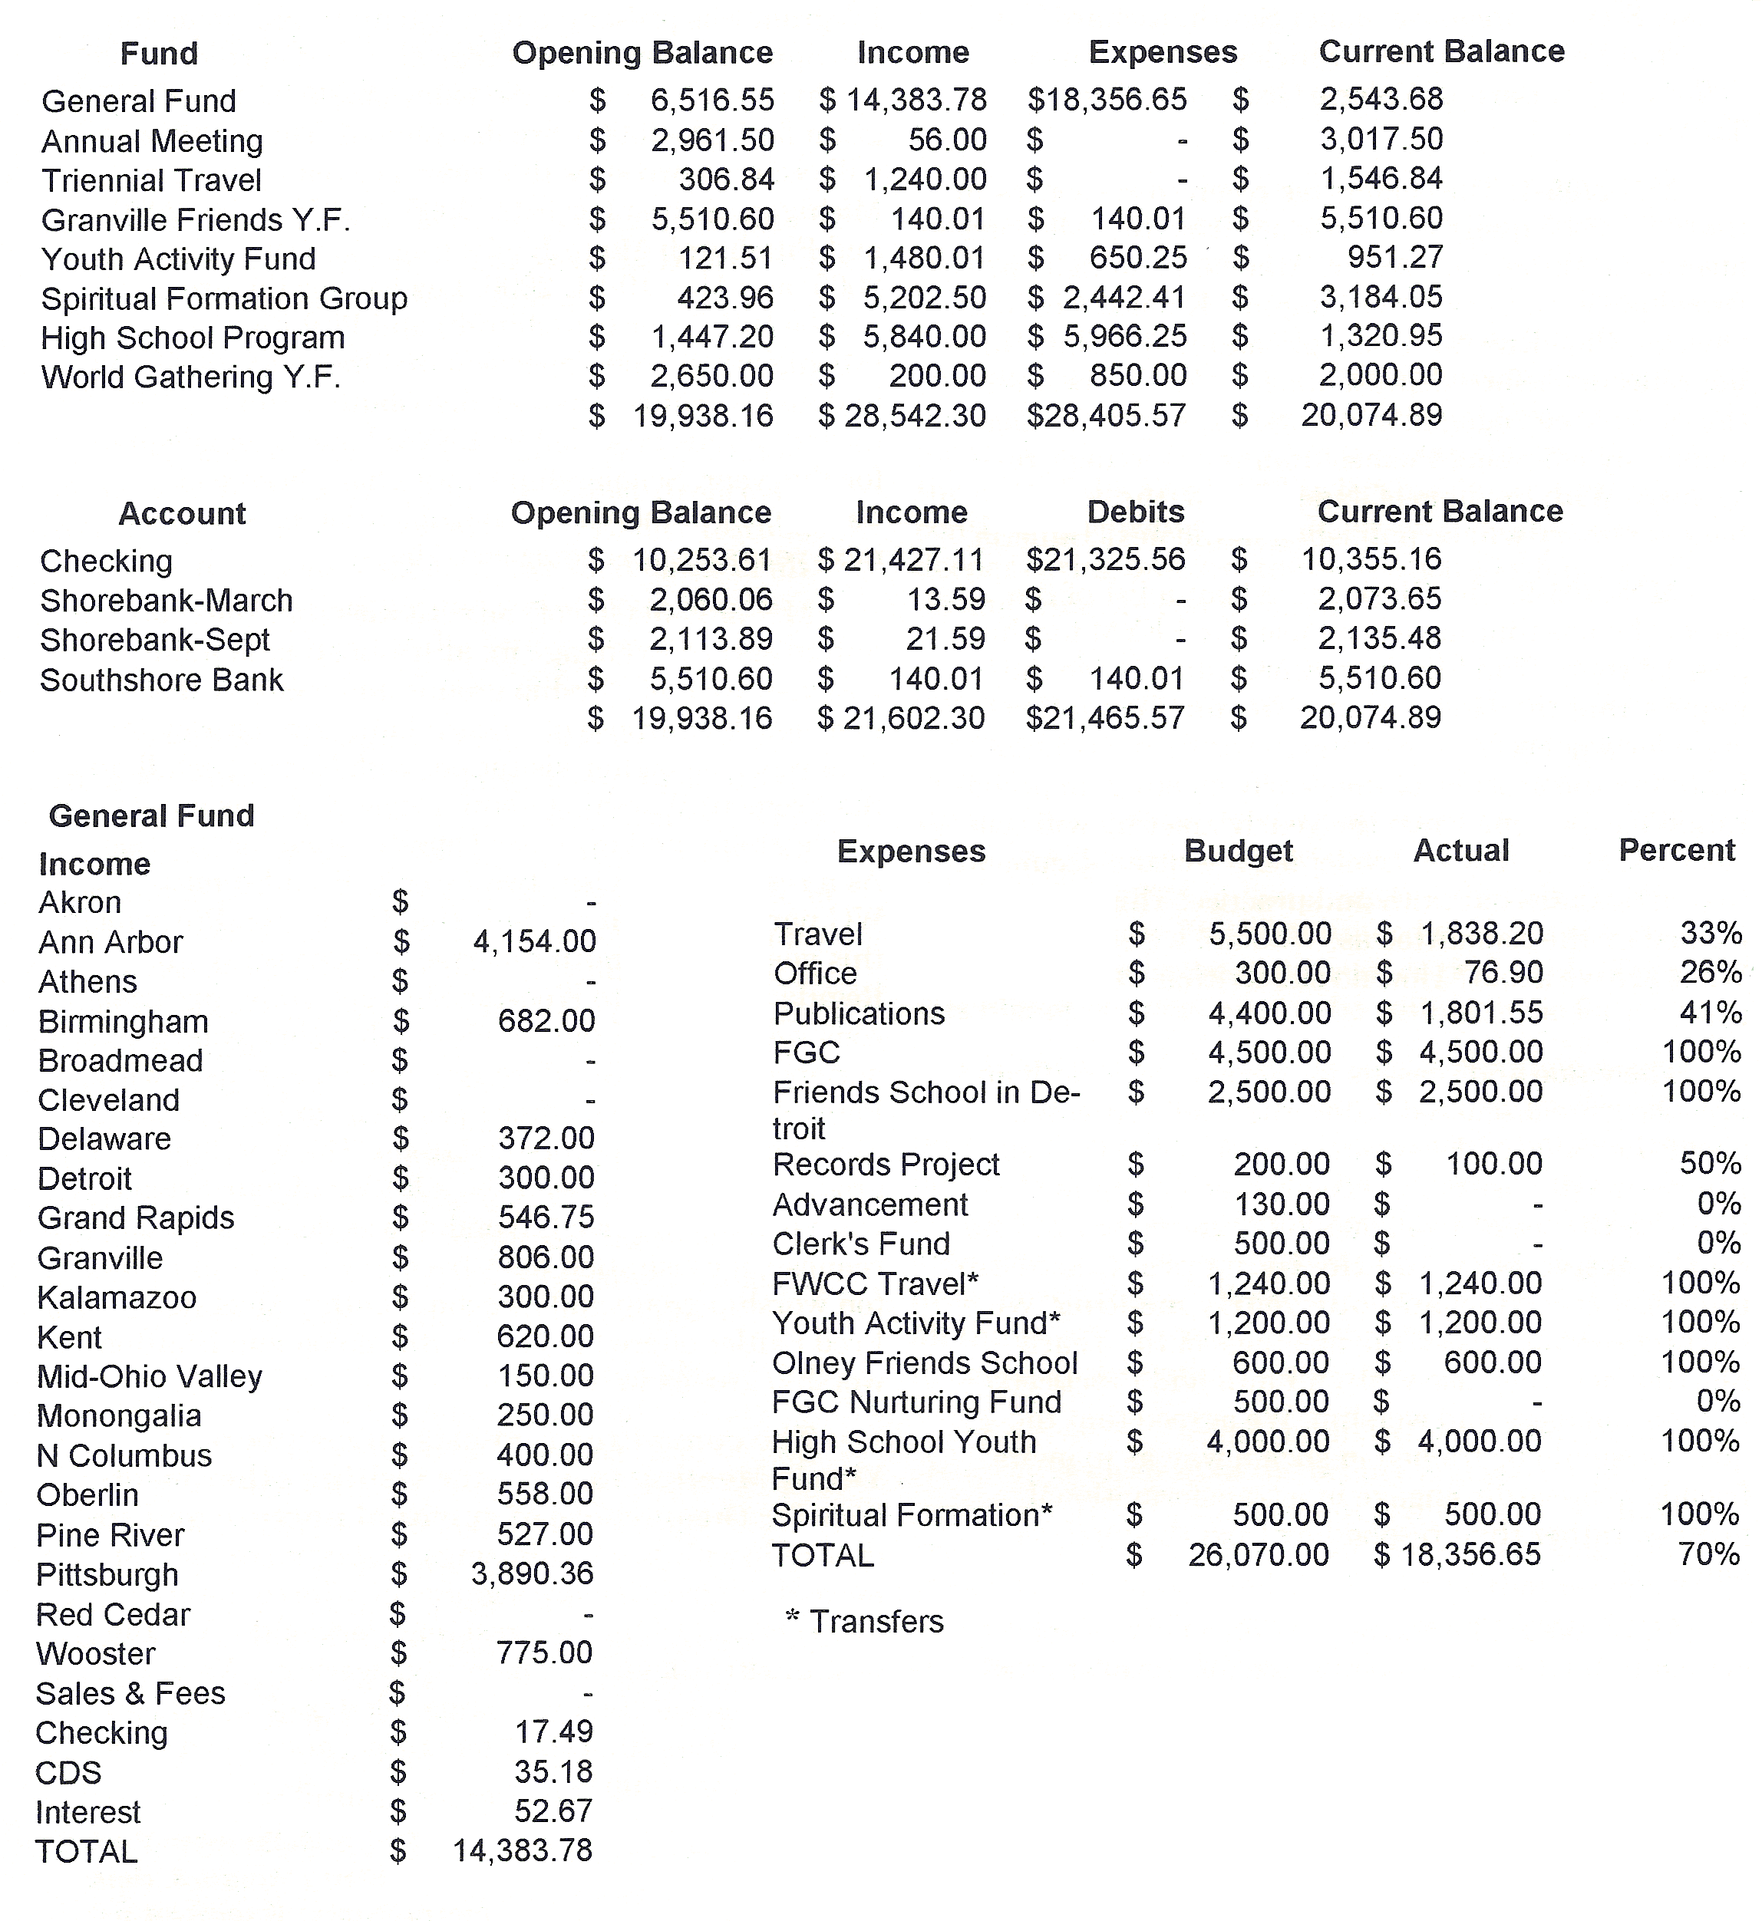
Treasurer's Report

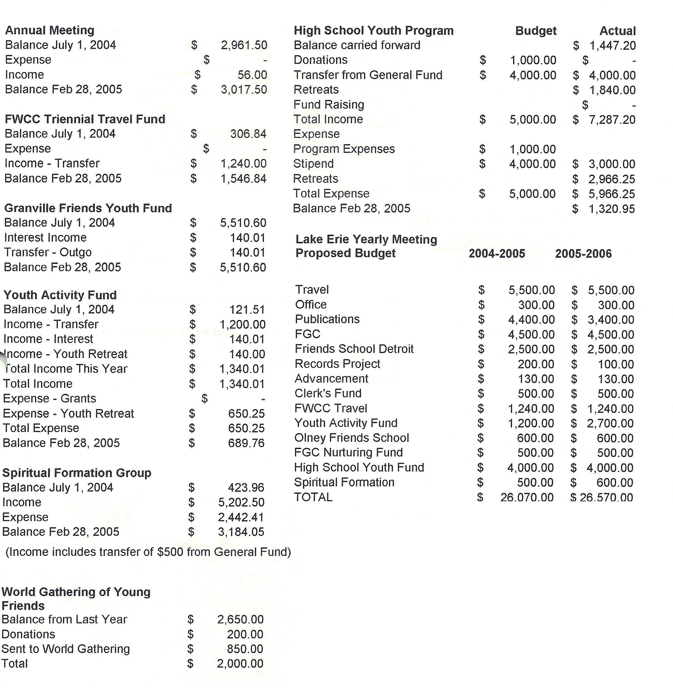
Connie Bimber

